# If you build it, they will come: coastal amenities facilitate human engagement in marine protected areas

Christopher M. Free1,2*, Joshua G. Smith3,4, Cori J. Lopazanski2, Julien Brun3 , Tessa B. Francis5, Jacob G. Eurich6,3, Joachim Claudet7, Jenifer E. Dugan1, David A. Gill8, Scott L. Hamilton9, Kristin Kaschner10, David Mouillot11,12, Shelby L. Ziegler13, Jennifer E. Caselle1, Kerry J. Nickols14,15

1 Marine Science Institute, University of California, Santa Barbara, Santa Barbara, CA, USA

2 Bren School of Environmental Science and Management, University of California, Santa Barbara, Santa Barbara, CA, USA

3 National Center for Ecological Analysis and Synthesis, University of California, Santa Barbara, Santa Barbara, CA, USA

4 Conservation and Science Division, Monterey Bay Aquarium, CA, USA

5 Puget Sound Institute, University of Washington, Tacoma, WA, USA

6 Environmental Defense Fund, Santa Barbara, CA, USA

7 National Center for Scientific Research, PSL Université Paris, CRIOBE, CNRS-EPHE-UPVD, Maison de l’Océan, Paris, France

8 Duke Marine Laboratory, Nicholas School of the Environment, Duke University, Beaufort, NC, USA

9 Moss Landing Marine Laboratories, San Jose State University, Moss Landing, CA, USA

10 Department of Biometry and Environmental Systems Analysis, Albert-Ludwigs-University of Freiburg, Freiburg, Germany

11 MARBEC, University of Montpellier, CNRS, IFREMER, IRD, Montpellier, France

12 Institut Universitaire de France, IUF, Paris, France

13 Odum School of Ecology, University of Georgia, Athens, GA, USA

14 Department of Biology, California State University Northridge, Northridge, CA, USA

15 Present affiliation: Ocean Visions, Leesburg, VA, USA

**\* Corresponding author:** Christopher M. Free, Bren School of Environmental Science and Management, University of California, Santa Barbara, Santa Barbara, CA, USA, [cfree14@gmail.com](mailto:cfree14@gmail.com)

## Abstract

1. Calls for using marine protected areas (MPAs) to achieve goals for nature and people are increasing globally. While the conservation and fisheries impacts of MPAs have been comparatively well studied, impacts on other dimensions of human use have received less attention. Understanding how humans engage with MPAs and identifying traits of MPAs that promote engagement is critical to designing MPA networks that achieve multiple goals effectively, equitably, and with minimal environmental impact.
2. In this paper, we characterize human engagement in California's MPA network, the world’s largest MPA network scientifically designed to function as a coherent network (124 MPAs spanning 16% of state waters and 1,300 km of coastline), and identify traits associated with higher human engagement. We assemble and compare diverse indicators of human engagement that capture recreational, educational, and scientific activities across California’s MPAs.
3. We find that human engagement is correlated with nearby population density and that site “charisma” can expand human engagement beyond what would be predicted based on population density alone. Charismatic MPAs tend to be located near tourist destinations, have long sandy beaches, and be adjacent to state parks and associated amenities. In contrast, underutilized MPAs were often more remote and lacked both sandy beaches and parking lot access.
4. *Synthesis and applications:* These results suggest that achieving MPA goals associated with human engagement can be promoted by developing land-based amenities that increase access to coastal MPAs or by locating new MPAs near existing amenities during the design phase. Alternatively, human engagement can be limited by locating MPAs in areas far from population centers, coastal amenities, or sandy beaches. Furthermore, managers may want to prioritize monitoring, enforcement, education, and outreach programs in MPAs with traits that predict high human engagement. Understanding the extent to which human engagement impacts the conservation performance of MPAs is a critical next step to designing MPAs that minimize tradeoffs among potentially competing objectives.

**Keywords:** California, citizen science, community engagement, human dimensions, human use, marine protected areas, recreation, tourism

## 1. Introduction

Marine protected areas (MPAs) — places where human activity, especially extractive practices such as fishing, is prohibited or restricted — are a common ocean management tool used to achieve a mixture of conservation, fisheries, and cultural objectives [(Erskine et al., 2021; Grorud-Colvert et al., 2021; Marcos et al., 2021)](https://www.zotero.org/google-docs/?0Up7PN). By restricting extractive and destructive human activities, adequately designed, funded, and regulated MPAs can increase the diversity and abundance of marine fish and invertebrates [(Edgar et al., 2014; Gill et al., 2017; Goetze et al., 2021; Zupan et al., 2018)](https://www.zotero.org/google-docs/?7QywHo) and the function and resilience of marine ecosystems [(Cheng et al., 2019; Mellin et al., 2016)](https://www.zotero.org/google-docs/?by7MGB). In the long term, and with concerted community participation and buy-in, well-designed MPAs can also yield fisheries benefits through increased productivity and spillover resulting from improved biomass and age structure of populations in the MPA [(Di Lorenzo et al., 2020; Marshall et al., 2019)](https://www.zotero.org/google-docs/?7OgqIS). Furthermore, MPAs can facilitate and enhance other non-extractive human engagement in ocean ecosystems, such as cultural activities, recreation and tourism, education and outreach, and scientific research [(Angulo-Valdés & Hatcher, 2010; Ban et al., 2019; Erskine et al., 2021; Roncin et al., 2008)](https://www.zotero.org/google-docs/?7k298r).

While the ability and prerequisites for MPAs to achieve conservation and fisheries objectives have been comparatively well-studied (e.g., [Claudet et al., 2008; Edgar et al., 2014; Giakoumi et al., 2017; Goñi et al., 2010; Lester & Halpern, 2008; Wilson et al., 2020)](https://www.zotero.org/google-docs/?Q8zqH5), the enabling conditions for achieving other human use objectives has received less attention [(Ban et al., 2019; Erskine et al., 2021; Gerber et al., 2003; Naidoo et al., 2019; Turnbull et al., 2021)](https://www.zotero.org/google-docs/?7xegfV). This is surprising given the frequency with which human engagement objectives — such as recreation, education, and scientific research — are identified in international, national, and regional MPA planning documents. For example, the Independent World Commission on the Oceans identifies the “*provision of areas for scientific research, education, and recreation”* as a key benefit of MPAs [(IWCO, 1998)](https://www.zotero.org/google-docs/?EuvQP0). Similarly, the U.S. Framework for the National System of Marine Protected Areas identifies the benefits of U.S. MPAs as: (1) *“supporting social and economic benefits [including] coastal tourism”*, (2) *“providing new educational opportunities”*, and (3) *“enhancing research opportunities”* [(NOAA, 2015)](https://www.zotero.org/google-docs/?qe86JX). In some cases, MPAs may aim to enhance cultural, spiritual, emotional, or intrinsic value benefits derived from the ocean [(Allison et al., 2020)](https://www.zotero.org/google-docs/?ZuIQK8). Evaluating human engagement in MPAs is needed to track progress towards achieving these objectives and for identifying the design principles that determine human engagement in MPAs. Here, we use California’s MPA network, the world’s largest MPA network scientifically designed to function as a coherent network [(Botsford et al., 2014)](https://www.zotero.org/google-docs/?hL8tqd), as a case study for identifying conditions that promote or limit human engagement in MPAs.

In 1999, the California state legislature passed the Marine Life Protection Act (MLPA), which directed the state to use the best available science to redesign and greatly expand its system of MPAs to function as a coherent network and to address six goals in service of conservation, fisheries, and other cultural objectives [(Marine Life Protection Act, 1999; Gleason et al., 2013)](https://www.zotero.org/google-docs/?LVmDFr). In addition to goals to preserve biodiversity and ecosystem function and to sustain, conserve, protect, and rebuild marine populations, including those of economic value, the MLPA also included a goal to *“improve recreational, educational, and study opportunities provided by marine ecosystems that are subject to minimal human disturbance, and to manage these uses in a manner consistent with protecting biodiversity.”* From 2004 to 2012, a community-driven and science-guided design process led to a coordinated network of 124 MPAs, containing 16% of state waters, along California’s 1,300 km (840 miles) coastline. Following implementation, an extensive monitoring effort began to ensure that the network could undergo adaptive management [(Botsford et al., 2014)](https://www.zotero.org/google-docs/?o77i1X). While some monitoring programs were developed around human engagement in MPAs (e.g., the MPA Watch citizen science program; [MPA Watch, 2022b)](https://www.zotero.org/google-docs/?2OpiaC), the majority of the monitoring effort was focused on the ecological goals of the MLPA and on elucidating ecological responses to MPA implementation.

Here, we characterize human engagement in California’s MPA network and identify traits associated with high engagement. We assemble and evaluate diverse indicators of engagement that capture a range of recreational, educational, and scientific activities. We then relate levels of human engagement to population density, accessibility, amenities, and other traits likely to influence engagement. This provides a rare quantification of the ways in which people engage with MPAs and the potential pathways for enhancing or limiting engagement based on management goals. These insights are helpful as California [(Executive Order N-82-20, 2020)](https://www.zotero.org/google-docs/?dvS7u3), the United States [(Executive Order on Tackling the Climate Crisis at Home and Abroad, 2021)](https://www.zotero.org/google-docs/?0ZWDRV), and the world [(CBD, 2021)](https://www.zotero.org/google-docs/?JreCwG) aim to protect 30% of the ocean by 2030 (30x30) to meet an array of conservation, fisheries, and other cultural objectives [(Sullivan-Stack et al., 2022)](https://www.zotero.org/google-docs/?ThT2LH).

## 2. Methods

### 2.1 Marine protected areas

California’s coastal waters are protected by a mosaic of spatial management areas that vary in regulatory authority and protection status (**Fig. 1A; Table S1**). State-managed areas include: (1) state marine reserves (SMRs), which prohibit all fishing; (2) state marine conservation areas (SMCAs), which restrict some types of fishing, except for within special no-take SMCAs, which prohibit all fishing; (3) state marine recreational managed areas (SMRMAs), which restrict fishing and allow hunting of waterfowl; (4) state marine parks (SMPs), which prohibit commercial fishing; and (5) special closures, which restrict activity around seabird colonies and marine mammal haulouts and are the only designation not defined as an MPA by the MLPA (**Table S1**). Federal marine reserves and conservation areas (FMRs and FMCAs, respectively) extend certain SMRs and SMCAs around the Channel Islands into federal waters (**Fig. 1A**).

We focus on the 124 MPAs that the MLPA identifies as being part of California’s state-managed coastal MPA network (**Fig. 1A; Table S1**). This excludes federally managed MPAs around the Channel Islands; SMRAs and SMPs in San Francisco Bay, which were established before the MLPA planning process and are not coastal; and special closures, which are not identified as MPAs by the MLPA. We refer to the resulting network of 49 SMRs, 60 SMCAs, 10 no-take SMCAs, and 5 SMRMAs as California’s state MPA network. While the Channel Islands MPAs were established before the MLPA planning process, they have been legally incorporated into the network. The four MLPA regions (South, Central, North Central, and North Coasts; **Fig. 1**) encompass a wide range of ecological dynamics, coastal features, oceanographic environments, cultures, and economies.

### 2.2 Surrounding human communities

We hypothesized that the number of people living near an MPA and the socioeconomic vulnerability of this population would contribute to engagement levels. In short, we expected that MPAs with larger and less vulnerable nearby human populations (i.e., populations with more disposable income and time for recreation) would experience greater human engagement. We characterized the human population living near MPAs using population demographics data from the 2010 U.S. Decennial Census [(USCB, 2010a)](https://www.zotero.org/google-docs/?32LfXf). The 2010 data is the most recent available data given extended delays in the release of the 2020 U.S. Census data [(Schneider, 2023)](https://www.zotero.org/google-docs/?zx1Kly). We downloaded total population estimates by census block, the smallest geographic unit used in the census, using the *tidycensus* R package [(Walker et al., 2022)](https://www.zotero.org/google-docs/?xR7OPd) and calculated the density of people living within each block. We rasterized (500x500 m resolution) these data and calculated the number of people living within a 50 km radius (~31 miles) of each MPA (**Fig. 1B**). The number of people living within 50 km is generally correlated (r2 > 0.8) with population densities using buffer distances ranging from 10 to 100 km (~6-60 miles) (**Fig. S1**).

We estimated the social vulnerability of these populations using twelve indicators identified by Jepson & Colburn (2013) and collected by the U.S. Census American Community Survey [(USCB, 2010b)](https://www.zotero.org/google-docs/?qQwM71). These indicators describe various metrics of poverty status, housing characteristics, labor force structure, and population composition (**Table S2; Figures S2-S4**). We downloaded these indicators by census tract, the smallest geographic unit for which all of the indicators were available (one level larger than census block), also using the *tidycensus* R package [(Walker et al., 2022)](https://www.zotero.org/google-docs/?uBzIjP). We combined these indicators into a single vulnerability index by averaging the z-scores of each indicator (i.e., indicators were centered on the statewide average and scaled to unit variance). Thus, a value of zero indicates average vulnerability across all of the various indicators, negative values indicate higher than average vulnerability, and positive values indicate lower than average vulnerability. We rasterized the tract-level index to match the population raster and calculated the average vulnerability of the population within 50 km of each MPA as the population-weighted average of the social vulnerability index.

### 2.3 Human engagement in protected areas

We developed indicators of human engagement in recreational, educational, and scientific activities in California’s state MPA network using a mixture of citizen science, naturalist, and state agency datasets (**Table S3**). We focused on recreational, educational, and scientific engagement given that they are specific objectives of the network [(Marine Life Protection Act, 1999)](https://www.zotero.org/google-docs/?sdN4gL) and given the lack of data on other cultural, spiritual, or emotional types of human engagement. We used data from two citizen science programs (MPA Watch and Reef Environmental Education Foundation) and two naturalist social networks (iNaturalist and eBird), which provide spatially referenced records of activities (e.g., surfing, swimming, boating, tidepooling, diving, etc.) or observations of wildlife submitted by individual users, as indicators of recreational and educational engagement in MPAs. While popular social media platforms such as Instagram, Facebook, Flickr, and Twitter may provide a better indicator of visitation rates than specialist platforms such as iNaturalist and eBird [(Tenkanen et al., 2017)](https://www.zotero.org/google-docs/?RkoYEk), the volume of data generated by these platforms requires careful subsampling to be manageable (e.g., [Hausmann et al., 2017)](https://www.zotero.org/google-docs/?GBCLyZ). Although analysis of these social media indicators of engagement was outside the scope of this study, we encourage their use in future research. We used data from the California Department of Fish and Wildlife (CDFW) on the annual numbers of permits issued for scientific research in California’s MPAs as an indicator of scientific engagement. Finally, we used CDFW data on regulatory citations as an indicator of regulatory compliance within the network.

We used MPA Watch survey data to measure consumptive and non-consumptive human activities in California’s MPA network. MPA Watch is a citizen science program that trains volunteers to observe and collect data on human engagement in protected areas [(MPA Watch, 2022b)](https://www.zotero.org/google-docs/?xNC2J4). Volunteers use a standardized survey protocol [(MPA Watch, 2022a)](https://www.zotero.org/google-docs/?iZLkml) to record consumptive (e.g., fishing) and non-consumptive (e.g., surfing, boating, tidepooling, running, etc.) activities occurring both on- and off-shore of coastal sampling sites (**Table S4**). Consumptive activities are classified as either active (e.g., fishing line in water) or inactive (e.g., fishing pole on boat but not being used); we focus on active consumptive activities. We caution that SMRMAs and some SMCAs allow some forms of harvest and that MPA Watch volunteers, while well trained, are not legal authorities on MPA boundaries and regulations. Thus, our ability to infer the legality of consumptive activities documented by MPA Watch volunteers is limited. MPA Watch has been in operation since 2011 and, as of writing, has conducted over 33,000 surveys in 49 MPAs (47 of which meet our inclusion criteria) and 60 control (non-MPA) locations (**Fig. S5**). While some MPAs have been surveyed consistently since 2011, others did not receive consistent visits until 2015 or later (**Fig. S5A**). To allow comparison between sites with variable temporal coverage, we limited analysis to surveys that took place from January 1, 2015 to December 31, 2021. To eliminate spurious results from surveys that were conducted either early in the morning or late at night or were either shorter or longer than the official protocol [(MPA Watch, 2022a)](https://www.zotero.org/google-docs/?Hp5jrP), we also limited analysis to surveys that occurred between 6AM and 8PM and lasted between 10 and 60 minutes (**Fig. S5BC**). We quantified human engagement by MPA in terms of (1) the percent of surveys in which an activity was observed and (2) the median number of activities observed per hour for surveys in which activities were observed (zeroes excluded because of high zero-inflation) (**Figs. S6 & S7**).

We used iNaturalist submission records to measure engagement in wildlife observation within and adjacent to MPAs. iNaturalist is a web- and app-based platform that allows observers to submit wildlife photos for identification by amateur and professional naturalists [(iNaturalist, 2022)](https://www.zotero.org/google-docs/?tA81k8). iNaturalist was launched in 2008 and as of writing, has more than 100 million observations, 2 million observers, and 380,000 observed species globally. We used the *rinat* R package [(Barve et al., 2021)](https://www.zotero.org/google-docs/?wEiga8) to download all iNaturalist observations submitted by users in a bounding box spanning the California coastline from January 1, 2000 to December 31, 2021 (iNaturalist allows back submissions, hence the availability of pre-2008 observations). We defined MPA-associated observations as observations occurring within 100 meters of an MPA and quantified human engagement from 2012 through 2021 by MPA in terms of the number of (1) unique observers (number of iNaturalist users who submitted wildlife observations) and (2) observations (number of entries submitted). More than 5,800 observers have submitted >72,000 observations associated with 121 of California’s state MPAs (**Figs. S8 & S9**).

We used eBird submission records to measure engagement in birding within and adjacent to MPAs. eBird is a global program that collates observations of birds submitted by birdwatchers [(eBird, 2022)](https://www.zotero.org/google-docs/?PAPjar). It was launched in 2002 by the Cornell University Lab of Ornithology and the National Audubon Society but allows back submissions from birding diaries. As a result, eBird contains observations dating back centuries in many locations. As of writing, the global eBird dataset includes over 69.7 million submissions from nearly 800,000 birders. We downloaded eBird observations from California and, as with the iNaturalist data, identified observations occurring within 100 meters of an MPA from 2012 through 2021. We quantified human engagement by MPA in terms of the number of (1) unique observers and (2) observations. More than 19,000 birders have conducted >193,000 surveys and made >3.8 million submissions to eBird associated with 114 of California’s state MPAs (**Figs. S10 & S11**).

We used Reef Environmental Education Foundation (REEF) diver surveys as an indicator of engagement in diving and snorkeling in California’s MPAs. REEF is an international marine conservation organization that trains volunteer SCUBA divers and snorkelers to collect and report information on marine fish and select invertebrate and algae species during recreational SCUBA dives and snorkels [(REEF, 2022)](https://www.zotero.org/google-docs/?jBDXSI). The diver survey program was launched in 1993 and, as of writing, has >250,000 surveys by 16,000 volunteers at 15,000 sites worldwide. We received records of >14,700 surveys conducted in California and identified 4,085 surveys occurring within 41 of California’s state MPAs from 2012 through 2021 (**Figs. S12 & S13**). We quantified human engagement by MPA in terms of the (1) number of surveys conducted and (2) number of years in which a survey was conducted.

We used records of scientific permits issued by CDFW for research conducted within California’s MPA network as an indicator of the contributions of MPAs to scientific knowledge. While permits are required for any extractive or manipulative research in California’s coastal waters, purely observational research (i.e., research without capturing, handling, etc.) does not require permits; thus, the permit data may underestimate the amount of research occurring in the network. From 2012-2021, 5,329 scientific permits were issued for research in all 124 of California’s state MPAs (**Figs. S14 & S15**). We quantified human engagement by MPA in terms of the (1) number of permits issued and (2) number of years in which permits were issued.

We used records of citations issued by the CDFW Law Enforcement Division for regulatory violations occurring within California’s MPA network as an indicator of compliance. From 2016-2021, 2,812 citations were issued for violations occurring within 85 of California’s state MPAs **(Figs. S16 & S17**). We quantified non-compliance by MPA in terms of the (1) number of citations issued and (2) number of years in which citations were issued. We used generalized linear models assuming a Poisson distribution to evaluate the correlation between the total number of citations issued within an MPA and human population density, human engagement (defined using the iNaturalist observer data), and observations of active fishing (defined using the MPA Watch survey data). We caution that the lack of patrol effort information limits our ability to infer non-compliance rates (i.e., whether more citations corresponds to more effort or more illegal activity) and advise that, going forward, CDFW record information on effort (e.g., number of patrol hours) to improve ability to document patterns of non-compliance and target patrol strategies.

To compare human engagement across indicators (**Fig. 2**), we selected key metrics for each indicator (**Table S3**) to display in an engagement scorecard (**Fig. 3)**. We centered each metric on its mean and scaled it to unit variance to facilitate comparisons across indicators. We also measured and compared the degree to which engagement is concentrated within specific MPAs, a metric of the selectivity of users, by developing the engagement accumulation curves shown in **Figure 4**. We developed these curves by first calculating the percent contribution of each MPA to network-wide engagement for each of the metrics selected for the scorecard. We then plotted the accumulation of these contributions beginning with the MPA with the highest engagement and ending with the MPA with the lowest engagement. The steeper the resulting curve, the more network-wide engagement is dominated by a few MPAs.

### 2.4 Drivers of human engagement

We hypothesized that human engagement in MPAs would be correlated with nearby population density [(Cinner et al., 2018; Ravenstein, 1885)](https://www.zotero.org/google-docs/?xmT1wi) except for (1) “charismatic” MPAs that draw participation from afar and thus generate more engagement than would be predicted based on nearby population density, and (2) “underutilized” MPAs that are difficult to access (e.g., located offshore, limited road access, etc.) and thus generate less engagement than would be predicted based on nearby population density. To distinguish charismatic and underutilized MPAs, we regressed human engagement (as measured by the number of iNaturalist observers) against population density and extracted the MPAs that fell above (charismatic) or below (underutilized) 75% of the fitted values (**Fig. 5**). For this model, we used the number of iNaturalist observers as our measure of human engagement because it was the most spatially comprehensive indicator (i.e., describes engagement in the greatest number of MPAs) and it correlates with all of the indicators of non-extractive engagement (i.e., it is not correlated with citations or consumptive activities; **Fig. S18**).

We used logistic regression to identify traits associated with charismatic and underutilized MPAs (**Fig. 6**). We considered 13 traits describing a range of MPA design features (age, size, protection level), habitats (sandy beach, rocky intertidal, kelp, estuary), accessibility and amenities (distance to port; number of parks, parking lots, campgrounds, and picnic areas within 1 km), and the social vulnerability index. See **Table S5** for the source of each explanatory variable. We then used a series of logistic regressions to evaluate the association between engagement (charismatic vs. typical and underutilized vs. typical) and these traits. We defined the logistic target level for each model based on “typical” MPAs (response of 0) versus charismatic or underutilized (response of 1). Logistic models were constructed stepwise after *a priori* identifying relevant drivers of engagement. The best fitting models were selected using Akaike Information Criterion [(Akaike, 1974)](https://www.zotero.org/google-docs/?VkpE5U) to identify the most parsimonious model of the relationship between engagement and the evaluated traits.

### 2.5 Comparison to non-MPA areas

The methods described above were used to determine which MPAs within California’s MPA network generate the most human engagement and to identify the factors that drive differences in the levels of engagement; however, they are unable to reveal whether MPAs generate more, less, or equivalent human engagement as similar non-MPA areas. To understand the degree to which MPA designations impact human engagement in coastal areas, we compared engagement in MPA areas to similar counterfactual non-MPA areas. We identified similar counterfactual areas through statistical matching [(Ferraro, 2009)](https://www.zotero.org/google-docs/?bBGMW7), which is increasingly used to elucidate the ecological impacts of MPAs [(Ahmadia et al., 2015; Gill et al., 2017)](https://www.zotero.org/google-docs/?0WeipH). In short, we rasterized California’s state waters into 200 m raster cells and paired each MPA cell with a non-MPA counterfactual cell with otherwise similar properties. We identified non-MPA counterfactual cells that were similar to their MPA reference cells in their depth (m), distance from shore (km), nearby population density, proximity to parks, and proximity to public beaches. These matching variables were selected based on their association with engagement based on theory [(Cinner et al., 2018; Ravenstein, 1885)](https://www.zotero.org/google-docs/?uEM055) and as revealed through the regression analysis (**Fig. 6**). Ideally, we would also match based on pre-MPA visitation rates [(Devillers et al., 2015)](https://www.zotero.org/google-docs/?46BMt1), but the lack of sufficient pre-MPA visitation data (see limited pre-2007 data in **Figure S8**) precluded this gold standard. However, by controlling for these known and quantifiable drivers of MPA site selection and human engagement, we can isolate, to the greatest extent practicable, the impact of MPA designation on human engagement. We derived these values for both MPA and counterfactual cells using the sources listed in **Table S6**. We identified suitable counterfactuals through statistical matching using the *MatchIt* package [(Ho et al., 2011)](https://www.zotero.org/google-docs/?8fC8QJ), using one-to-one Mahalanobis distance matching with replacement and propensity score calipers of 0.20 standard deviations [(Ho et al., 2007)](https://www.zotero.org/google-docs/?JcoPoj). After an appropriate counterfactual was identified for each MPA cell (**Fig. S19**), we calculated the log-response ratio of the sum of activities within each MPA’s cells and its paired counterfactuals cells for the three engagement indicators with activities reported inside and outside MPAs using GPS coordinates (i.e., the iNaturalist, eBird, and REEF indicators). We tested whether the mean log-ratio of these sums differed from zero using t-tests (i.e., whether MPAs and non-MPAs generate different levels of human engagement). Log-response ratios were calculated after adding 1 to the engagement values occurring in both the numerator and denominator to avoid non-finite ratio values.

All data analysis and visualization was done in R [(R Core Team, 2021)](https://www.zotero.org/google-docs/?gcMCG5) and all data and code are available on GitHub here: <https://github.com/NCEAS/ca-mpa>

## 3. Results

### 3.1 Human engagement in protected areas

MPA Watch volunteers observed non-consumptive activities in the vast majority of surveys conducted coastwide and within all of the 47 surveyed MPAs (**Fig. 2A**). MPA visitors were most commonly observed walking and recreating on the beach, often with their pets. Offshore recreation included boating, surfing, bodyboarding, and swimming. MPA visitors were also often observed viewing wildlife and exploring tidepools (**Fig. S6BC**). MPAs in the South Coast region were most popular, especially those near the metropolitan areas of San Diego and Los Angeles (**Fig. 2A**).

MPA Watch volunteers observed active consumptive activities (i.e., fishing and hand collection of organisms) in all but four of the 47 surveyed MPAs (**Fig. 2B**) but at rates substantially lower than those observed for non-consumptive activities (**Fig. S7BC**). Hook and line fishing was the most commonly observed consumptive activity and was observed in ~6% of surveys within SMCAs (MPAs in which certain types of fishing are often allowed). However, active hook and line fishing was also reported by volunteers in surveys in no-take SMCAs (~1.8% of surveys) and SMRs (~2% of surveys) (**Fig. S7B**). Hand collection of organisms, trap fishing, and spear fishing were the next most frequently reported consumptive activities. Net fishing, dive fishing, commercial passenger fishing vessel (CPFV) fishing, and kelp harvest were more rarely reported (**Fig. S7BC**). Observations of consumptive activities were more frequent in South Coast MPAs and within SMCAs, which allow some types of harvest.

The number of people submitting wildlife observations to iNaturalist from within California’s MPA network increased through time (**Fig. S8BC**). The majority of observers submit observations from only one MPA per year, but some observers make submissions from up to 21 MPAs per year (**Fig. S8C**). Observers are especially interested in plants (often land-based), shells (mollusks), and seabirds (**Fig. S8B**). iNaturalist participation is especially high in the touristic Monterey Bay area and secondarily high in the densely populated San Diego, Los Angeles, and San Francisco areas (**Fig. 2C**). MPA engagement was less selective than predicted by human population density for this form of human engagement (**Fig. 4**). On average, California’s MPAs have not generated more iNaturalist engagement than counterfactual sites (p=0.12), indicating that non-MPA areas with similar features generate just as much engagement as MPAs for this type of activity **(Fig. 7)**.

Birders have been visiting California’s MPAs since before they were designated as protected areas (**Fig. S11BC**). The participation of birders in the eBird citizen science program increased linearly from the 1960-2005 and exponentially since 2005 (**Fig. S11B**). Participation has been greatest, in terms of number of birders submitting eBird observations, at popular birding hotspots such as Bolsa Chica Basin SMCA, Elkhorn Slough SMR, Matlahuayl SMR, Morro Bay SMRMA, and Point Reyes SMR (**Figs. 2D & 3**). MPAs within estuaries -- including Bolsa Chica Basin, Elkhorn Slough, and Morro Bay -- generate a disproportionate amount of eBird activity: despite representing only 2% of California’s state MPA network by area (17% by count), around 40% of recent annual visits to the network logged by eBirders have been within estuarine MPAs (**Fig. S11C**). Despite the tendency for eBirders to visit estuarine MPAs, the selectivity of birders was generally proportional to that predicted by population density (**Fig. 4**), suggesting that estuarine MPAs are located in areas with high population density. On average, California’s MPAs have generated slightly more eBird engagement than counterfactual sites (p=0.02), indicating that MPA status attracts engagement for this type of activity **(Fig. 7)**.

The number of recreational divers and snorkelers contributing to the REEF citizen science survey program from within California’s MPA network increased from the program’s inception in 1994 to a peak in 2011, then decreased until a resurgence during the COVID-19 pandemic (2020-2021) (**Fig. S13BC**). Participants visited a range of habitats and depths but generally favored kelp forests and rocky reefs (**Fig. S13BC**). The majority of participation has come from MPAs with high profile dive sites including, in decreasing order of prevalence, Matlahuayl SMR, Edward F. Ricketts SMCA, Point Lobos SMR, Pacific Grove Marine Gardens SMCA, and Carmel Bay SMCA (**Figs. 2E & 3**). REEF divers have been more selective in their MPA visitation than any of the other evaluated user groups (**Fig. 4**). California’s MPAs have, on average, generated much more REEF survey engagement than counterfactual sites (p<0.0001), indicating that MPA status attracts engagement for this type of activity **(Fig. 7)**.

The number of scientific permits issued for research within California’s MPA network has been variable through time and decreased during the COVID-19 pandemic (2020-2021) (**Fig. S15B**). The distribution of scientific research throughout the MPA network has been more even than any other type of human engagement (**Fig. 4**). In general, fewer permits have been issued for research in the North and North Central Coast regions and more permits have been issued for research in the Central (especially Monterey Bay) and South (especially Los Angeles and San Diego) Coast regions (**Figs. 2F & 3**), where academic institutions and marine science non-profits are more highly concentrated. Scientific research in MPAs of different designations has generally occurred in proportion to the representation of the different MPA designations within the network (i.e., no bias towards no-take areas) (**Fig. S15C**).

The number of citations issued for regulatory violations was highest in MPAs in the South Coast region, especially in the MPAs around Catalina Island, a major tourist destination off the coast of Los Angeles (**Fig. S17A**). In general, the number of citations is positively correlated with nearby human population size (p<0.001; **Fig. S17B**) and human engagement (p<0.001; **Fig. S17C**) in MPAs, where engagement is defined as the total number of people contributing iNaturalist observations from within an MPA from 2012-2021. Interestingly, the number of citations was negatively correlated with the observation of active consumptive activity by MPA Watch observers (**Fig. S17D**), which could indicate that the active consumptive activity reported by MPA Watch observers is sanctioned or that active consumptive activity is more prominent in areas with less active enforcement. Citations were more highly concentrated in certain MPAs than would be predicted by human population density alone (**Fig. 4**).

### 3.2 Drivers of human engagement

Across all indicators, human engagement in MPAs was highest in the populous South Coast region and the touristic Monterey Bay area in the Central Coast region, and lowest in the remote North Coast region (**Figs. 2 & 3**). We found that human engagement in MPAs was correlated to nearby population density (r2=0.14; p<0.001) but that MPA traits can enhance or reduce engagement beyond what would be predicted based on population density alone (**Fig. 5**). Elevated engagement in 20 “charismatic” MPAs (MPAs whose engagement is greater than would be expected based on population density) was associated with older MPAs with long sandy beaches and many adjacent land-based parks (**Fig. 6; Table S7**). Reduced engagement in 42 “underutilized” MPAs (MPAs whose engagement is lower than would be expected based on population density) was associated with remoteness (i.e., far from the nearest port), lack of sandy beaches, and lack of parking lot access (**Fig. 6; Table S7**). Counter to our hypothesis, social vulnerability was not a significant driver of human engagement in MPAs (**Table S7**).

## 4. Discussion

Understanding the ability and prerequisites for MPAs to achieve human use objectives is central to designing MPA networks that provide multiple benefits to people and nature. California’s MPA network supports a diverse array of recreational, educational, and scientific activities. MPAs are commonly used for recreational activities such as walking, playing, or relaxing on the beach or boating, surfing, swimming, or SCUBA diving in the ocean. Engagement in these activities makes important contributions to local economies [(Pendleton & Kildow, 2006)](https://www.zotero.org/google-docs/?fwnm2g) and to cultural, emotional, and physical health [(Hipp & Ogunseitan, 2011; Jacobson, 2020)](https://www.zotero.org/google-docs/?INjFIl). Wildlife viewing is also common within California’s MPAs and provides a platform for education and research. Many visitors engage in MPAs through citizen science programs that provide opportunities both to learn about the natural world and to contribute to meaningful scientific datasets [(Freiwald et al., 2018; Rapacciuolo et al., 2021)](https://www.zotero.org/google-docs/?r6F82C). Finally, scientific researchers have utilized the MPA network as a “large-scale ecological experiment” (*sensu* [Jensen et al., 2012)](https://www.zotero.org/google-docs/?BRoyXZ) to derive globally-relevant insights into MPA performance, marine ecology, and fisheries and conservation science (e.g., [Starr et al., 2015; White et al., 2021; Ziegler et al., 2022)](https://www.zotero.org/google-docs/?4xQcmK).

However, not all MPAs generate equal levels of human engagement. In general, engagement is positively correlated with surrounding human population density: the more people living near an MPA, the more engagement an MPA generates. Charismatic MPAs, MPAs that receive more engagement than would be expected based on nearby population density, likely draw additional users because they have adjacent land-based attractions (i.e., parks) and associated amenities (e.g., parking lots, restrooms, campgrounds). These MPAs also have higher amounts of sandy beaches, which based on the MPA Watch surveys, tend to generate higher engagement than rocky beaches. Furthermore, many of the charismatic MPAs are located in areas spanning the Monterey Bay and Big Sur coastlines and the city of San Diego, which attract high numbers of tourists. These results are consistent with studies of land-based protected areas that find that visitation rates are driven primarily by the availability of amenities such as parking lots, walking paths, and campgrounds and the accessibility of parks to human populations (see Heagney et al. 2018 and references within). Finally, engagement is moderated by the selectivity of different user groups. For example, whereas divers are highly selective in their choice of MPAs to visit, scientists have conducted research much more evenly across the statewide MPA network. Birders disproportionately visit estuarine MPAs, which tend to harbor large bird populations due to their high productivity [(Paracuellos & Tellería, 2004)](https://www.zotero.org/google-docs/?yVnWh2).

It is also critical to understand patterns of unsanctioned use within California’s MPA network. Overall, consumptive use was observed in a higher proportion of surveys conducted in MPAs that allow some types of harvest (i.e., SMCAs and SMRMAs) than in fully no-take MPAs that prohibit all fishing (i.e., SMRs and no-take SMCAs). However, MPA Watch surveys, which we caution are conducted by citizen scientists and not by law enforcement officers, document fishing inside many of California’s no-take MPAs. While observed much less frequently than non-consumptive activities, fishing was still reported in 10% of all MPA Watch surveys conducted in no-take MPAs. The vast majority of reported fishing in no-take areas was by recreational anglers using hook-and-line fishing gear. In most cases, we suspect this was due to a lack of education on the location of MPA boundaries by recreational anglers, as opposed to deliberate poaching activities. The rare observation of commercial fishing in MPAs suggests high compliance by the commercial fleet, which is highly informed about the location and regulations of MPAs. This is consistent with official summaries showing that, in 2011 (the most recent year with publicly available data), 271 citations were issued to commercial fishers while 10,052 citations were issued to recreational fishers (~4 times larger than the number issued to recreational hunters) [(CDFW, 2011)](https://www.zotero.org/google-docs/?cJeKGQ). This suggests that outreach within the recreational fishing community could be especially effective at increasing compliance with MPA regulations.

Our findings have several key management implications. If promoting human engagement in MPAs is a management objective, our results suggest that MPA planners could improve access and promote engagement either by (1) locating new MPAs in areas with adjacent land-based parks and amenities or (2) investing in the development of new land-based parks and/or amenities adjacent to existing MPAs. Furthermore, aligning protections on land and sea could improve MPA performance by preventing pollution, sedimentation, or eutrophication resulting from run-off from land-based activities [(Cicin-Sain & Belfiore, 2005)](https://www.zotero.org/google-docs/?fxjerO). Alternatively, if reducing human engagement is desired — for example, to enhance protection of biodiversity or other ecosystem or cultural services sensitive to human visitation or to limit cumulative stressors to promote climate resilience — then planners could locate MPAs far from people or land-based parks and amenities [(Campbell et al., 2020)](https://www.zotero.org/google-docs/?5RwpSp). Our results could also help guide decisions about where to invest in the monitoring, enforcement, and outreach programs required to ensure compliance [(Murray & Hee, 2019)](https://www.zotero.org/google-docs/?0cs3Ix). We found that the citation frequency for MPA rule violations increased with engagement and adjacent population size. These programs may want to prioritize MPAs in areas of high population density and with adjacent land-based amenities and sandy beaches. However, remote MPAs can also be areas of elevated non-compliance due to lower levels of perceived risk of detection [(Crawford et al., 2004; Rojo et al., 2019)](https://www.zotero.org/google-docs/?ckvFMq), and enforcement should not entirely abandon these areas. In addition to monitoring and enforcement, expanded education and outreach is needed to prevent non-compliance before it happens, especially amongst recreational anglers [(Bergseth & Roscher, 2018)](https://www.zotero.org/google-docs/?NRQAdg).

Equitable human engagement in California’s MPA network is also an important socioeconomic objective. Unfortunately, the indicators of engagement evaluated here do not include demographic information on the identity of human users, limiting our ability to evaluate the equity of engagement among different user groups. The collection of information in the identity of MPA users is thus a vital first step towards considering equity in future MPA planning and outreach. Knowledge of the representativeness of current users is necessary to design and implement programs that promote access and engagement among underrepresented groups. This knowledge could be gained by interviewing MPA visitors in intercept surveys and assessing the composition of these users relative to that of surrounding communities (e.g., [Scully-Engelmeyer et al., 2021)](https://www.zotero.org/google-docs/?TYZGuY). It could also be gained through focus groups with the various community organizations that engage with MPAs, such as fishing, diving, and/or birding clubs, or direct interaction with communities (e.g., [Diedrich et al., 2017)](https://www.zotero.org/google-docs/?Ctn3WD). The equity of access and engagement should be considered at the outset of any additional MPA planning, including the identification of methods for tracking and benchmarking progress towards these objectives. As California prepares to expand its MPA network to meet 30x30 goals, it will be important to build on the successes and lessons of the original participatory planning process [(Gleason et al., 2013)](https://www.zotero.org/google-docs/?4TKxQG) to further enhance the ability for ocean users, especially indigenous people, to ensure that their values are reflected in the objectives, regulations, and design of the expanded network [(Barclay et al., 2017; Voyer et al., 2015; Voyer & Gladstone, 2018)](https://www.zotero.org/google-docs/?SDJ1b5).

MPAs with low human engagement can still provide valuable contributions to the human engagement, conservation, and fisheries goals of the MPA network. While total engagement at some MPAs is low, these MPAs could be more important to small but underserved human populations in the neighboring area. This is a key benefit of the MLPA’s spacing requirements, which mandated that California’s MPAs be placed within 50-100 km of each other [(Saarman & Carr, 2013)](https://www.zotero.org/google-docs/?Vuf7EP). This spacing ensures that coastal populations have relatively similar access to MPAs along the entire California coast. Thus, while MPAs in low population areas have lower engagement, the people living in these areas have opportunities for access similar to people living in higher population areas. Furthermore, MPAs also aim to achieve conservation and fisheries benefits and MPAs with low human engagement can be critical contributors to these goals. This is especially true given that human engagement with MPAs has the potential to negatively impact ecosystem function and MPA performance [(Milazzo et al., 2002)](https://www.zotero.org/google-docs/?bke58I). Limiting human engagement can also reduce the cumulative impacts of multiple stressors on MPAs, including climate change, eutrophication, and pollution [(Mach et al., 2017)](https://www.zotero.org/google-docs/?qWBVSd). MPAs with low human engagement are thus key in the design of effective MPA networks, as they can buffer or offset the impacts of human activities in MPAs with greater engagement and limit cumulative impacts in a multi-stressor environment. A network of MPAs, like that in California, provides the opportunity to design individual MPAs that meet differing criteria and perspectives regarding human-nature relationships [(Pereira et al., 2020)](https://www.zotero.org/google-docs/?2iP62d) while contributing to overall network performance across a range of axes.

The methodological framework developed here presents a useful starting point for assessing human engagement in any MPA network. To start, the iNaturalist and eBird citizen science programs already have wide global coverage and REEF has high participation in many regions. Other social media platforms, such as Instagram, Twitter, and Flickr, may also be used to assess how, when, and where people engage in MPAs [(Retka et al., 2019; Tenkanen et al., 2017)](https://www.zotero.org/google-docs/?awCrPN). However, these indicators do not capture all types of human engagement or all of the information needed to understand the ecological impacts of human engagement or the equity of engagement amongst different human populations. Notably, our indicators do not capture information on: (1) user demographics, which are key for understanding equality in access [(Nicholls & Shafer, 2001)](https://www.zotero.org/google-docs/?ek772P); (2) activities that have negative ecological impacts, such as anchoring [(Creed & Amado Filho, 1999)](https://www.zotero.org/google-docs/?6JCDBm); or (3) money spent on licenses, entry fees, food, gas, and lodging, among other expenses associated with human engagement in MPAs, which are helpful in quantifying the broader impact of MPAs to local economies [(Sala et al., 2013)](https://www.zotero.org/google-docs/?a8d1q3). Furthermore, the types of engagement evaluated here, especially engagement in science and tourism, likely undercount underserved and disadvantaged communities, as the geoscientific community remains largely white [(Dutt, 2020)](https://www.zotero.org/google-docs/?TyJEx9) and the expense of tourism and even coastal parking can be a barrier to engagement. Notably, our analysis does not explicitly account for tribal and indigenous engagement with MPAs, which is an important consideration for California’s MPA network. In addition, some of our datasets have known biases. For example, iNaturalist observations require the use of a smartphone, which may exclude some user groups.

Understanding the ability and enabling conditions for MPAs to achieve human engagement objectives is important as entities around the world aim to protect 30% of the ocean by 2030 to meet objectives for people and nature [(CBD, 2021)](https://www.zotero.org/google-docs/?lUwoEC). This paper presents a transferable framework for evaluating human engagement with MPA networks and our analyses indicate that human engagement can potentially be increased by placing or developing MPAs near people in concert with existing land-based attractions or amenities. Critical next steps in MPA and human engagement research are to identify strategies for designing MPA networks to promote equitable human engagement, capturing the full extent and value of MPAs in promoting recreation and tourism, education and outreach, and scientific research, and minimizing negative impacts of engagement on the conservation and fisheries objectives.

## Acknowledgements

This research was funded by the California Ocean Protection Council (OPC) and California Department of Fish and Wildlife as part of the Decadal Review of California’s Marine Protected Areas. CMF was funded through the Arnhold UC Santa Barbara-Conservation International Climate Solutions Collaborative. JC was funded through BiodivERsA METRODIVER and Fondation de France MultiNet projects. JED is grateful for support by the California Ocean Protection Council and the Santa Barbara Coastal Long Term Ecological Research project (National Science Foundation OCE-1831937). The paper improved from the feedback of Freya Croft and an anonymous reviewer. We thank Sophie Morgan for help with data collection, Angela Kemsley for sharing the MPA Watch data, Christy Pattengill-Semmens for sharing the REEF data, Amanda Van Diggelen (CDFW) for sharing the citations data, and Stephen Wertz (CDFW) and Sara Worden (CDFW) for sharing the scientific permit data. CDFW collects data from various sources for fisheries management purposes, and data may be modified at any time to improve accuracy and as new data are acquired. CDFW may provide data upon request under a formal agreement. Data are provided as-is and in good faith, but CDFW does not endorse any particular analytical methods, interpretations, or conclusions based upon the data it provides. Unless otherwise stated, use of CDFW’s data does not constitute CDFW’s professional advice or formal recommendation of any given analysis. CDFW recommends users consult with CDFW prior to data use regarding known limitations of certain data sets.

## Author Contributions Statement

Christopher Free, Jacob Eurich, Jennifer Caselle, Joshua Smith, Kerry Nickols, and Tessa Francis conceived the ideas and designed methodology; Christopher Free, Jacob Eurich, Joshua Smith, Julien Brun, Kerry Nickols, and Tessa Francis collected the data; Christopher Free, Joshua Smith, and Julien Brun analyzed the data; Christopher Free led the writing of the manuscript. All authors contributed critically to the drafts and gave final approval for publication.

## Conflict of Interests Statement

The authors have no conflicts of interest to declare.

## Data Availability Statement

All code and data are available on GitHub here: <https://github.com/NCEAS/ca-mpa>

## References

[Ahmadia, G. N., Glew, L., Provost, M., Gill, D., Hidayat, N. I., Mangubhai, S., Purwanto, null, & Fox, H. E. (2015). Integrating impact evaluation in the design and implementation of monitoring marine protected areas. *Philosophical Transactions of the Royal Society B: Biological Sciences*, *370*(1681), 20140275. https://doi.org/10.1098/rstb.2014.0275](https://www.zotero.org/google-docs/?w2YRNa)

[Akaike, H. (1974). A new look at the statistical model identification. *IEEE Transactions on Automatic Control*, *19*(6), 716–723. https://doi.org/10.1109/TAC.1974.1100705](https://www.zotero.org/google-docs/?w2YRNa)

[Allison, E. H., Kurien, J., Ota, Y., Adhuri, D. S., Bavinck, J. M., Cisneros-Montemayor, A., Jentoft, S., Lau, S., Mallory, T. G., Olukoju, A., van Putten, I., Stacey, N., Voyer, M., & Weeratunge, N. (2020). *The Human Relationship with Our Ocean Planet*. World Resources Institute. https://oceanpanel.org/blue-papers/HumanRelationshipwithOurOceanPlanet](https://www.zotero.org/google-docs/?w2YRNa)

[Angulo-Valdés, J. A., & Hatcher, B. G. (2010). A new typology of benefits derived from marine protected areas. *Marine Policy*, *34*(3), 635–644. https://doi.org/10.1016/j.marpol.2009.12.002](https://www.zotero.org/google-docs/?w2YRNa)

[Ban, N. C., Gurney, G. G., Marshall, N. A., Whitney, C. K., Mills, M., Gelcich, S., Bennett, N. J., Meehan, M. C., Butler, C., Ban, S., Tran, T. C., Cox, M. E., & Breslow, S. J. (2019). Well-being outcomes of marine protected areas. *Nature Sustainability*, *2*(6), Article 6. https://doi.org/10.1038/s41893-019-0306-2](https://www.zotero.org/google-docs/?w2YRNa)

[Barclay, K., Voyer, M., Mazur, N., Payne, A. M., Mauli, S., Kinch, J., Fabinyi, M., & Smith, G. (2017). The importance of qualitative social research for effective fisheries management. *Fisheries Research*, *186*, 426–438. https://doi.org/10.1016/j.fishres.2016.08.007](https://www.zotero.org/google-docs/?w2YRNa)

[Barve, V., Hart, E., & Guillou, S. (2021). *rinat: Access “iNaturalist” Data Through APIs* (0.1.8) [R package]. https://cran.r-project.org/web/packages/rinat/rinat.pdf](https://www.zotero.org/google-docs/?w2YRNa)

[Bergseth, B. J., & Roscher, M. (2018). Discerning the culture of compliance through recreational fisher’s perceptions of poaching. *Marine Policy*, *89*, 132–141. https://doi.org/10.1016/j.marpol.2017.12.022](https://www.zotero.org/google-docs/?w2YRNa)

[Executive Order on Tackling the Climate Crisis at Home and Abroad, Executive Order 14008 (2021). https://www.whitehouse.gov/briefing-room/presidential-actions/2021/01/27/executive-order-on-tackling-the-climate-crisis-at-home-and-abroad/](https://www.zotero.org/google-docs/?w2YRNa)

[Botsford, L. W., White, J. W., Carr, M. H., & Caselle, J. E. (2014). Chapter Six—Marine Protected Area Networks in California, USA. In M. L. Johnson & J. Sandell (Eds.), *Advances in Marine Biology* (Vol. 69, pp. 205–251). Academic Press. https://doi.org/10.1016/B978-0-12-800214-8.00006-2](https://www.zotero.org/google-docs/?w2YRNa)

[Campbell, S. J., Darling, E. S., Pardede, S., Ahmadia, G., Mangubhai, S., Amkieltiela, Estradivari, & Maire, E. (2020). Fishing restrictions and remoteness deliver conservation outcomes for Indonesia’s coral reef fisheries. *Conservation Letters*, *13*(2), e12698. https://doi.org/10.1111/conl.12698](https://www.zotero.org/google-docs/?w2YRNa)

[CBD. (2021). *First draft of the post-2020 global biodiversity framework*. 12.](https://www.zotero.org/google-docs/?w2YRNa)

[CDFW. (2011). *Law Enforcement Division Citation Summary 2011*. California Department of Fish and Wildlife (CDFW). https://nrm.dfg.ca.gov/FileHandler.ashx?DocumentID=86746&inline](https://www.zotero.org/google-docs/?w2YRNa)

[Cheng, B. S., Altieri, A. H., Torchin, M. E., & Ruiz, G. M. (2019). Can marine reserves restore lost ecosystem functioning? A global synthesis. *Ecology*, *100*(4), e02617. https://doi.org/10.1002/ecy.2617](https://www.zotero.org/google-docs/?w2YRNa)

[Cicin-Sain, B., & Belfiore, S. (2005). Linking marine protected areas to integrated coastal and ocean management: A review of theory and practice. *Ocean & Coastal Management*, *48*(11), 847–868. https://doi.org/10.1016/j.ocecoaman.2006.01.001](https://www.zotero.org/google-docs/?w2YRNa)

[Cinner, J. E., Maire, E., Huchery, C., MacNeil, M. A., Graham, N. A. J., Mora, C., Mcclanahan, T. R., Barnes, M. L., Kittinger, J. N., Hicks, C. C., D’Agata, S., Hoey, A. S., Gurney, G. G., Feary, D. A., Williams, I. D., Kulbicki, M., Vigliola, L., Wantiez, L., Edgar, G. J., … Mouillot, D. (2018). Gravity of human impacts mediates coral reef conservation gains. *Proceedings of the National Academy of Sciences of the United States of America*, *115*(7), E6116–E6125. https://doi.org/10.1073/pnas.1708001115](https://www.zotero.org/google-docs/?w2YRNa)

[Claudet, J., Osenberg, C. W., Benedetti-Cecchi, L., Domenici, P., García-Charton, J.-A., Pérez-Ruzafa, Á., Badalamenti, F., Bayle-Sempere, J., Brito, A., Bulleri, F., Culioli, J.-M., Dimech, M., Falcón, J. M., Guala, I., Milazzo, M., Sánchez-Meca, J., Somerfield, P. J., Stobart, B., Vandeperre, F., … Planes, S. (2008). Marine reserves: Size and age do matter. *Ecology Letters*, *11*(5), 481–489. https://doi.org/10.1111/j.1461-0248.2008.01166.x](https://www.zotero.org/google-docs/?w2YRNa)

[Crawford, B. R., Siahainenia, A., Rotinsulu, C., & Sukmara, A. (2004). Compliance and enforcement of community-based coastal resource management regulations in North Sulawesi, Indonesia. *Coastal Management*, *32*(1), 39–50. https://doi.org/10.1080/08920750490247481](https://www.zotero.org/google-docs/?w2YRNa)

[Creed, J. C., & Amado Filho, G. M. (1999). Disturbance and recovery of the macroflora of a seagrass (Halodule wrightii Ascherson) meadow in the Abrolhos Marine National Park, Brazil: An experimental evaluation of anchor damage. *Journal of Experimental Marine Biology and Ecology*, *235*(2), 285–306. https://doi.org/10.1016/S0022-0981(98)00188-9](https://www.zotero.org/google-docs/?w2YRNa)

[Devillers, R., Pressey, R. L., Grech, A., Kittinger, J. N., Edgar, G. J., Ward, T., & Watson, R. (2015). Reinventing residual reserves in the sea: Are we favouring ease of establishment over need for protection? *Aquatic Conservation: Marine and Freshwater Ecosystems*, *25*(4), 480–504. https://doi.org/10.1002/aqc.2445](https://www.zotero.org/google-docs/?w2YRNa)

[Di Lorenzo, M., Guidetti, P., Di Franco, A., Calò, A., & Claudet, J. (2020). Assessing spillover from marine protected areas and its drivers: A meta‐analytical approach. *Fish and Fisheries*, *21*(5), 906–915. https://doi.org/10.1111/faf.12469](https://www.zotero.org/google-docs/?w2YRNa)

[Diedrich, A., Stoeckl, N., Gurney, G. G., Esparon, M., & Pollnac, R. (2017). Social capital as a key determinant of perceived benefits of community-based marine protected areas. *Conservation Biology*, *31*(2), 311–321. https://doi.org/10.1111/cobi.12808](https://www.zotero.org/google-docs/?w2YRNa)

[Dutt, K. (2020). Race and racism in the geosciences. *Nature Geoscience*, *13*(1), Article 1. https://doi.org/10.1038/s41561-019-0519-z](https://www.zotero.org/google-docs/?w2YRNa)

[eBird. (2022). *EBird Basic Dataset. Version: EBD_relMay-2022.* Cornell Lab of Ornithology. https://ebird.org/home](https://www.zotero.org/google-docs/?w2YRNa)

[Edgar, G. J., Stuart-Smith, R. D., Willis, T. J., Kininmonth, S., Baker, S. C., Banks, S., Barrett, N. S., Becerro, M. A., Bernard, A. T. F., Berkhout, J., Buxton, C. D., Campbell, S. J., Cooper, A. T., Davey, M., Edgar, S. C., Försterra, G., Galván, D. E., Irigoyen, A. J., Kushner, D. J., … Thomson, R. J. (2014). Global conservation outcomes depend on marine protected areas with five key features. *Nature*, *506*(7487), 216–220. https://doi.org/10.1038/nature13022](https://www.zotero.org/google-docs/?w2YRNa)

[Erskine, E., Baillie, R., & Lusseau, D. (2021). Marine Protected Areas provide more cultural ecosystem services than other adjacent coastal areas. *One Earth*, *4*(8), 1175–1185. https://doi.org/10.1016/j.oneear.2021.07.014](https://www.zotero.org/google-docs/?w2YRNa)

[Ferraro, P. J. (2009). Counterfactual thinking and impact evaluation in environmental policy. *New Directions for Evaluation*, *2009*(122), 75–84. https://doi.org/10.1002/ev.297](https://www.zotero.org/google-docs/?w2YRNa)

[Freiwald, J., Meyer, R., Caselle, J. E., Blanchette, C. A., Hovel, K., Neilson, D., Dugan, J., Altstatt, J., Nielsen, K., & Bursek, J. (2018). Citizen science monitoring of marine protected areas: Case studies and recommendations for integration into monitoring programs. *Marine Ecology*, *39*(S1), e12470. https://doi.org/10.1111/maec.12470](https://www.zotero.org/google-docs/?w2YRNa)

[Gerber, L. R., Botsford, L. W., Hastings, A., Possingham, H. P., Gaines, S. D., Palumbi, S. R., & Andelman, S. (2003). Population Models for Marine Reserve Design: A Retrospective and Prospective Synthesis. *Ecological Applications*, *13*(1), S47–S64.](https://www.zotero.org/google-docs/?w2YRNa)

[Giakoumi, S., Scianna, C., Plass-Johnson, J., Micheli, F., Grorud-Colvert, K., Thiriet, P., Claudet, J., Di Carlo, G., Di Franco, A., Gaines, S. D., García-Charton, J. A., Lubchenco, J., Reimer, J., Sala, E., & Guidetti, P. (2017). Ecological effects of full and partial protection in the crowded Mediterranean Sea: A regional meta-analysis. *Scientific Reports*, *7*(1), Article 1. https://doi.org/10.1038/s41598-017-08850-w](https://www.zotero.org/google-docs/?w2YRNa)

[Gill, D. A., Mascia, M. B., Ahmadia, G. N., Glew, L., Lester, S. E., Barnes, M., Craigie, I., Darling, E. S., Free, C. M., Geldmann, J., Holst, S., Jensen, O. P., White, A. T., Basurto, X., Coad, L., Gates, R. D., Guannel, G., Mumby, P. J., Thomas, H., … Fox, H. E. (2017). Capacity shortfalls hinder the performance of marine protected areas globally. *Nature*, *543*(7647), 665–669. https://doi.org/10.1038/nature21708](https://www.zotero.org/google-docs/?w2YRNa)

[Gleason, M., Fox, E., Ashcraft, S., Vasques, J., Whiteman, E., Serpa, P., Saarman, E., Caldwell, M., Frimodig, A., Miller-Henson, M., Kirlin, J., Ota, B., Pope, E., Weber, M., & Wiseman, K. (2013). Designing a network of marine protected areas in California: Achievements, costs, lessons learned, and challenges ahead. *Ocean & Coastal Management*, *74*, 90–101. https://doi.org/10.1016/j.ocecoaman.2012.08.013](https://www.zotero.org/google-docs/?w2YRNa)

[Goetze, J. S., Wilson, S., Radford, B., Fisher, R., Langlois, T. J., Monk, J., Knott, N. A., Malcolm, H., Currey-Randall, L. M., Ierodiaconou, D., Harasti, D., Barrett, N., Babcock, R. C., Bosch, N. E., Brock, D., Claudet, J., Clough, J., Fairclough, D. V., Heupel, M. R., … Harvey, E. S. (2021). Increased connectivity and depth improve the effectiveness of marine reserves. *Global Change Biology*, *27*(15), 3432–3447. https://doi.org/10.1111/gcb.15635](https://www.zotero.org/google-docs/?w2YRNa)

[Goñi, R., Hilborn, R., Díaz, D., Mallol, S., & Adlerstein, S. (2010). Net contribution of spillover from a marine reserve to fishery catches. *Marine Ecology Progress Series*, *400*, 233–243. https://doi.org/10.3354/meps08419](https://www.zotero.org/google-docs/?w2YRNa)

[Grorud-Colvert, K., Sullivan-Stack, J., Roberts, C., Constant, V., Pike, E. P., Kingston, N., Laffoley, D., Sala, E., Claudet, J., Friedlander, A. M., Gill, D. A., Lester, S. E., Day, J. C., Gonçalves, E. J., Ahmadia, G. N., Rand, M., Villagomez, A., Ban, N. C., Gurney, G. G., … Lubchenco, J. (2021). The MPA Guide: A framework to achieve global goals for the ocean. *Science*, *373*, eabf0861.](https://www.zotero.org/google-docs/?w2YRNa)

[Hausmann, A., Toivonen, T., Heikinheimo, V., Tenkanen, H., Slotow, R., & Di Minin, E. (2017). Social media reveal that charismatic species are not the main attractor of ecotourists to sub-Saharan protected areas. *Scientific Reports*, *7*(1), Article 1. https://doi.org/10.1038/s41598-017-00858-6](https://www.zotero.org/google-docs/?w2YRNa)

[Heagney, E. C., Rose, J. M., Ardeshiri, A., & Kovač, M. (2018). Optimising recreation services from protected areas – Understanding the role of natural values, built infrastructure and contextual factors. *Ecosystem Services*, *31*, 358–370. https://doi.org/10.1016/j.ecoser.2017.10.007](https://www.zotero.org/google-docs/?w2YRNa)

[Hipp, J. A., & Ogunseitan, O. A. (2011). Effect of environmental conditions on perceived psychological restorativeness of coastal parks. *Journal of Environmental Psychology*, *31*(4), 421–429. https://doi.org/10.1016/j.jenvp.2011.08.008](https://www.zotero.org/google-docs/?w2YRNa)

[Ho, D. E., Imai, K., King, G., & Stuart, E. A. (2007). Matching as Nonparametric Preprocessing for Reducing Model Dependence in Parametric Causal Inference. *Political Analysis*, *15*(3), 199–236. https://doi.org/10.1093/pan/mpl013](https://www.zotero.org/google-docs/?w2YRNa)

[Ho, D., Imai, K., King, G., & Stuart, E. A. (2011). MatchIt: Nonparametric Preprocessing for Parametric Causal Inference. *Journal of Statistical Software*, *42*, 1–28. https://doi.org/10.18637/jss.v042.i08](https://www.zotero.org/google-docs/?w2YRNa)

[iNaturalist. (2022). *INaturalist*. INaturalist. https://www.inaturalist.org/](https://www.zotero.org/google-docs/?w2YRNa)

[IWCO. (1998). *The Ocean: Our Future*. Cambridge University Press.](https://www.zotero.org/google-docs/?w2YRNa)

[Jacobson, S. (2020). *‘Blue’ Space and ‘Blue Recreation’ Importance: A Case Study of Marine Education Programs in the state of California* [Master’s Thesis]. The Evergreen State College.](https://www.zotero.org/google-docs/?w2YRNa)

[Jensen, O. P., Branch, T. A., & Hilborn, R. (2012). Marine fisheries as ecological experiments. *Theoretical Ecology*, *5*(1), 3–22. https://doi.org/10.1007/s12080-011-0146-9](https://www.zotero.org/google-docs/?w2YRNa)

[Jepson, M., & Colburn, L. L. (2013). *Development of social indicators of fishing community vulnerability and resilience in the U.S. Southeast and Northeast regions* (NOAA Technical Memorandum NMFS-F/SPO-129; p. 64 p.). U.S. Dept. of Commerce. https://repository.library.noaa.gov/view/noaa/4438](https://www.zotero.org/google-docs/?w2YRNa)

[Lester, S., & Halpern, B. (2008). Biological responses in marine no-take reserves versus partially protected areas. *Marine Ecology Progress Series*, *367*, 49–56. https://doi.org/10.3354/meps07599](https://www.zotero.org/google-docs/?w2YRNa)

[Mach, M. E., Wedding, L. M., Reiter, S. M., Micheli, F., Fujita, R. M., & Martone, R. G. (2017). Assessment and management of cumulative impacts in California’s network of marine protected areas. *Ocean & Coastal Management*, *137*, 1–11. https://doi.org/10.1016/j.ocecoaman.2016.11.028](https://www.zotero.org/google-docs/?w2YRNa)

[Marcos, C., Díaz, D., Fietz, K., Forcada, A., Ford, A., García-Charton, J. A., Goñi, R., Lenfant, P., Mallol, S., Mouillot, D., Pérez-Marcos, M., Puebla, O., Manel, S., & Pérez-Ruzafa, A. (2021). Reviewing the Ecosystem Services, Societal Goods, and Benefits of Marine Protected Areas. *Frontiers in Marine Science*, *8*. https://www.frontiersin.org/articles/10.3389/fmars.2021.613819](https://www.zotero.org/google-docs/?w2YRNa)

[Marine Life Protection Act, Chapter 10.5, California State Legislature, Fish and Game Code (FGC) (1999). https://leginfo.legislature.ca.gov/faces/codes_displayText.xhtml?lawCode=FGC&division=3.&title=&part=&chapter=10.5.&article=](https://www.zotero.org/google-docs/?w2YRNa)

[Marshall, D. J., Gaines, S., Warner, R., Barneche, D. R., & Bode, M. (2019). Underestimating the benefits of marine protected areas for the replenishment of fished populations. *Frontiers in Ecology and the Environment*, *17*(7), 407–413. https://doi.org/10.1002/fee.2075](https://www.zotero.org/google-docs/?w2YRNa)

[Mellin, C., Aaron MacNeil, M., Cheal, A. J., Emslie, M. J., & Julian Caley, M. (2016). Marine protected areas increase resilience among coral reef communities. *Ecology Letters*, *19*(6), 629–637. https://doi.org/10.1111/ele.12598](https://www.zotero.org/google-docs/?w2YRNa)

[Milazzo, M., Chemello, R., Badalamenti, F., Camarda, R., & Riggio, S. (2002). The Impact of Human Recreational Activities in Marine Protected Areas: What Lessons Should Be Learnt in the Mediterranean Sea? *Marine Ecology*, *23*(s1), 280–290. https://doi.org/10.1111/j.1439-0485.2002.tb00026.x](https://www.zotero.org/google-docs/?w2YRNa)

[MPA Watch. (2022a). *MPA Watch Statewide Methodology*. https://mpawatch.org/resources/](https://www.zotero.org/google-docs/?w2YRNa)

[MPA Watch. (2022b). *MPA Watch*. MPA Watch. https://mpawatch.org/](https://www.zotero.org/google-docs/?w2YRNa)

[Murray, S., & Hee, T. T. (2019). A rising tide: California’s ongoing commitment to monitoring, managing and enforcing its marine protected areas. *Ocean & Coastal Management*, *182*, 104920. https://doi.org/10.1016/j.ocecoaman.2019.104920](https://www.zotero.org/google-docs/?w2YRNa)

[Naidoo, R., Gerkey, D., Hole, D., Pfaff, A., Ellis, A. M., Golden, C. D., Herrera, D., Johnson, K., Mulligan, M., Ricketts, T. H., & Fisher, B. (2019). Evaluating the impacts of protected areas on human well-being across the developing world. *Science Advances*, *5*(4), eaav3006. https://doi.org/10.1126/sciadv.aav3006](https://www.zotero.org/google-docs/?w2YRNa)

[Executive Order N-82-20, 5 (2020).](https://www.zotero.org/google-docs/?w2YRNa)

[Nicholls, S., & Shafer, C. S. (2001). Measuring Accessibility and Equity in a Local Park System: The Utility of Geospatial Technologies to Park and Recreation Professionals. *Journal of Park and Recreation Administration*, *19*(4), Article 4. https://js.sagamorepub.com/jpra/article/view/1564](https://www.zotero.org/google-docs/?w2YRNa)

[NOAA. (2015). *Framework for the National System of Marine Protected Areas of the United States of America*. National Marine Protected Areas Center. https://nmsmarineprotectedareas.blob.core.windows.net/marineprotectedareas-prod/media/archive/nationalsystem/framework/final-mpa-framework-0315.pdf](https://www.zotero.org/google-docs/?w2YRNa)

[Paracuellos, M., & Tellería, J. L. (2004). Factors Affecting the Distribution of a Waterbird Community: The Role of Habitat Configuration and Bird Abundance. *Waterbirds*, *27*(4), 446–453. https://doi.org/10.1675/1524-4695(2004)027[0446:FATDOA]2.0.CO;2](https://www.zotero.org/google-docs/?w2YRNa)

[Pendleton, L., & Kildow, J. (2006). *The Non-Market Value of Beach Recreation in California*. *74*(2), 4.](https://www.zotero.org/google-docs/?w2YRNa)

[Pereira, L. M., Davies, K. K., den Belder, E., Ferrier, S., Karlsson-Vinkhuyzen, S., Kim, H., Kuiper, J. J., Okayasu, S., Palomo, M. G., Pereira, H. M., Peterson, G., Sathyapalan, J., Schoolenberg, M., Alkemade, R., Carvalho Ribeiro, S., Greenaway, A., Hauck, J., King, N., Lazarova, T., … Lundquist, C. J. (2020). Developing multiscale and integrative nature–people scenarios using the Nature Futures Framework. *People and Nature*, *2*(4), 1172–1195. https://doi.org/10.1002/pan3.10146](https://www.zotero.org/google-docs/?w2YRNa)

[R Core Team. (2021). *R: A Language and Environment for Statistical Computing*. R Foundation for Statistical Computing. http://www.R-project.org/](https://www.zotero.org/google-docs/?w2YRNa)

[Rapacciuolo, G., Young, A., & Johnson, R. (2021). Deriving indicators of biodiversity change from unstructured community-contributed data. *Oikos*, *130*(8), 1225–1239. https://doi.org/10.1111/oik.08215](https://www.zotero.org/google-docs/?w2YRNa)

[Ravenstein, E. G. (1885). The Laws of Migration. *Journal of the Statistical Society of London*, *48*(2), 167–235. https://doi.org/10.2307/2979181](https://www.zotero.org/google-docs/?w2YRNa)

[REEF. (2022). *Reef Environmental Education Foundation*. www.REEF.org](https://www.zotero.org/google-docs/?w2YRNa)

[Retka, J., Jepson, P., Ladle, R. J., Malhado, A. C. M., Vieira, F. A. S., Normande, I. C., Souza, C. N., Bragagnolo, C., & Correia, R. A. (2019). Assessing cultural ecosystem services of a large marine protected area through social media photographs. *Ocean & Coastal Management*, *176*, 40–48. https://doi.org/10.1016/j.ocecoaman.2019.04.018](https://www.zotero.org/google-docs/?w2YRNa)

[Rojo, I., Sánchez-Meca, J., & García-Charton, J. A. (2019). Small-sized and well-enforced Marine Protected Areas provide ecological benefits for piscivorous fish populations worldwide. *Marine Environmental Research*, *149*, 100–110. https://doi.org/10.1016/j.marenvres.2019.06.005](https://www.zotero.org/google-docs/?w2YRNa)

[Roncin, N., Alban, F., Charbonnel, E., Crec’hriou, R., de la Cruz Modino, R., Culioli, J.-M., Dimech, M., Goñi, R., Guala, I., Higgins, R., Lavisse, E., Direach, L. L., Luna, B., Marcos, C., Maynou, F., Pascual, J., Person, J., Smith, P., Stobart, B., … Boncoeur, J. (2008). Uses of ecosystem services provided by MPAs: How much do they impact the local economy? A southern Europe perspective. *Journal for Nature Conservation*, *16*(4), 256–270. https://doi.org/10.1016/j.jnc.2008.09.006](https://www.zotero.org/google-docs/?w2YRNa)

[Saarman, E. T., & Carr, M. H. (2013). The California Marine Life Protection Act: A balance of top down and bottom up governance in MPA planning. *Marine Policy*, *41*, 41–49. https://doi.org/10.1016/j.marpol.2013.01.004](https://www.zotero.org/google-docs/?w2YRNa)

[Sala, E., Costello, C., Dougherty, D., Heal, G., Kelleher, K., Murray, J. H., Rosenberg, A. A., & Sumaila, R. (2013). A General Business Model for Marine Reserves. *PLOS ONE*, *8*(4), e58799. https://doi.org/10.1371/journal.pone.0058799](https://www.zotero.org/google-docs/?w2YRNa)

[Schneider, M. (2023, May 31). Census Bureau delays release of some of census’ most detailed data until 2024. *AP News*. https://apnews.com/article/2020-census-data-households-race-f4767583f0819f0ba79e9752fbf8129e](https://www.zotero.org/google-docs/?w2YRNa)

[Scully-Engelmeyer, K. M., Granek, E. F., Nielsen-Pincus, M., & Brown, G. (2021). Participatory GIS mapping highlights indirect use and existence values of coastal resources and marine conservation areas. *Ecosystem Services*, *50*, 101301. https://doi.org/10.1016/j.ecoser.2021.101301](https://www.zotero.org/google-docs/?w2YRNa)

[Starr, R. M., Wendt, D. E., Barnes, C. L., Marks, C. I., Malone, D., Waltz, G., Schmidt, K. T., Chiu, J., Launer, A. L., Hall, N. C., & Yochum, N. (2015). Variation in Responses of Fishes across Multiple Reserves within a Network of Marine Protected Areas in Temperate Waters. *PLOS ONE*, *10*(3), e0118502. https://doi.org/10.1371/journal.pone.0118502](https://www.zotero.org/google-docs/?w2YRNa)

[Sullivan-Stack, J., Aburto-Oropeza, O., Brooks, C. M., Cabral, R. B., Caselle, J. E., Chan, F., Duffy, J. E., Dunn, D. C., Friedlander, A. M., Fulton-Bennett, H. K., Gaines, S. D., Gerber, L. R., Hines, E., Leslie, H. M., Lester, S. E., MacCarthy, J. M. C., Maxwell, S. M., Mayorga, J., McCauley, D. J., … Grorud-Colvert, K. (2022). A Scientific Synthesis of Marine Protected Areas in the United States: Status and Recommendations. *Frontiers in Marine Science*, *9*. https://www.frontiersin.org/articles/10.3389/fmars.2022.849927](https://www.zotero.org/google-docs/?w2YRNa)

[Tenkanen, H., Di Minin, E., Heikinheimo, V., Hausmann, A., Herbst, M., Kajala, L., & Toivonen, T. (2017). Instagram, Flickr, or Twitter: Assessing the usability of social media data for visitor monitoring in protected areas. *Scientific Reports*, *7*(1), Article 1. https://doi.org/10.1038/s41598-017-18007-4](https://www.zotero.org/google-docs/?w2YRNa)

[Turnbull, J. W., Johnston, E. L., & Clark, G. F. (2021). Evaluating the social and ecological effectiveness of partially protected marine areas. *Conservation Biology*, *35*(3), 921–932. https://doi.org/10.1111/cobi.13677](https://www.zotero.org/google-docs/?w2YRNa)

[USCB. (2010a). *2010 Decennial Census*. US Census Bureau (USCB). https://www.census.gov/programs-surveys/decennial-census/decade/2010/about-2010.html](https://www.zotero.org/google-docs/?w2YRNa)

[USCB. (2010b). *U.S. Census American Community*. US Census Bureau (USCB). https://www.census.gov/programs-surveys/acs](https://www.zotero.org/google-docs/?w2YRNa)

[Voyer, M., & Gladstone, W. (2018). Human considerations in the use of marine protected areas for biodiversity conservation. *Australian Zoologist*, *39*(2), 173–180. https://doi.org/10.7882/AZ.2015.029](https://www.zotero.org/google-docs/?w2YRNa)

[Voyer, M., Gollan, N., Barclay, K., & Gladstone, W. (2015). ‘It’s part of me’; understanding the values, images and principles of coastal users and their in fluence on the social acceptability of MPAs. *Marine Policy*, *52*, 93–102. https://doi.org/10.1016/j.marpol.2014.10.027](https://www.zotero.org/google-docs/?w2YRNa)

[Walker, K., Herman, M., & Eberwein, K. (2022). *tidycensus: Load US Census Boundary and Attribute Data as “tidyverse” and ’sf’-Ready Data Frames* (1.2.1) [R package]. https://walker-data.com/tidycensus/](https://www.zotero.org/google-docs/?w2YRNa)

[White, J. W., Yamane, M. T., Nickols, K. J., & Caselle, J. E. (2021). Analysis of fish population size distributions confirms cessation of fishing in marine protected areas. *Conservation Letters*, *14*(2), e12775. https://doi.org/10.1111/conl.12775](https://www.zotero.org/google-docs/?w2YRNa)

[Wilson, J. R., Bradley, D., Phipps, K., & Gleason, M. G. (2020). Beyond protection: Fisheries co-benefits of no-take marine reserves. *Marine Policy*, *122*, 104224. https://doi.org/10.1016/j.marpol.2020.104224](https://www.zotero.org/google-docs/?w2YRNa)

[Ziegler, S. L., Brooks, R. O., Hamilton, S. L., Ruttenberg, B. I., Chiu, J. A., Fields, R. T., Waltz, G. T., Shen, C., Wendt, D. E., & Starr, R. M. (2022). External fishing effort regulates positive effects of no-take marine protected areas. *Biological Conservation*, *269*, 109546. https://doi.org/10.1016/j.biocon.2022.109546](https://www.zotero.org/google-docs/?w2YRNa)

[Zupan, M., Fragkopoulou, E., Claudet, J., Erzini, K., Horta e Costa, B., & Gonçalves, E. J. (2018). Marine partially protected areas: Drivers of ecological effectiveness. *Frontiers in Ecology and the Environment*, *16*(7), 381–387. https://doi.org/10.1002/fee.1934](https://www.zotero.org/google-docs/?w2YRNa)

## Tables & Figures

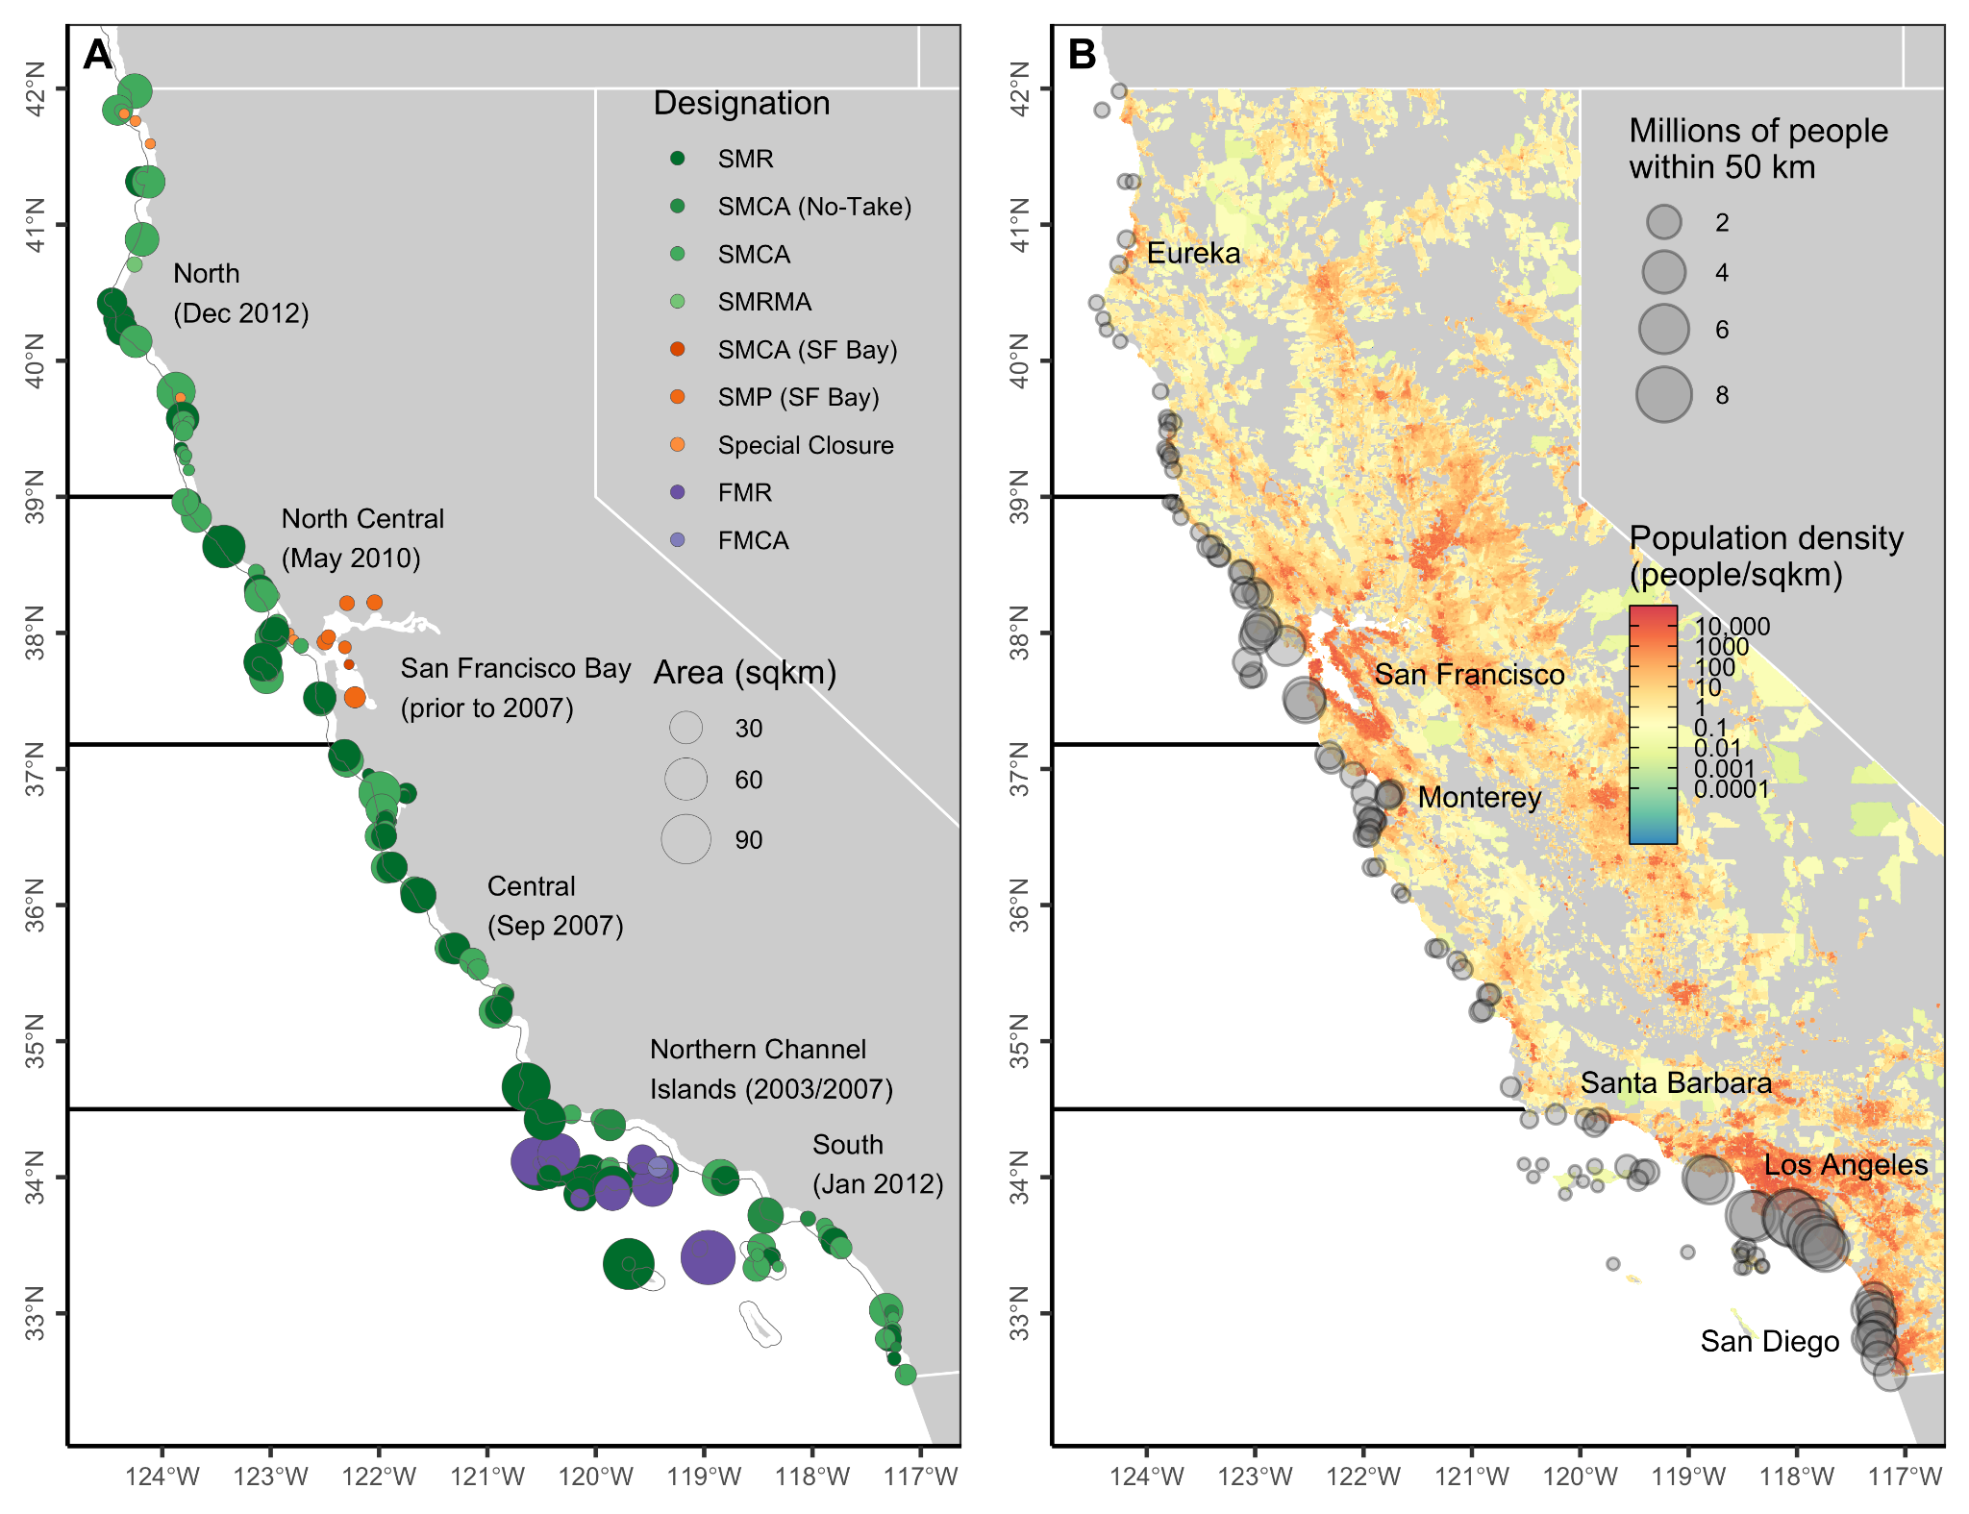

**Figure 1.** Maps illustrating **(A)** California’s marine protected area (MPA) network and **(B)** nearby human population density. In **(A)**, greens indicate state MPAs established by the Marine Life Protection Act (MLPA), oranges indicate state MPA designations excluded from the analysis, and purples indicate federal MPAs excluded from the analysis. See *Section 2.1* and **Table S1** for the definition of each MPA designation. Point size indicates MPA area (km2). Dark horizontal lines delineate the four primary MLPA regions (labeled with month of implementation). MPAs in the San Francisco Bay region were established before 2007 and were not part of the MLPA planning effort. MPAs in the Northern Channel Islands were also established before MLPA (2003 and 2007 in state and federal waters, respectively) but have been officially incorporated into the network. The thin gray line indicates state waters (3 nautical miles offshore). In **(B)**, point size indicates the number of people living within 50 km of each MPA. Colors indicate population density by census block in the 2010 U.S. Census. A few key coastal cities are labeled for reference.

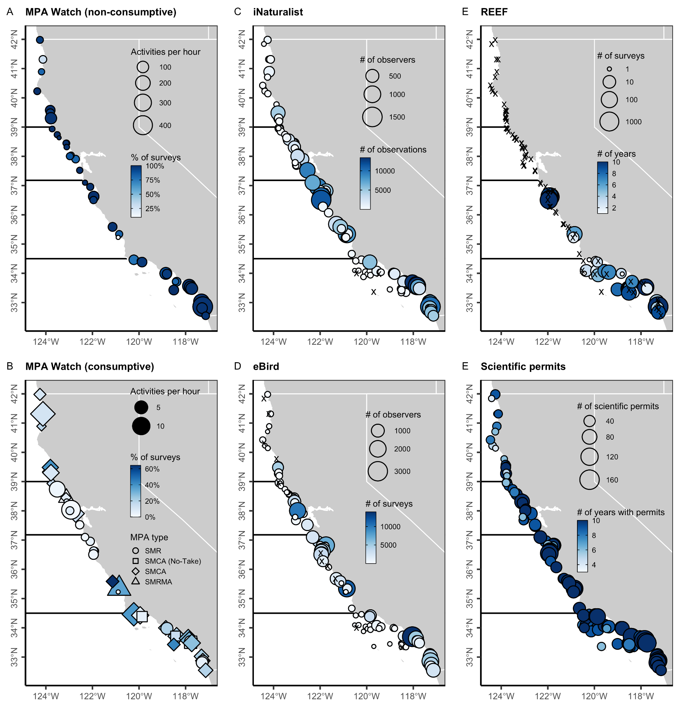**Figure 2.** Maps illustrating six indicators of human engagement in California’s state marine protected area (MPA) network. Multiple metrics are used to measure engagement for each indicator; see **Table S3** for definitions of these metrics. Across indicators, larger symbols and deeper colors indicate higher engagement. In **C-F**, black x’s mark MPAs without any reported engagement. Dark horizontal lines delineate the four MLPA regions. See **Figure S17** for a map of the regulatory citations indicator.

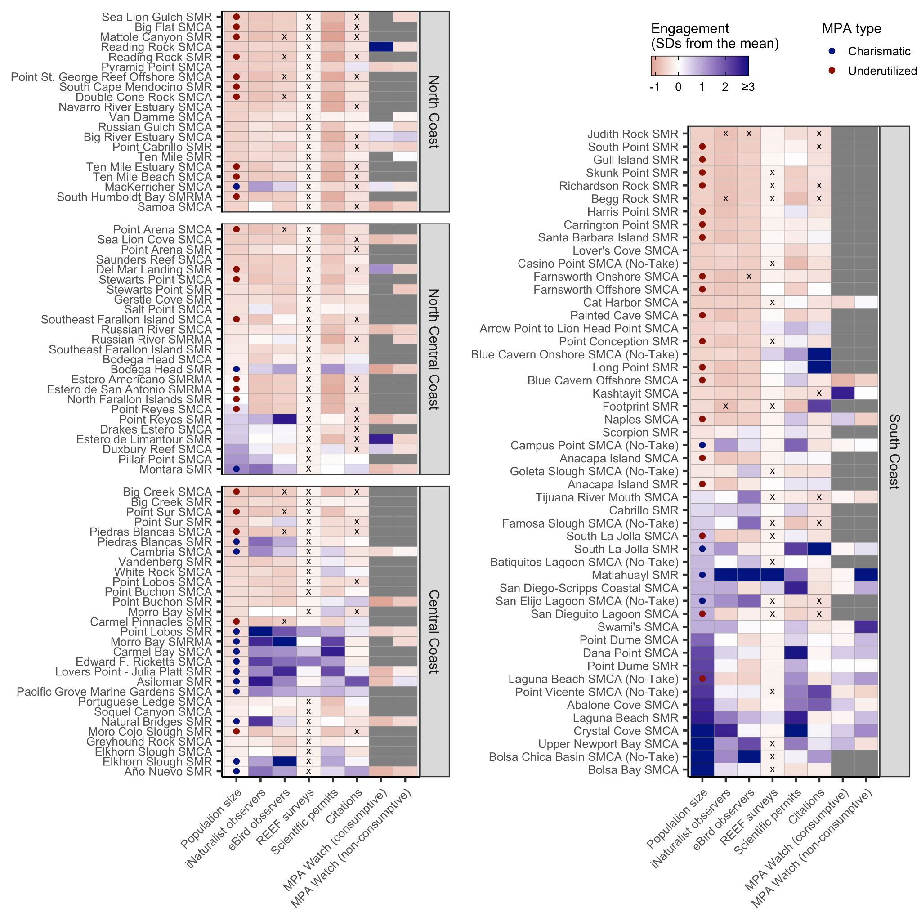**Figure 3.** A synthesis of human engagement indicators within California’s state marine protected areas (MPAs). MPAs are sorted by population density within 50 km (first column of each plot) within each region. Engagement indicators are centered on the average of each indicator and scaled to unit variance to ease comparison across indicators; thus, color indicates the number of standard deviations (SDs) from the mean where blue shades indicate MPAs with above average engagement and red shades indicate MPAs with below average engagement. Gray indicates MPAs without data and x’s indicate MPAs with true zeros. MPAs with greater (“charismatic”) and less (“underutilized”) engagement than expected based on surrounding population density are marked in the population size column. See **Table S3** for definitions and metrics of the displayed indicators.

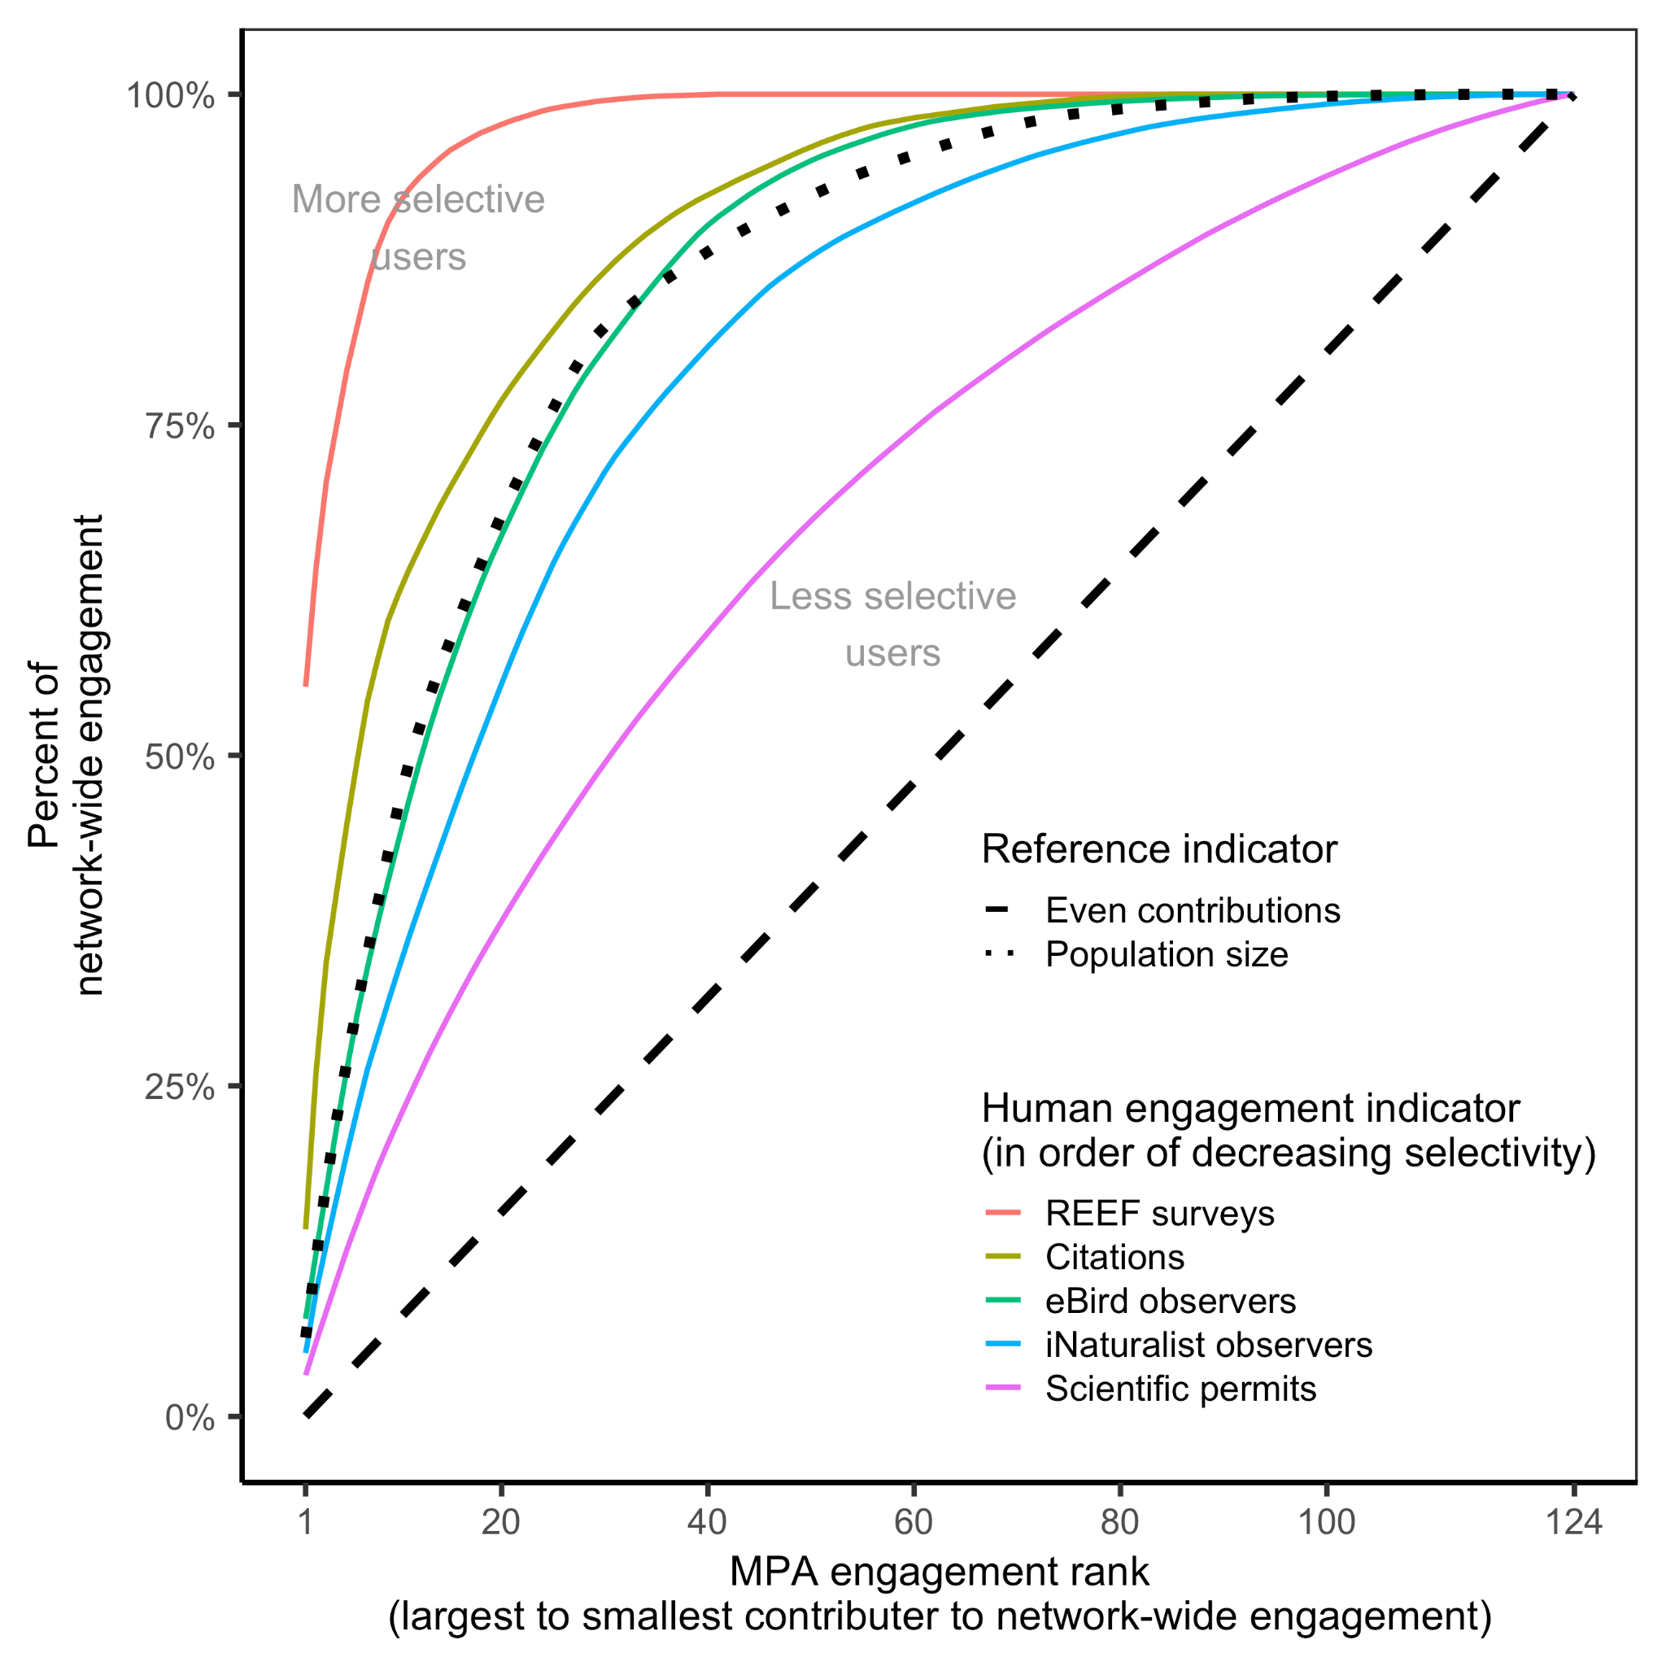

**Figure 4.** Cumulative contributions of individual marine protected areas (MPAs) to network-wide engagement based on several indicators of human engagement. The diagonal dashed line indicates a theoretical accumulation curve in which individual protected areas contribute equally to engagement within the overall network. Curved lines above this reference line indicate accumulation curves in which some protected areas make larger contributions (higher performers) to network-wide engagement than others (lower performers); the steeper the curve, the more network-wide engagement is dominated by a few protected areas. The accumulation curve for population size (dotted black line) provides an additional frame of reference: if human engagement were proportional to population size, engagement would accumulate according to this curve. Thus, curves steeper than this line indicate that benefits are more concentrated than would be predicted by population density (i.e., engagement is more selective) whereas curves shallower than this line indicate a more even distribution of benefits than would be predicted by population density (i.e., engagement is less selective). The MPA Watch indicators are excluded because they are not available for all MPAs within the network.

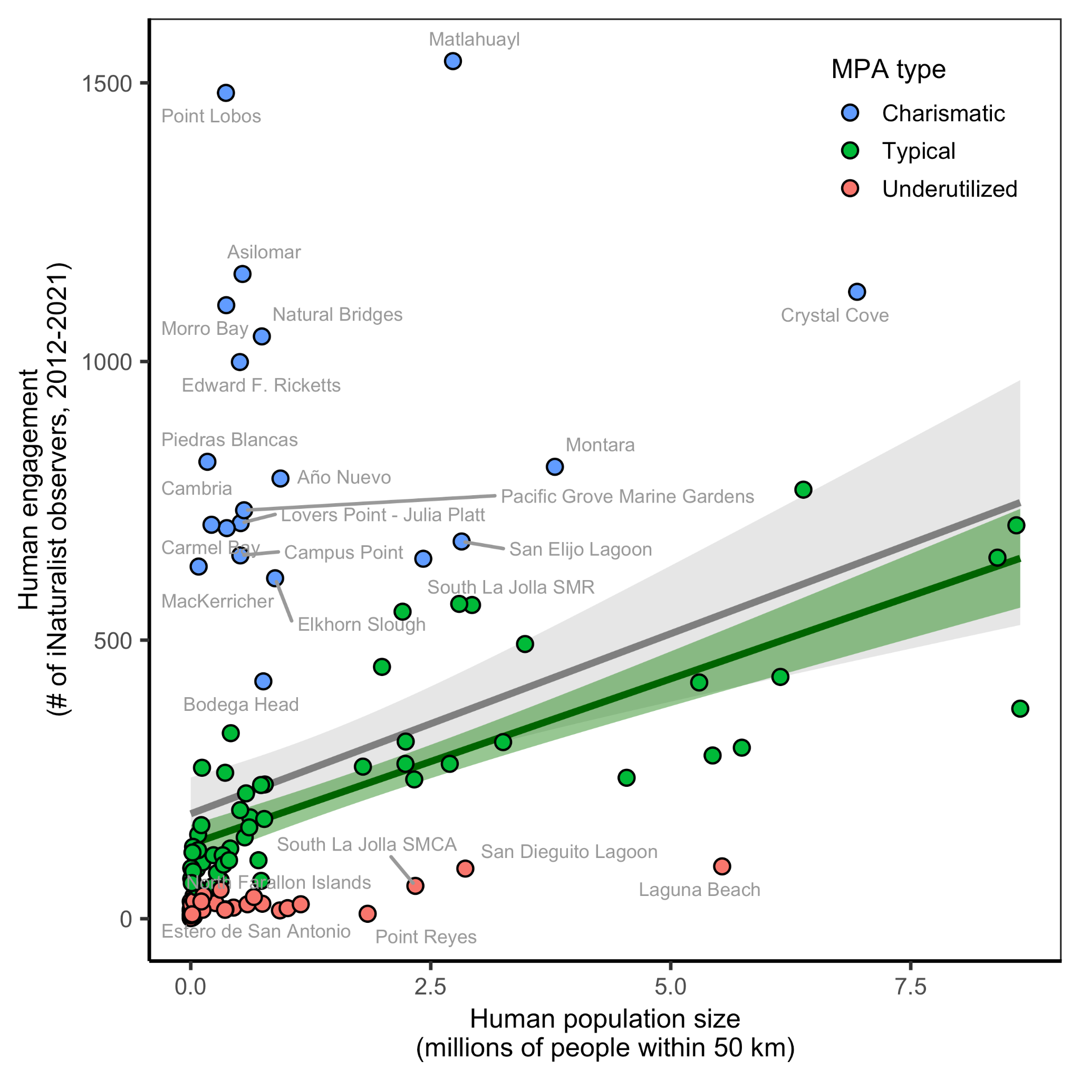

**Figure 5.** Correlation between human engagement in an MPA and the number of people living within 50 km of the area. Human engagement is measured as the number of iNaturalist observers submitting observations within 100 m of an MPA from 2012 through 2021. The gray line and 95% confidence interval illustrate a linear regression (r2=0.14; p<0.001) fit to all points. Blue points with residuals greater than 75% of the fitted values were classified as “charismatic” MPAs, whose engagement is higher than would be expected based on population density. Red points with residuals less than 75% of the fitted values were classified as “underutilized” MPAs, whose engagement is lower than would be expected based on population density. The charismatic and selected underutilized MPAs are labeled with their abbreviated names. The green line and 95% confidence interval illustrate a linear regression (r2=0.62; p<0.001) fit to the “typical” protected areas (green points), whose engagement is largely determined by population density.

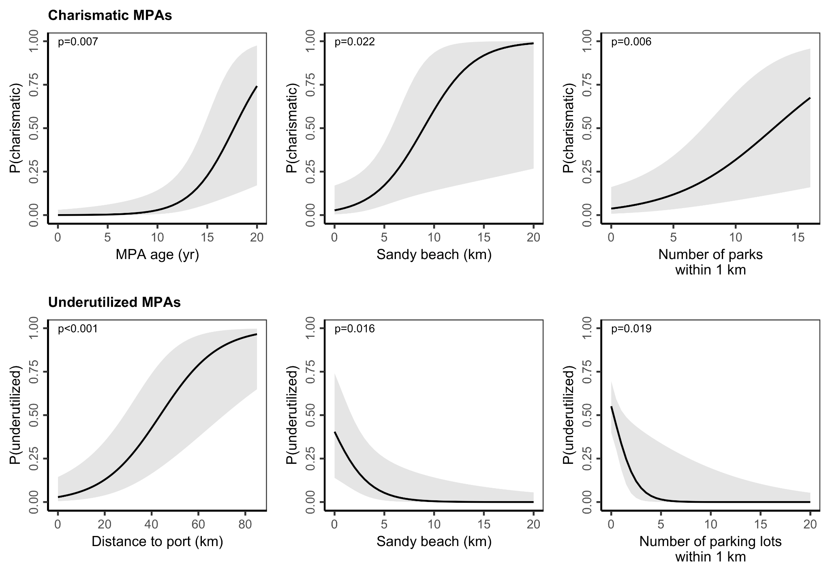**Figure 6.** Marginal effects of significant predictors of “charismatic” (top row) and “underutilized” (bottom row) MPAs as identified through stepwise logistic regression. Marginal effects represent the predicted probability when varying the variable of interest while fixing the other variables at their means. Shading depicts 95% confidence intervals. See **Table S5** for the list of predictors included in each model and **Table S7** for the results of each model fit.

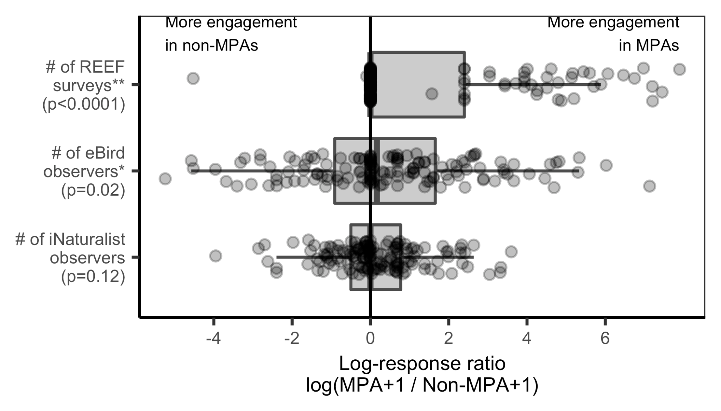

**Figure 7.** The level of human engagement in marine protected areas (MPAs) compared to non-MPA counterfactuals for indicators with the required data. Log-response ratios were calculated after adding 1 to the engagement values occurring in both the numerator and denominator to avoid non-finite values. Log-response ratios greater than zero indicate MPAs where the MPA designation is associated with higher engagement relative to the counterfactual whereas ratios less than zero indicate MPAs where the MPA designation is associated with lower engagement relative to the counterfactual. Asterisks indicate indicators whose mean response ratio is significantly different from zero (* p<0.01, ** p<0.05). P-values are shown parenthetically. In the boxplots, the solid line indicates the median, the box indicates the interquartile range (IQR; 25th to 75th percentiles), the whiskers indicate 1.5 times the IQR, and the points beyond the whiskers indicate outliers. Points represent log-response ratios for each MPA and counterfactual pair.

## Supplemental Tables & Figures

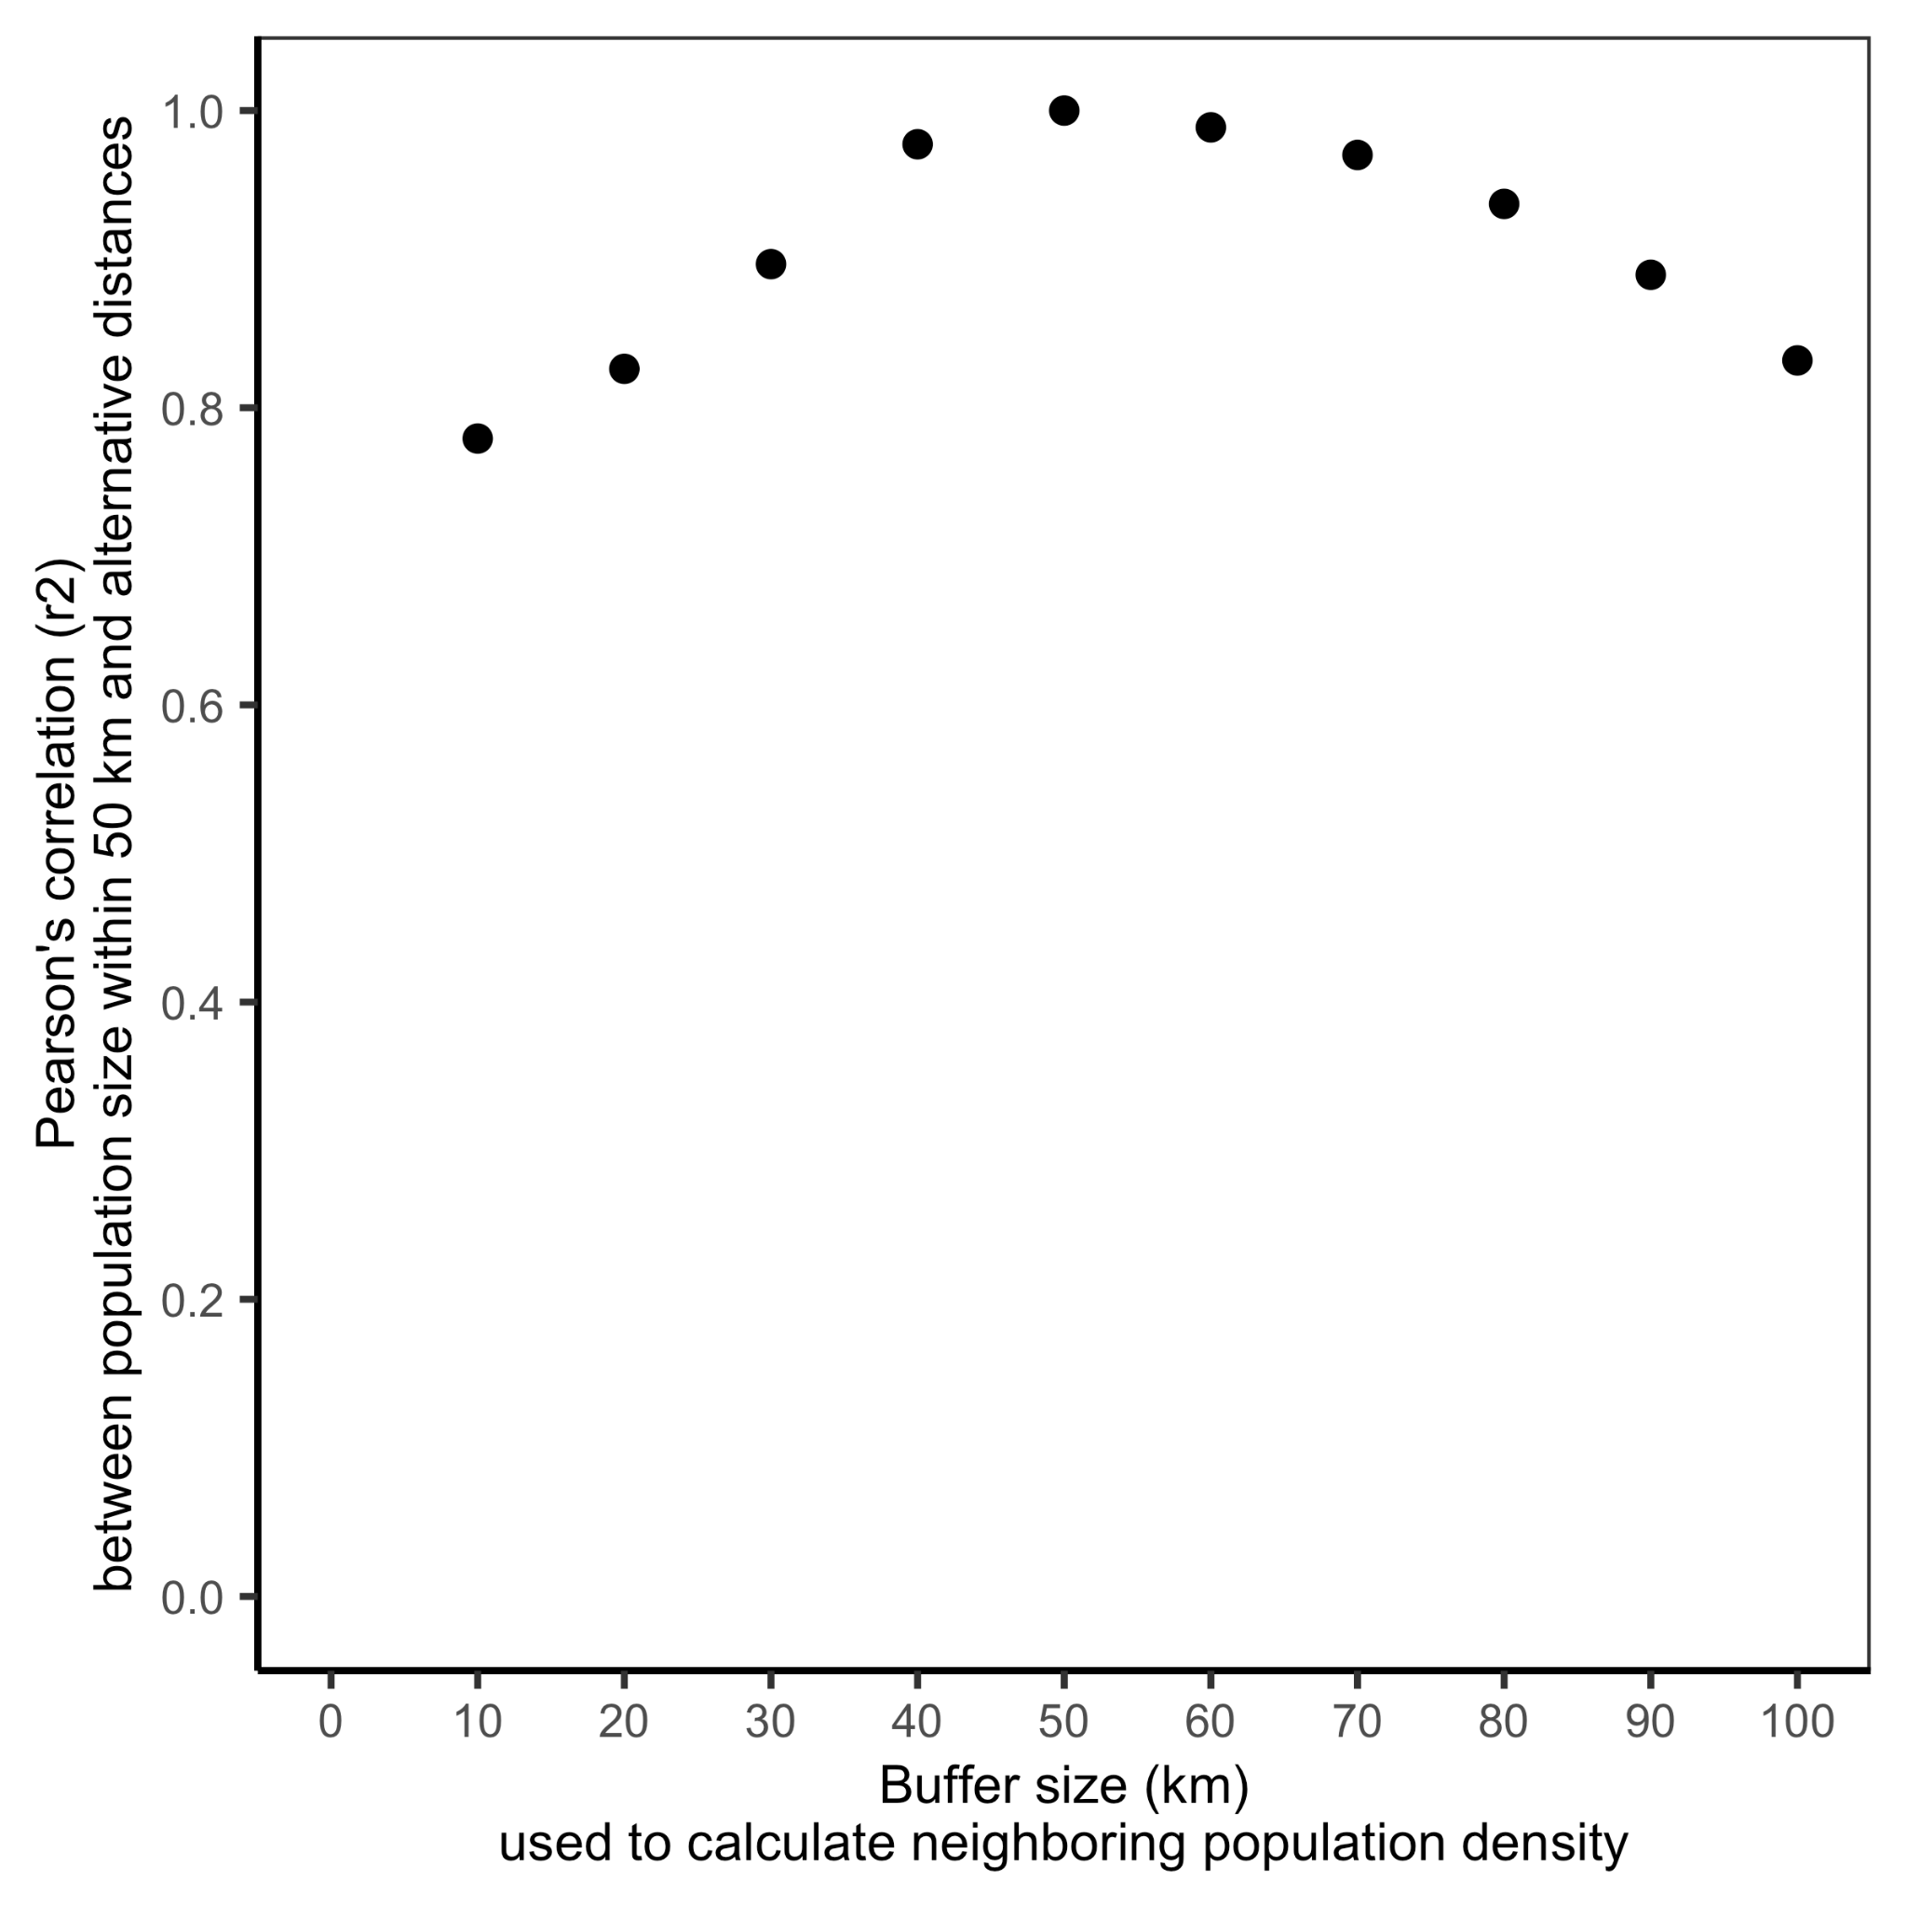

**Figure S1.** The correlation between population density calculated using the selected 50 km buffer and population densities calculated using alternative buffer distances.

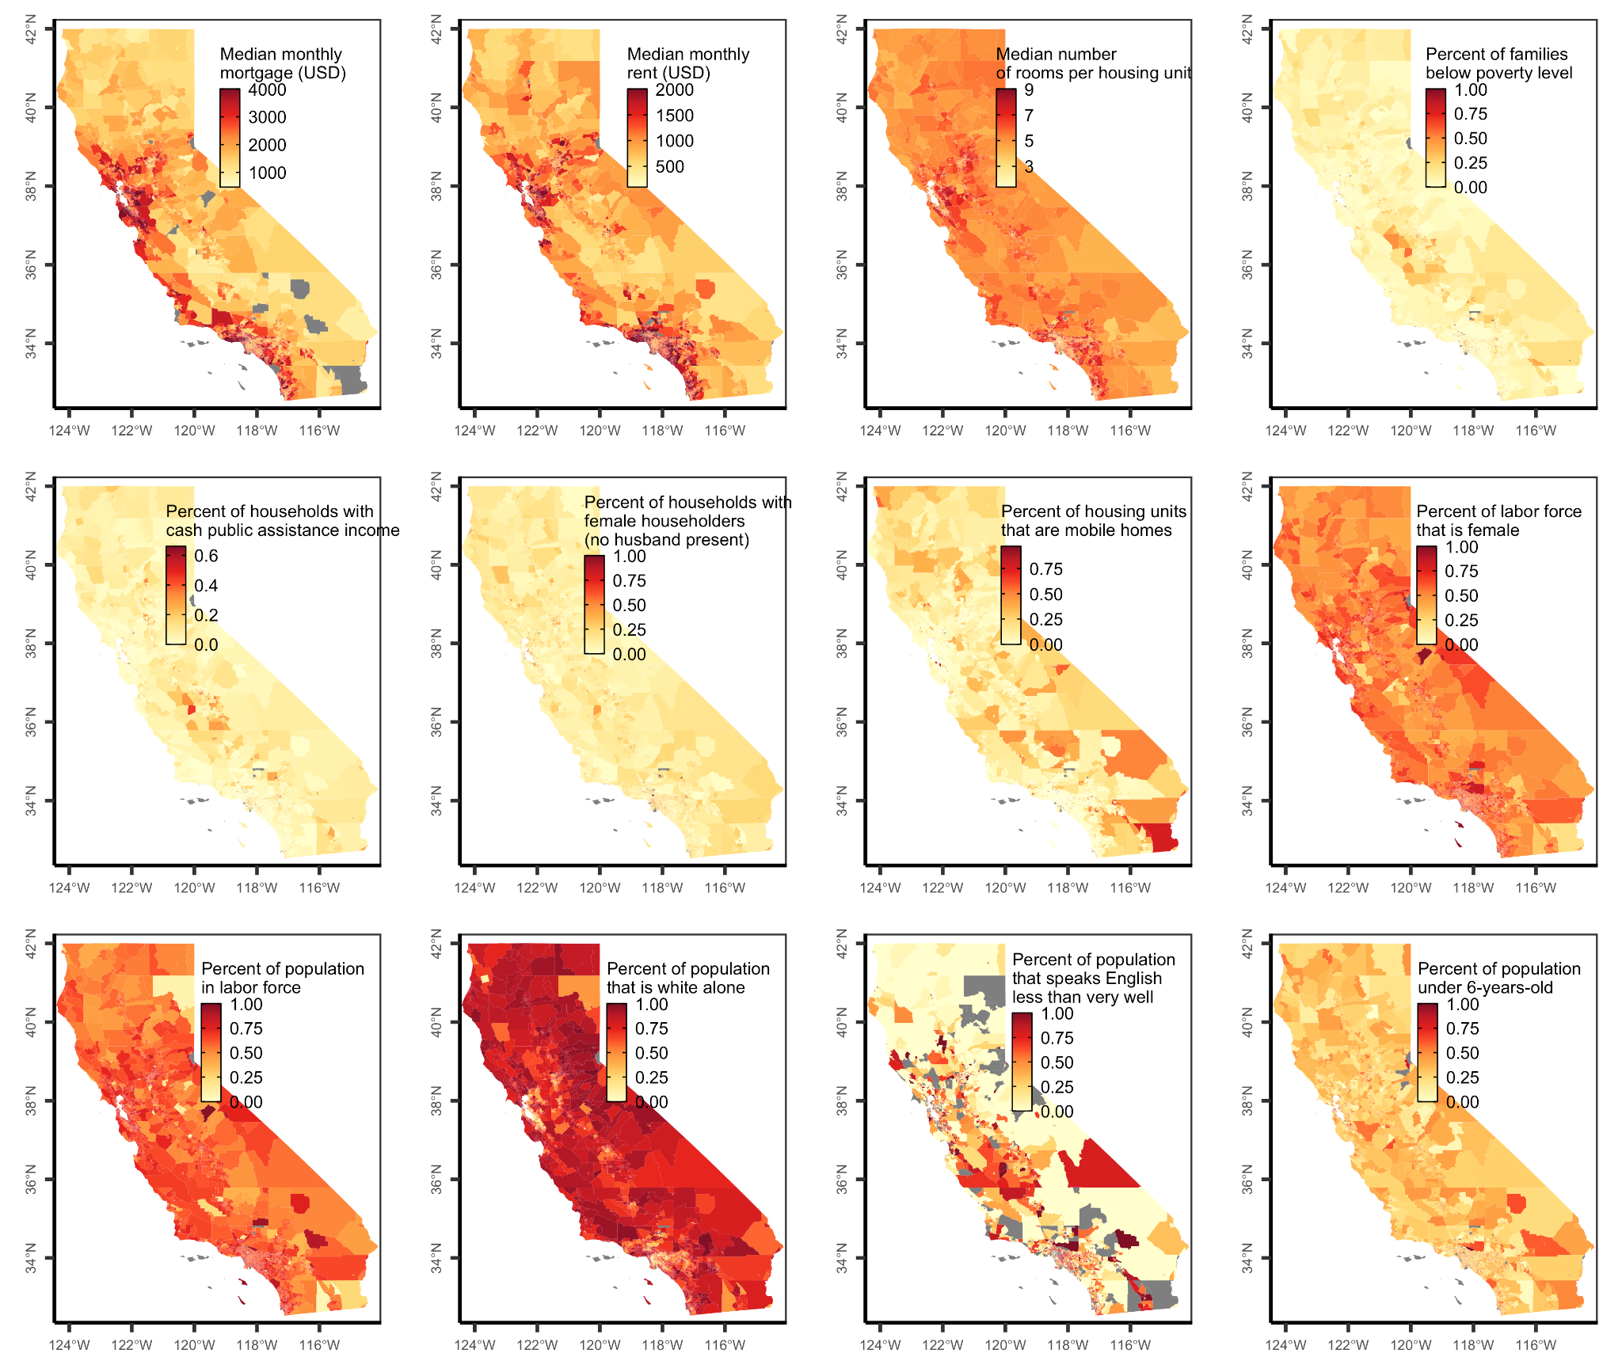**Figure S2.** Maps of the social vulnerability indicator used to calculate the social vulnerability index by California US Census tract.

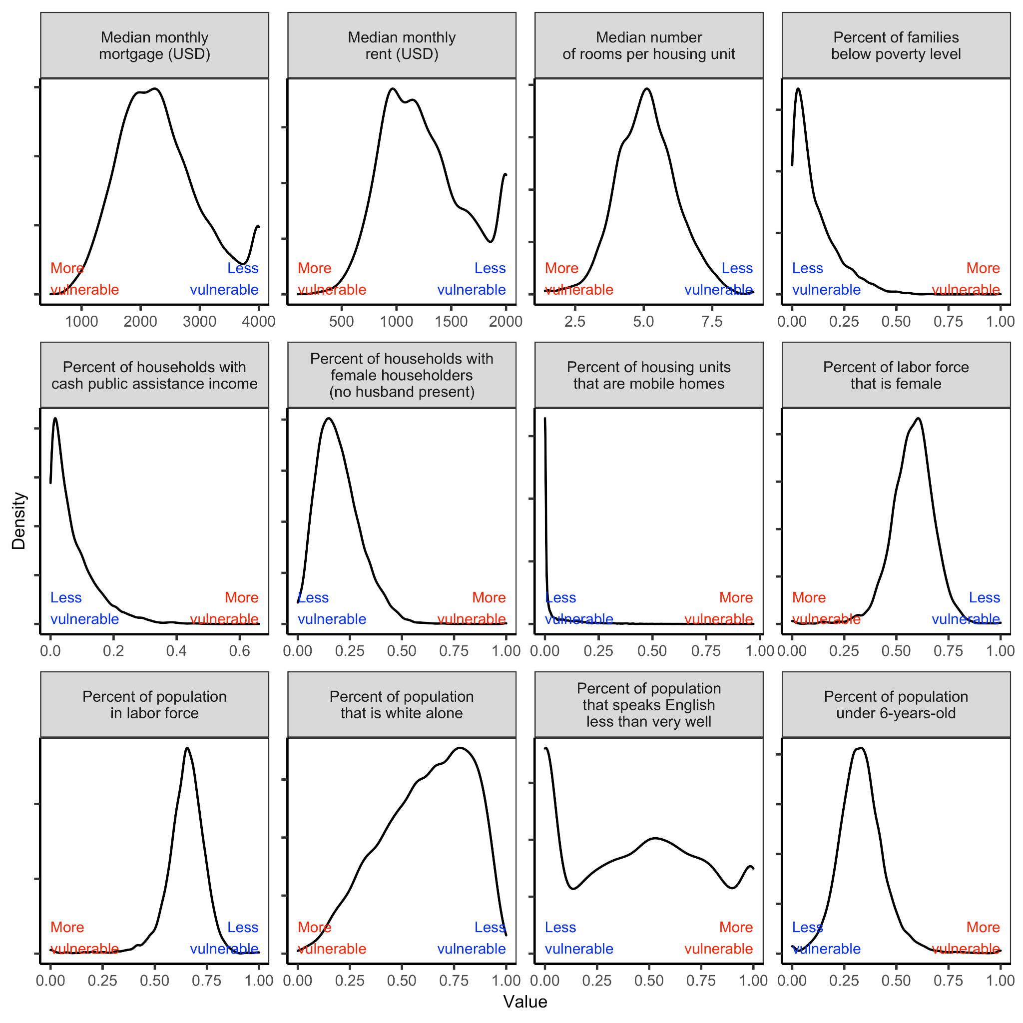**Figure S3.** Distribution of the social vulnerability indicator values by California US Census tract used to calculate the social vulnerability index. Values were centered on the statewide average and scaled to unit variance. Indicators in which higher vulnerability is indicated by higher values (e.g., percent of families below poverty level, percent of households with cash public assistance income) were multiplied by -1 so that higher vulnerability is represented as low values for all indicators. The social vulnerability index, mapped in **Figure S4**, was calculated as the average of the centered, scaled, and standardized indicators.

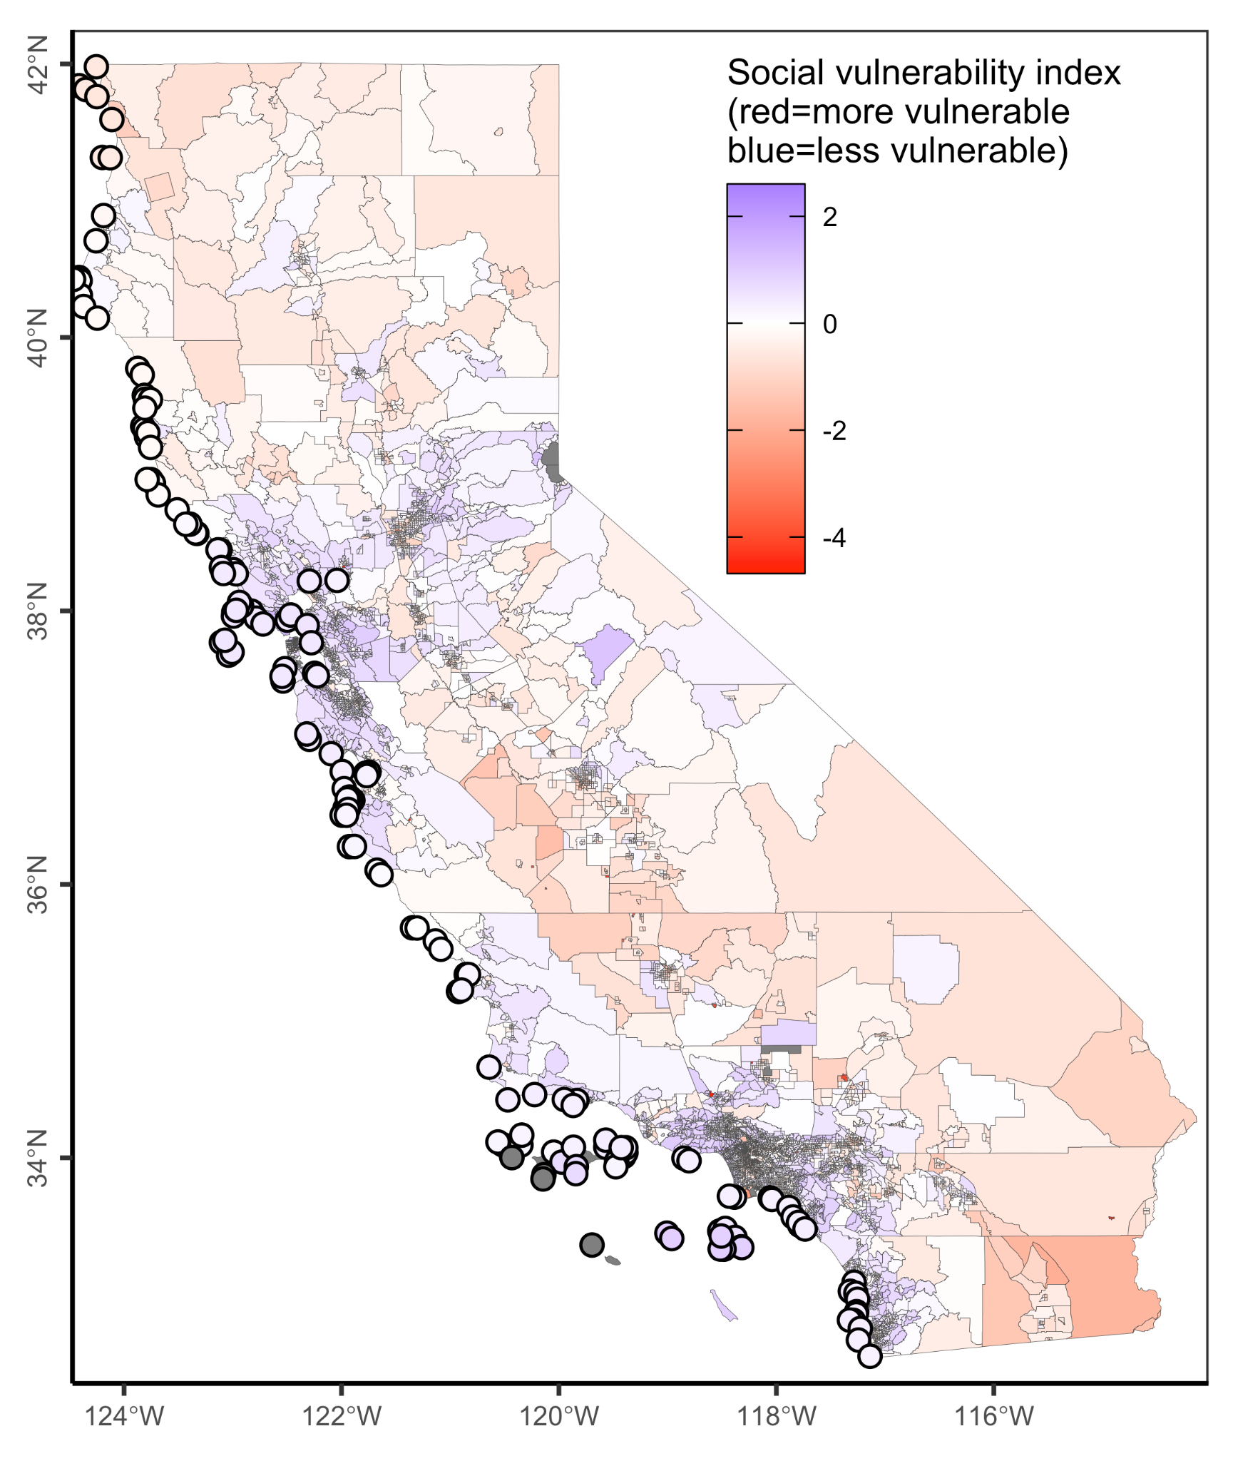

**Figure S4.** Social vulnerability index by US Census tract (polygons on land) and average social vulnerability index within 50 km of each MPA (points at sea). The social vulnerability index is calculated as the average of the 12 indicators of social vulnerability described in **Table S2**. Indicators were centered on their statewide average and scaled to unit variance before the index was calculated. Negative (red) values indicate higher social vulnerability and positive (blue) values indicate lower social vulnerability.

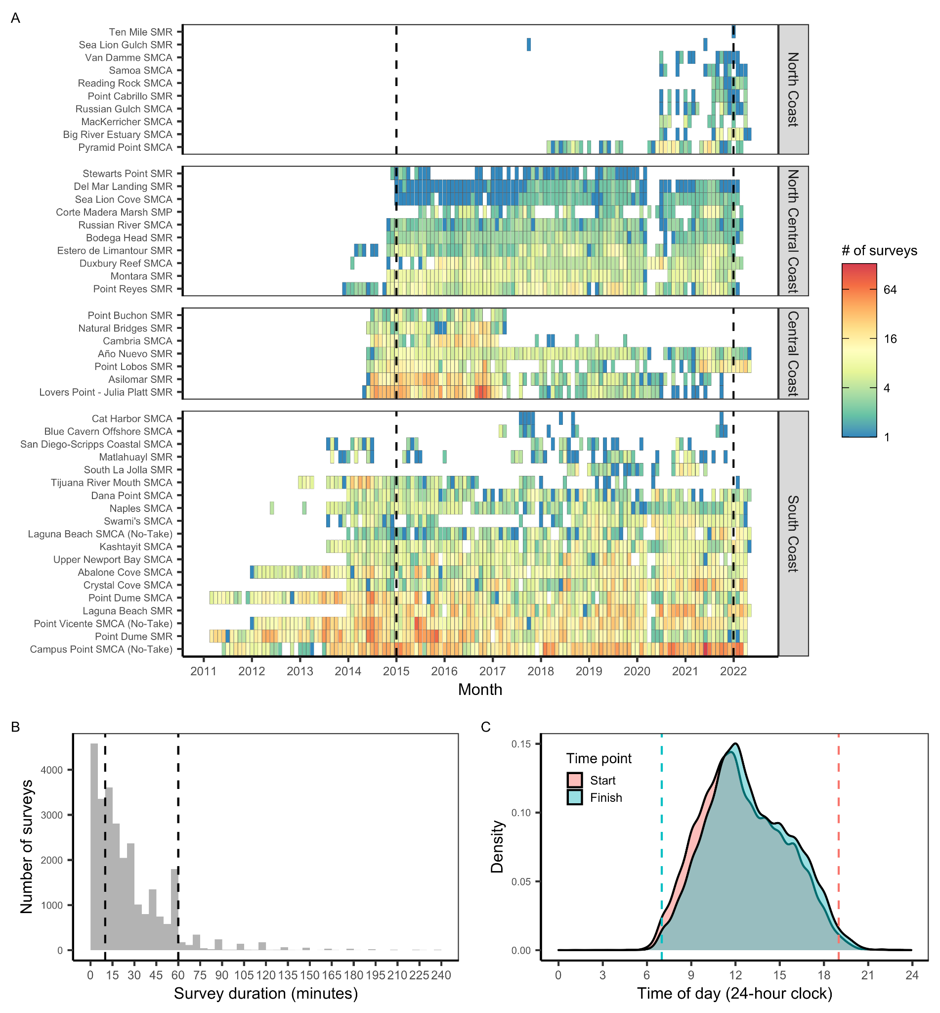**Figure S5.** The **(A)** coverage of usable MPA Watch surveys over time by marine protected area (MPA). A usable survey is a survey in which the duration was accurately recorded (i.e., end time occurs after start time). Note log-scale for fill color. San Francisco Bay MPAs are plotted in the North Central Coast region for simplicity. Only surveys occurring between January 1, 2015 and December 31, 2022 were considered in the analysis. We also excluded **(B)** surveys shorter than 10 minutes or longer than 60 minutes and **(C)** surveys ending before 7AM or starting after 7PM.

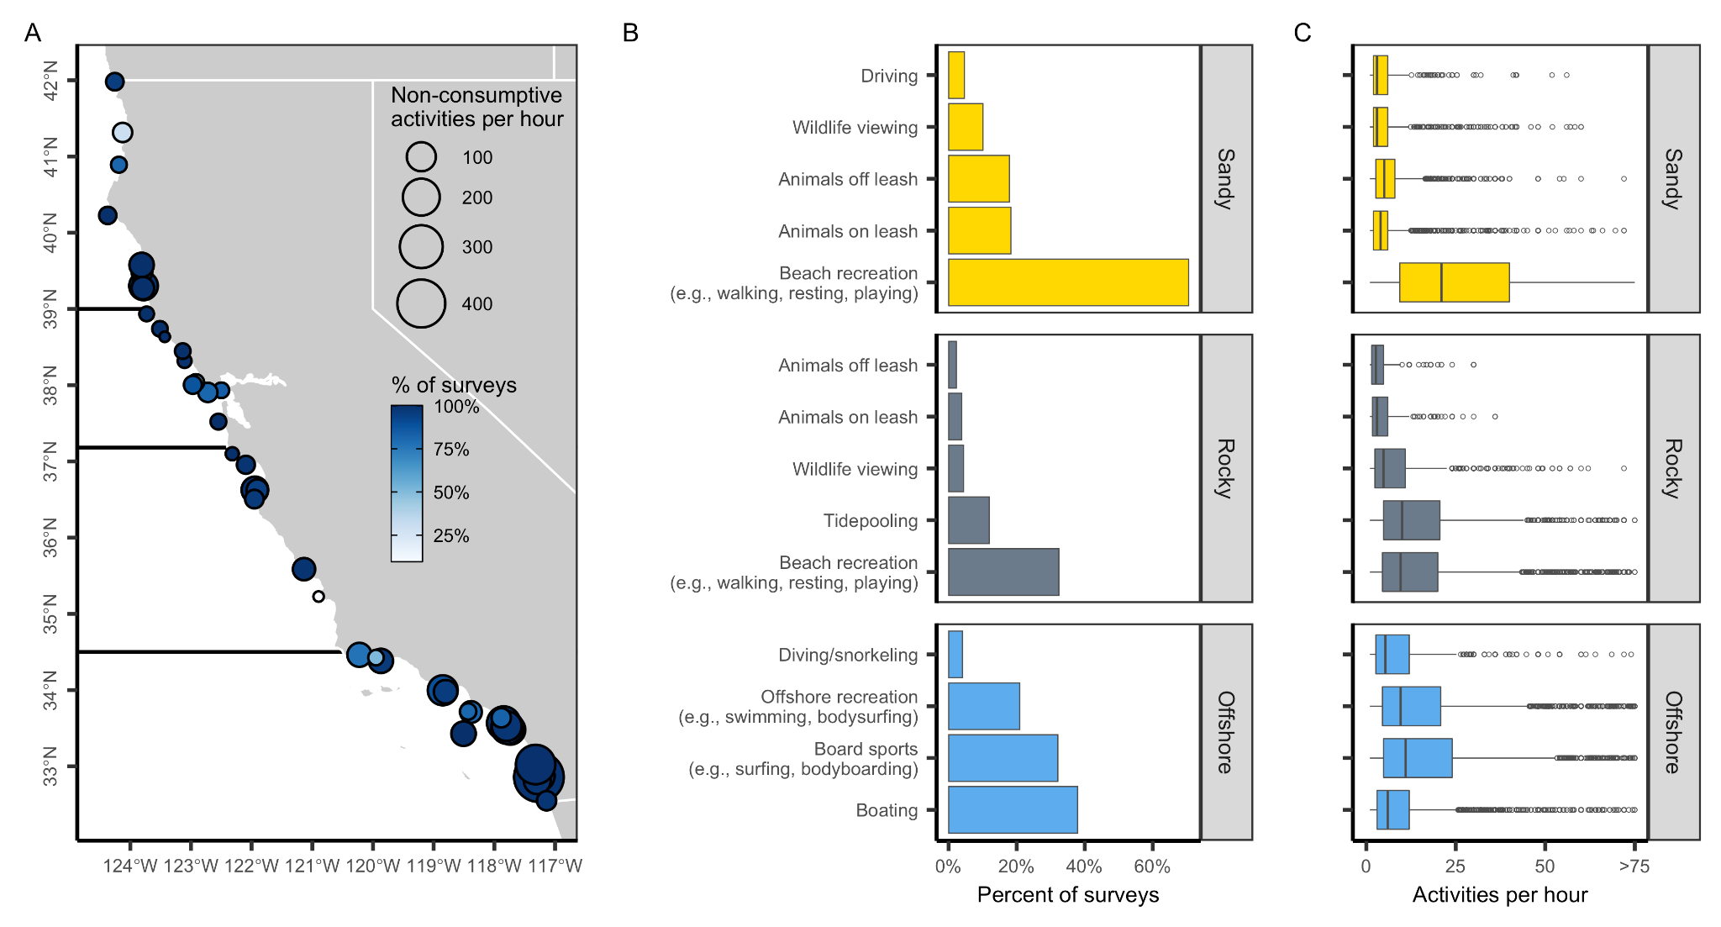**Figure S6.** Non-consumptive activities in California’s state marine protected areas (MPAs) based on surveys conducted by MPA Watch. Panel **A** shows the percent of surveys within an MPA in which non-consumptive activities were observed (color ramp) and the median number of non-consumptive activities observed per hour (point size) for surveys in which such activities were observed (i.e., zeroes excluded). Dark horizontal lines delineate the four MLPA regions. Panel **B** shows the percent of surveys in which non-consumptive activities were observed by habitat area. Panel **C** shows the number of non-consumptive activities observed per hour for surveys in which such activities were observed (i.e., zeroes excluded). In the boxplots, the solid line indicates the median, the box indicates the interquartile range (IQR; 25th to 75th percentiles), the whiskers indicate 1.5 times the IQR, and the points beyond the whiskers indicate outliers.

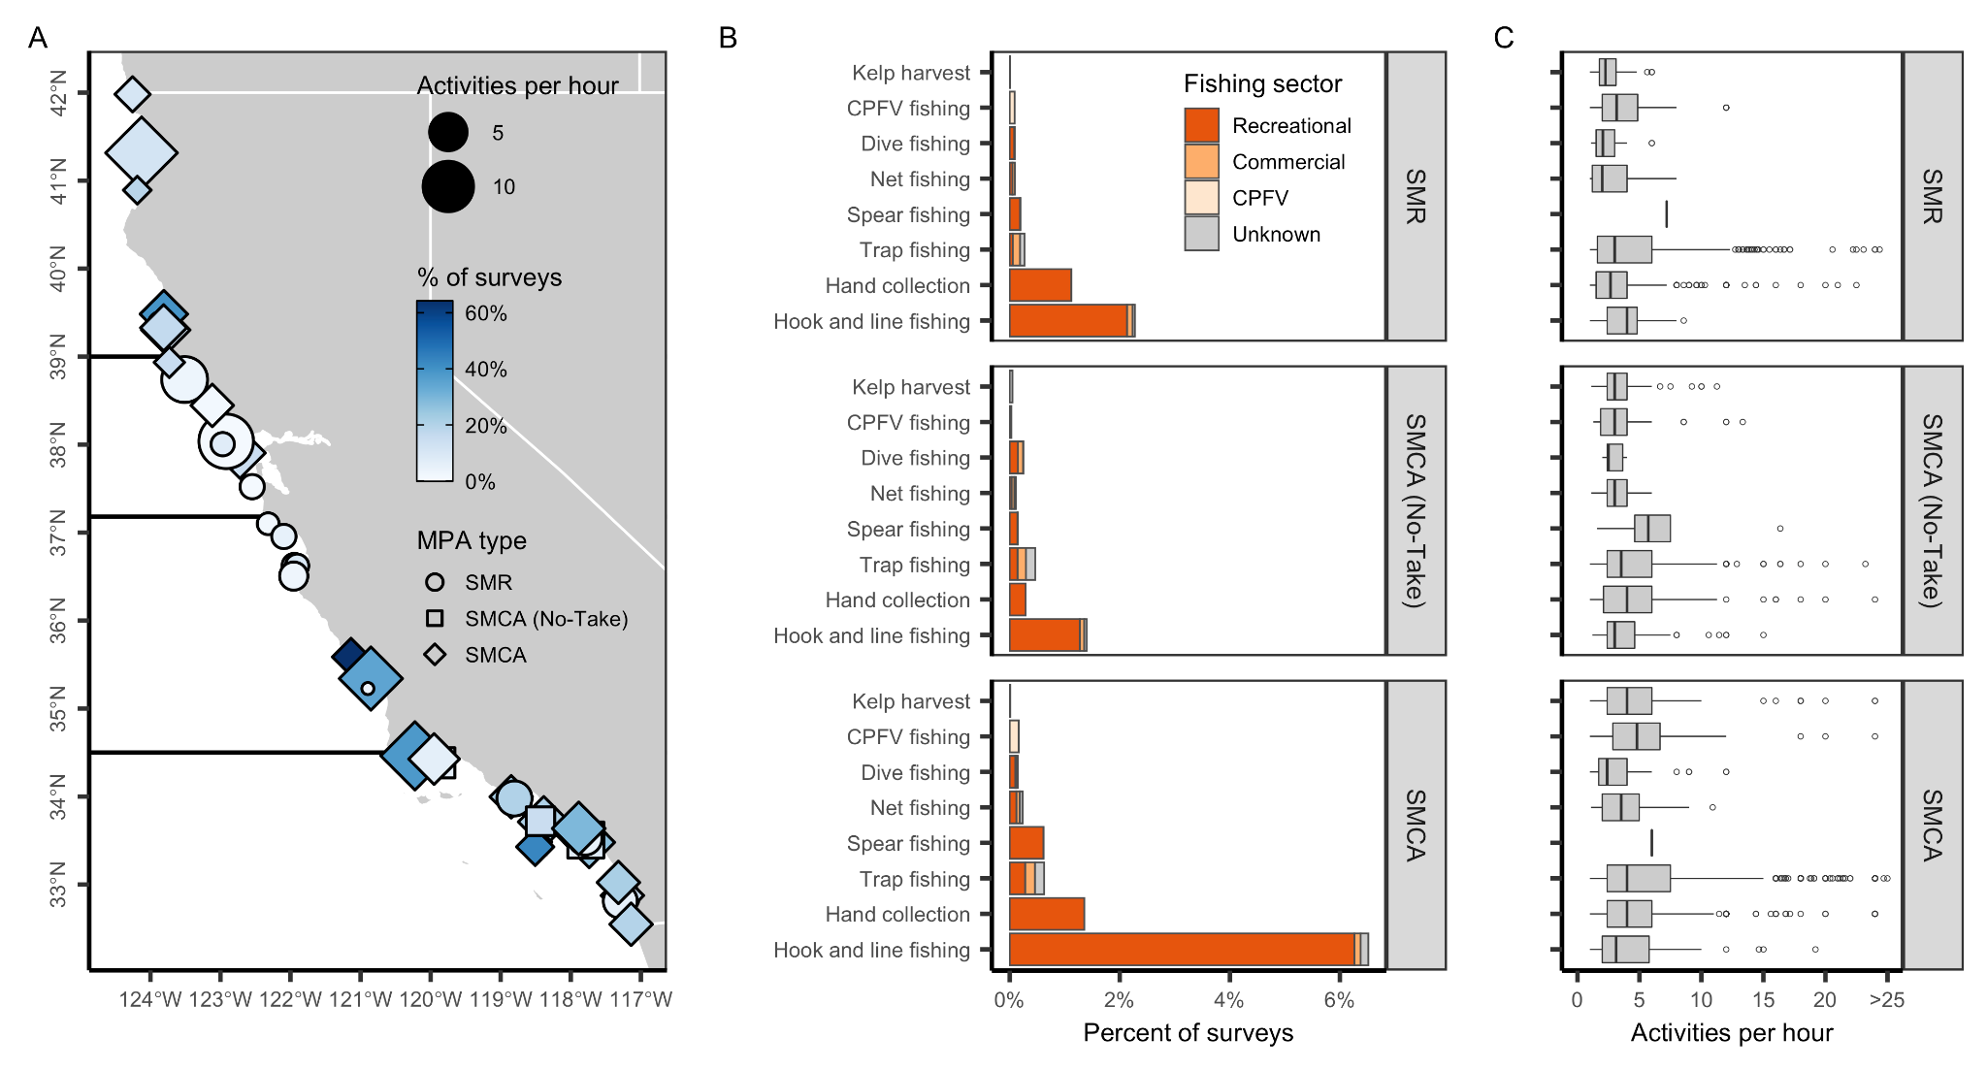**Figure S7.** Active consumptive activities in California’s state marine protected areas (MPAs) based on surveys conducted by MPA Watch. Two SMRMAs are categorized as SMCAs to increase visibility. Panel **A** shows the percent of surveys within MPAs of varying levels of protection (point shape) in which active consumptive activities were observed (color ramp) and the median number of active consumptive activities observed per hour (point size) for surveys in which such activities were observed (i.e., zeroes excluded). Dark horizontal lines delineate the four MLPA regions. Panel **B** shows the percent of surveys in which active consumptive activities were observed by fishing sector (CPFV=commercial passenger fishing vessel). Panel **C** shows the number of active consumptive activities observed per hour for surveys in which such activities were observed (i.e., zeroes excluded). In the boxplots, the solid line indicates the median, the box indicates the interquartile range (IQR; 25th to 75th percentiles), the whiskers indicate 1.5 times the IQR, and the points beyond the whiskers indicate outliers.

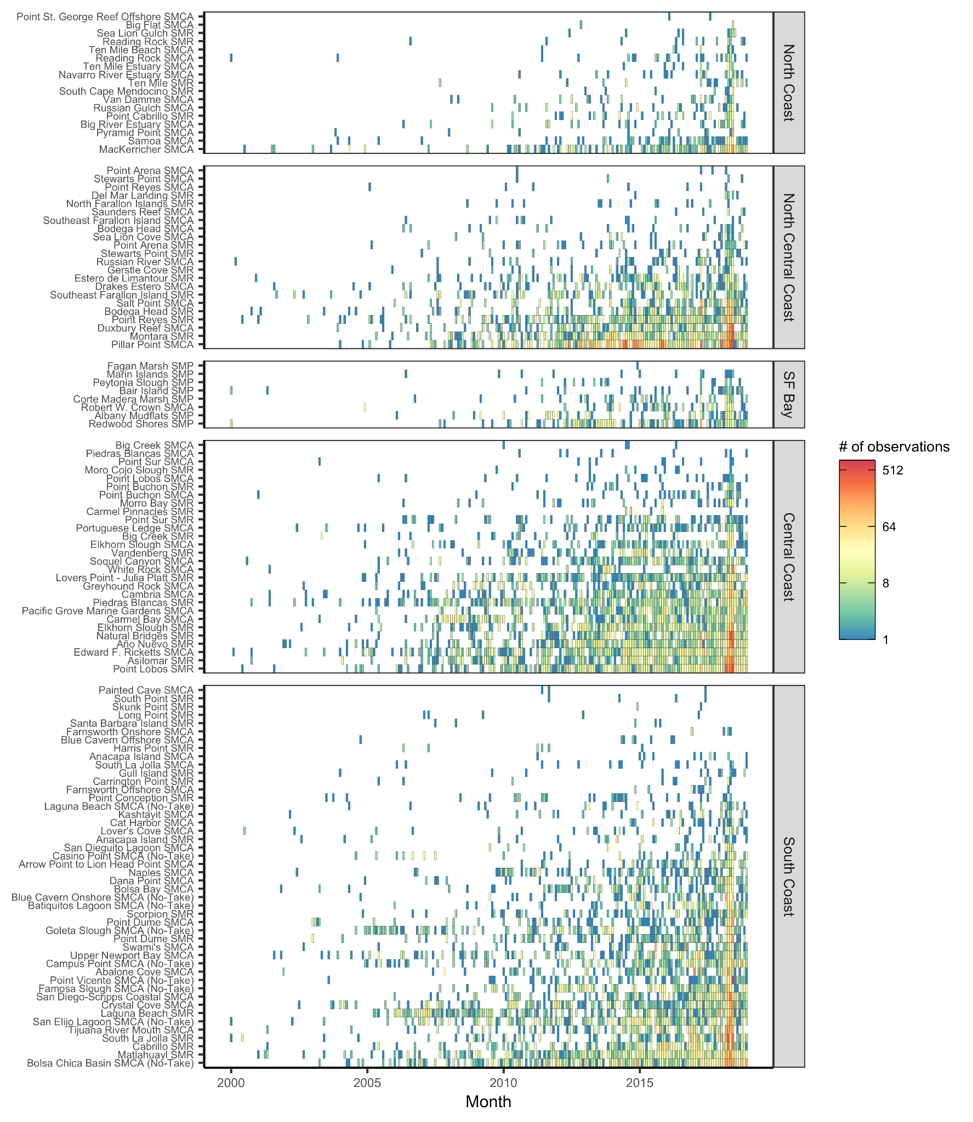

**Figure S8.** Coverage of iNaturalist observation data over time by marine protected area (MPA). Note log-scale for fill color. MPAs are listed in order of overall sample size within each region.

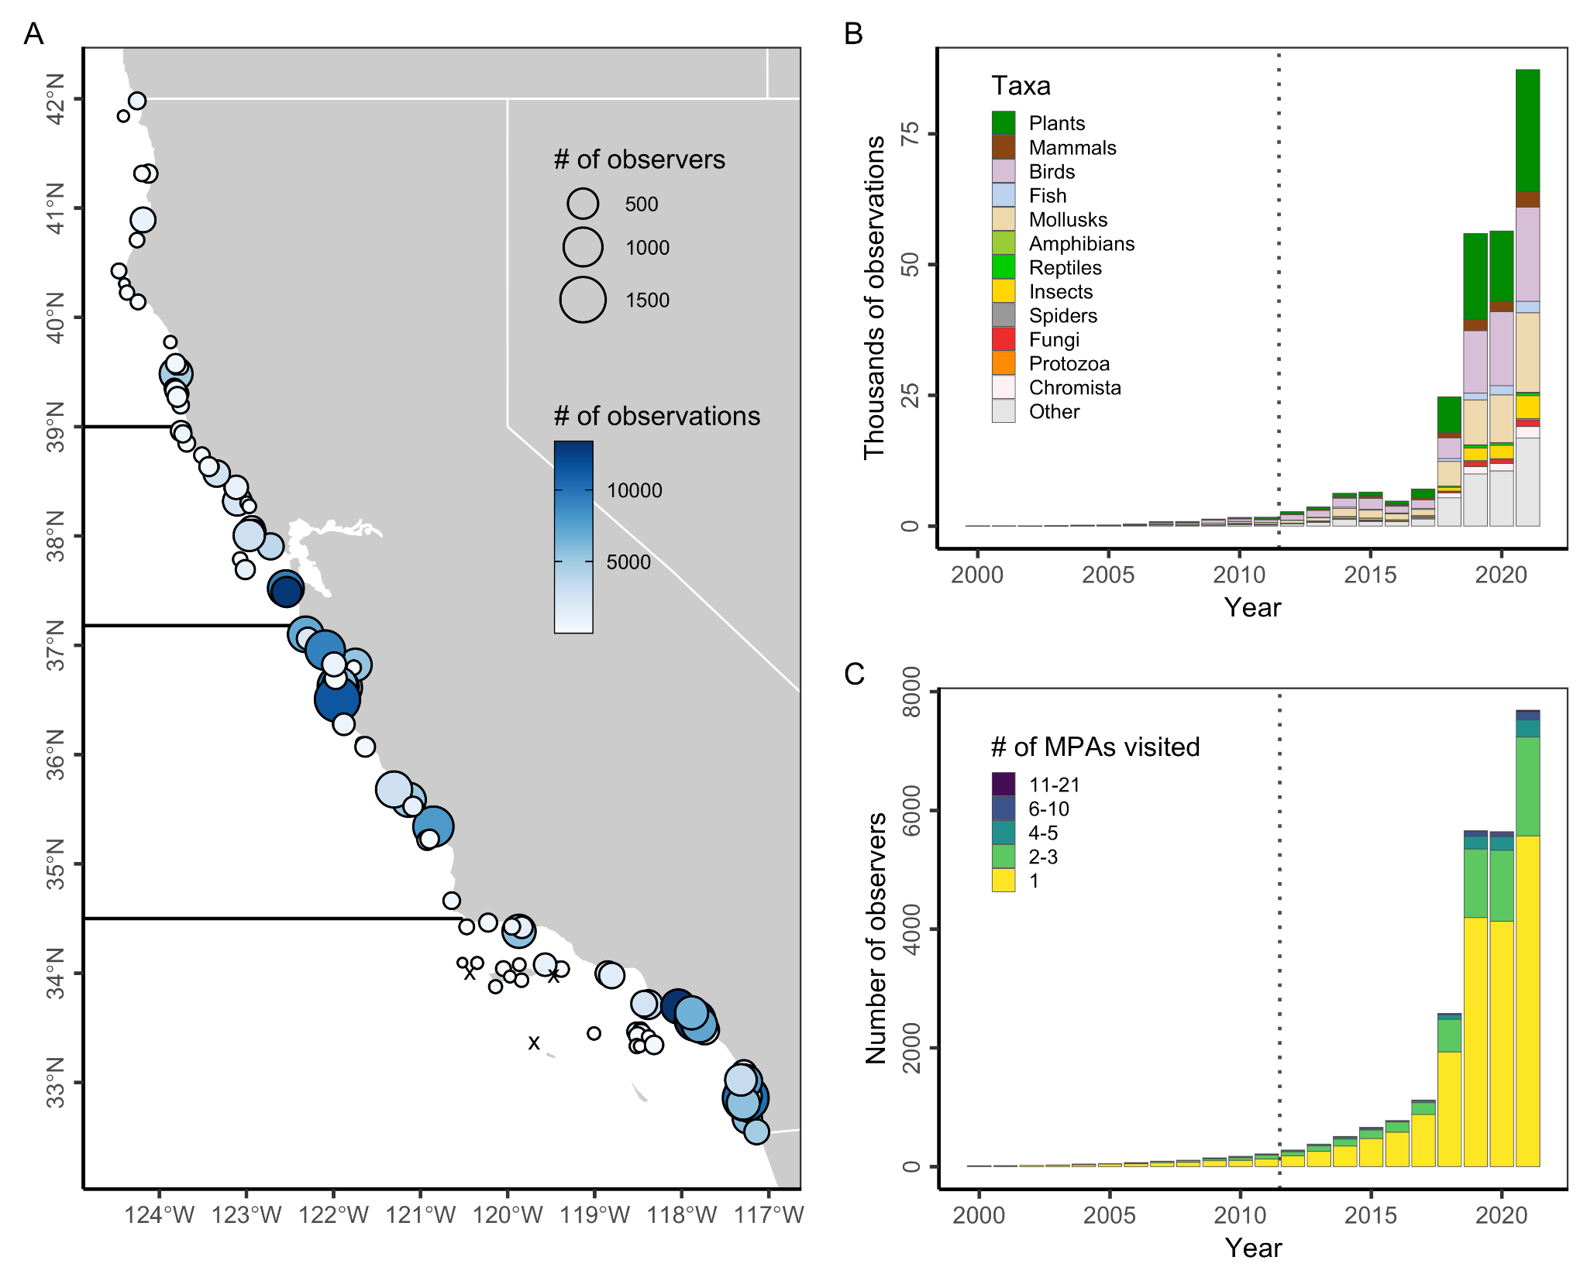**Figure S9.** Human interest in wildlife within California’s state marine protected areas (MPAs) based on usage of the iNaturalist web- and app-based application. Panel **A** shows the number of observers (point size) and observations (color ramp) within 100 m of California’s MPAs from 2012 through 2021. Note log-scale in fill color. Black x’s mark the 4 MPAs without any iNaturalist submissions. Dark horizontal lines delineate the four MLPA regions. Panel **B** shows the number of observations made within 100 m of California MPAs from 2000-2021 by taxonomic group. Panel **C** shows the number of observers making observations within 100 m of California MPAs from 2000-2021 grouped by the number of MPAs that they visited.

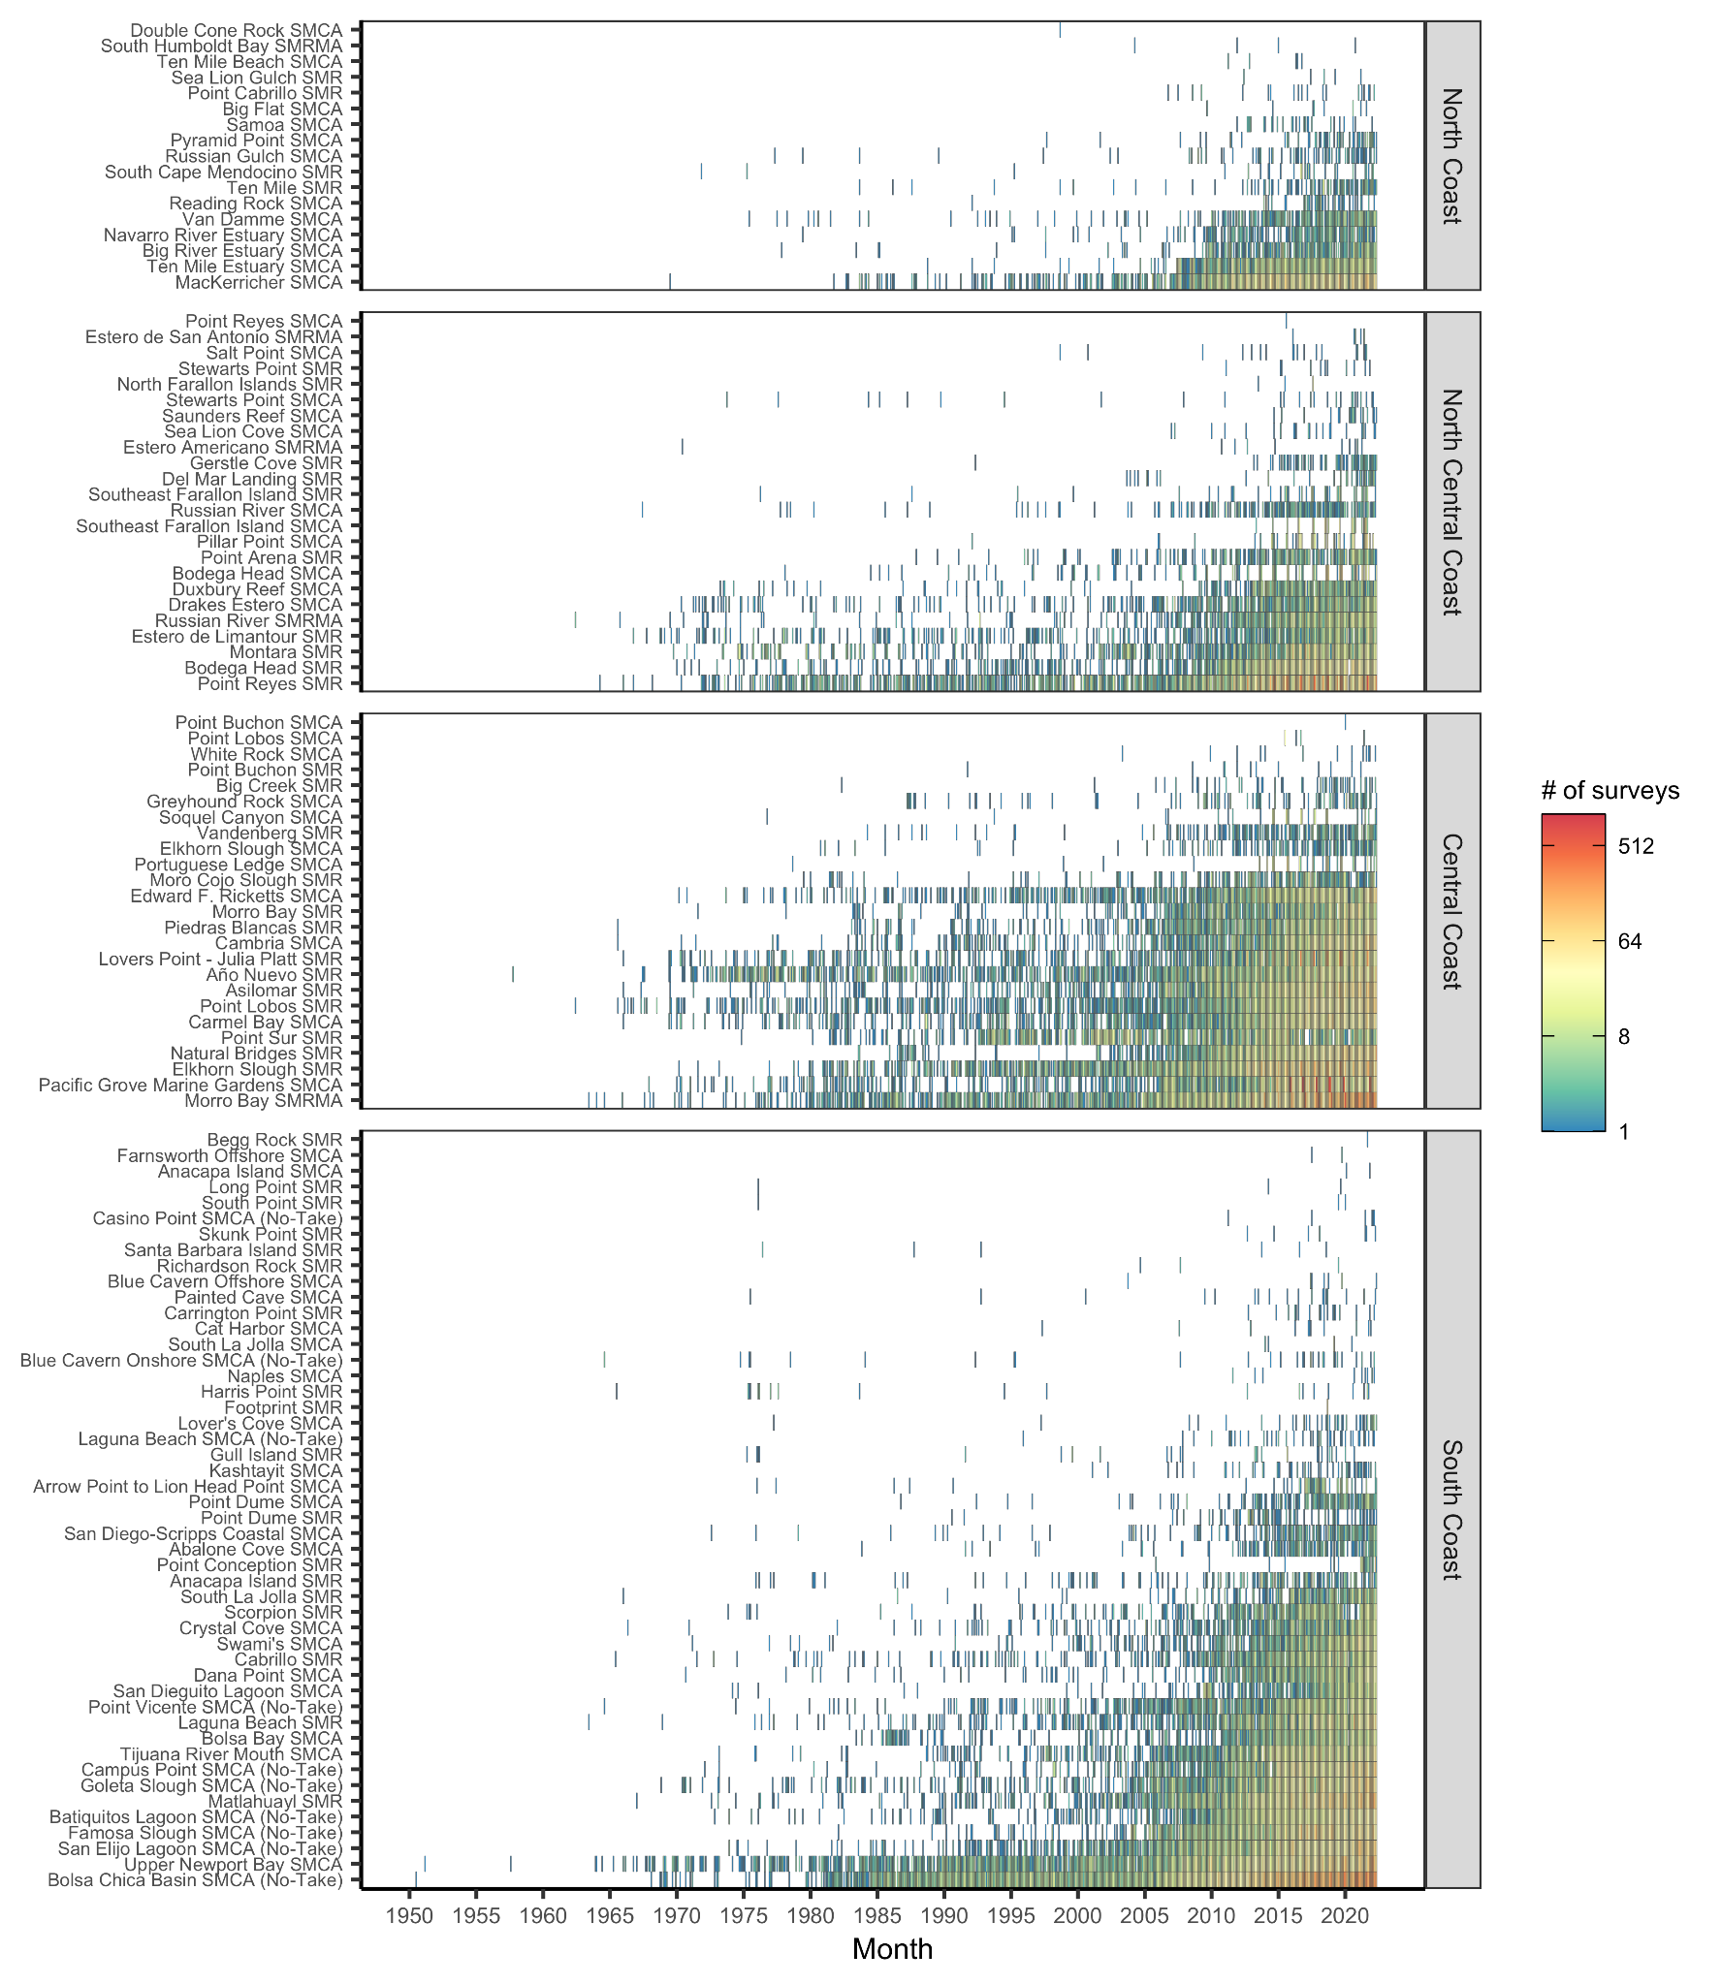**Figure S10.** Coverage of eBird observation data over time by marine protected area (MPA). Note log-scale for fill color. MPAs are listed in order of overall sample size within each region.

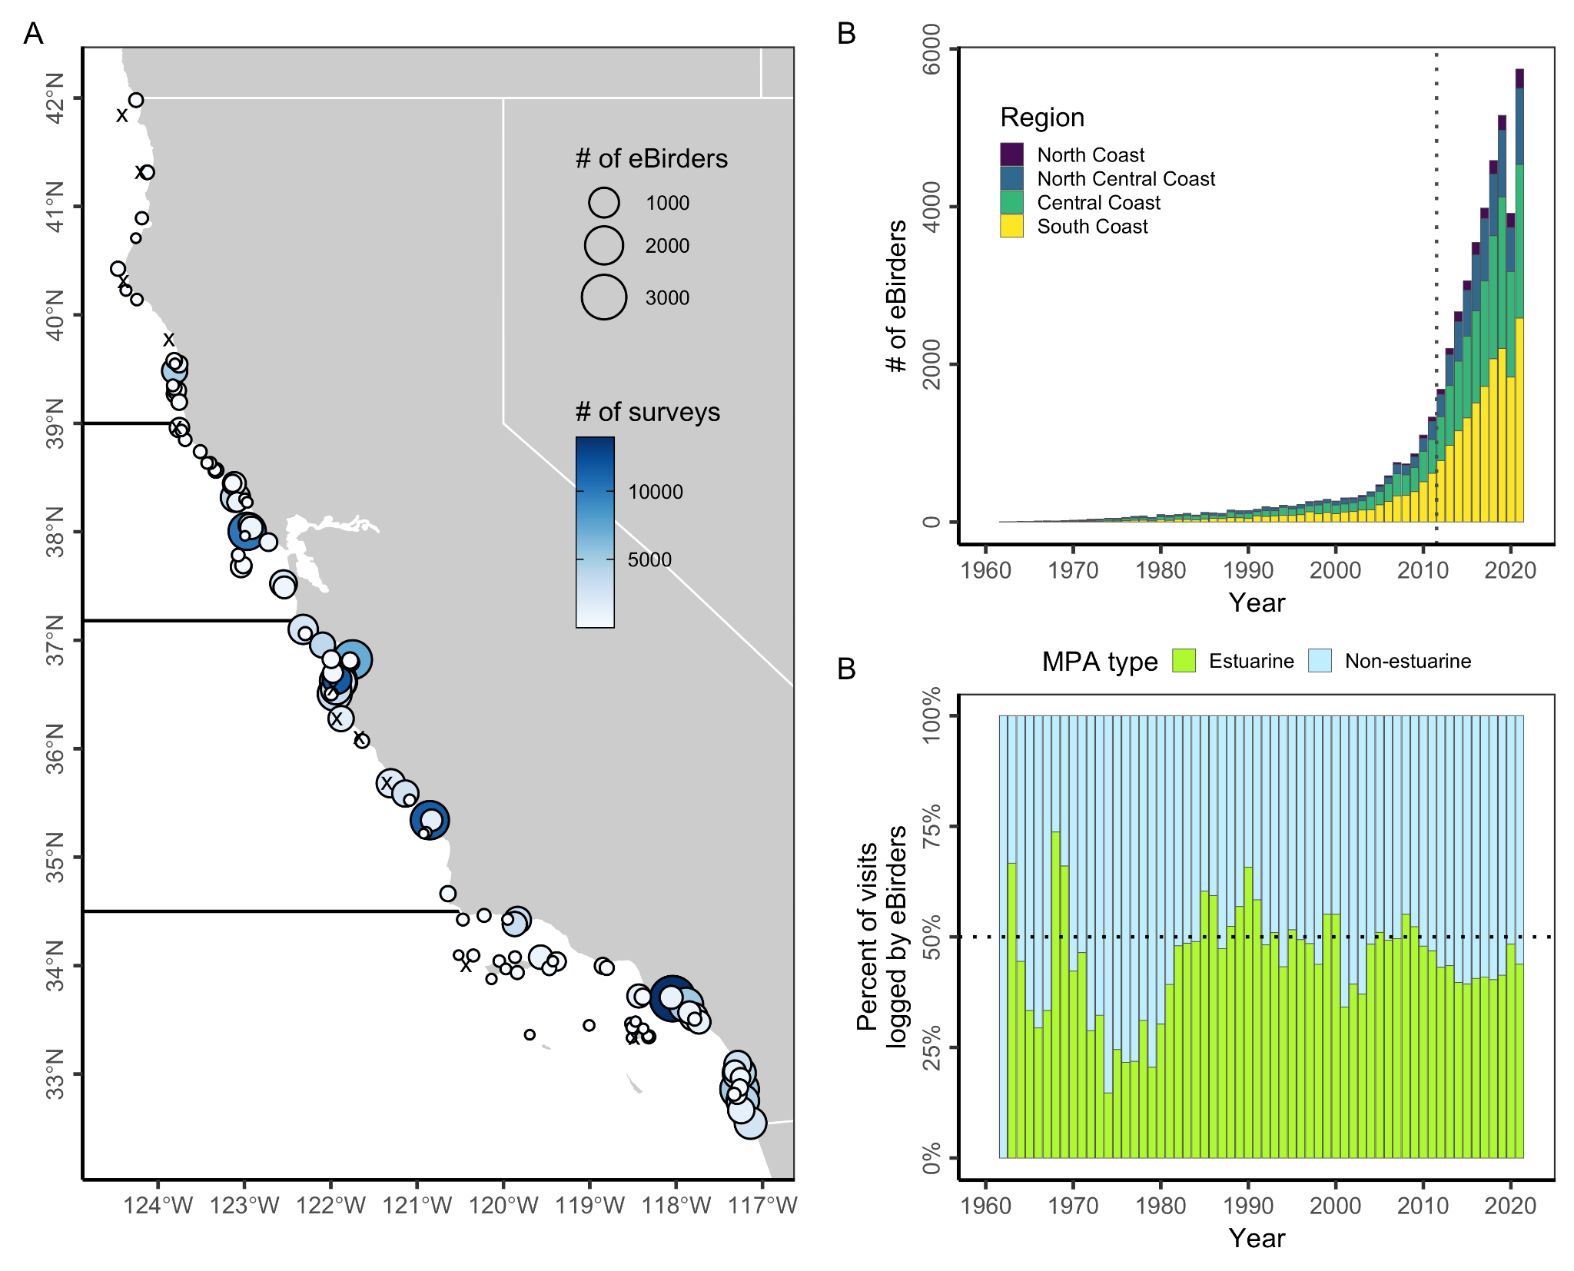

**Figure S11.** Human engagement in birding within California’s state marine protected areas (MPAs) based on submissions to the eBird citizen science program. Panel **A** shows the total number of eBirders (point size) and surveys (color ramp) submitted by eBirders from within 100 m of California’s MPAs from 2012 through 2021. Black x’s mark the 11 MPAs without any eBird submissions. Dark horizontal lines delineate the four MLPA regions. Panel **B** shows the number of eBirders making observations from within 100 m of California MPAs from 1960-2021. Panel **C** shows the percent of visits to MPAs logged by eBirders occurring from within estuarine and non-estuarine MPAs from 1960-2021. Estuarine MPAs represent 2% of the network by area and 17% by count.

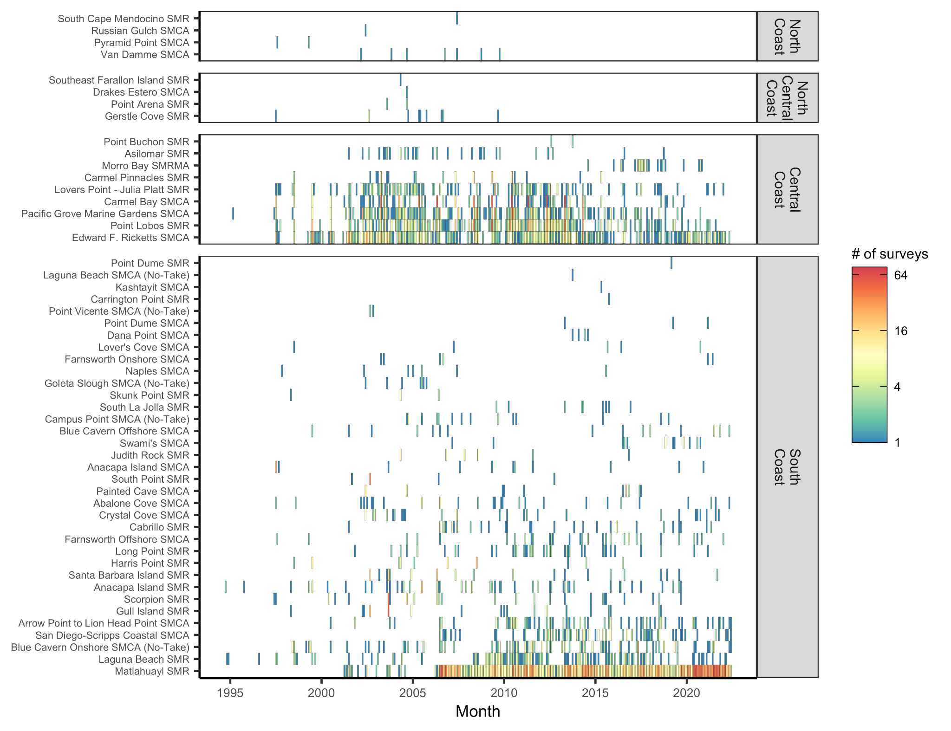**Figure S12.** Coverage of REEF survey data over time by marine protected area (MPA). Note log-scale for fill color. MPAs are listed in order of overall sample size within each region. One San Francisco Bay MPA (Redwood Shores SMP) is plotted in the North Central Region for simplicity.

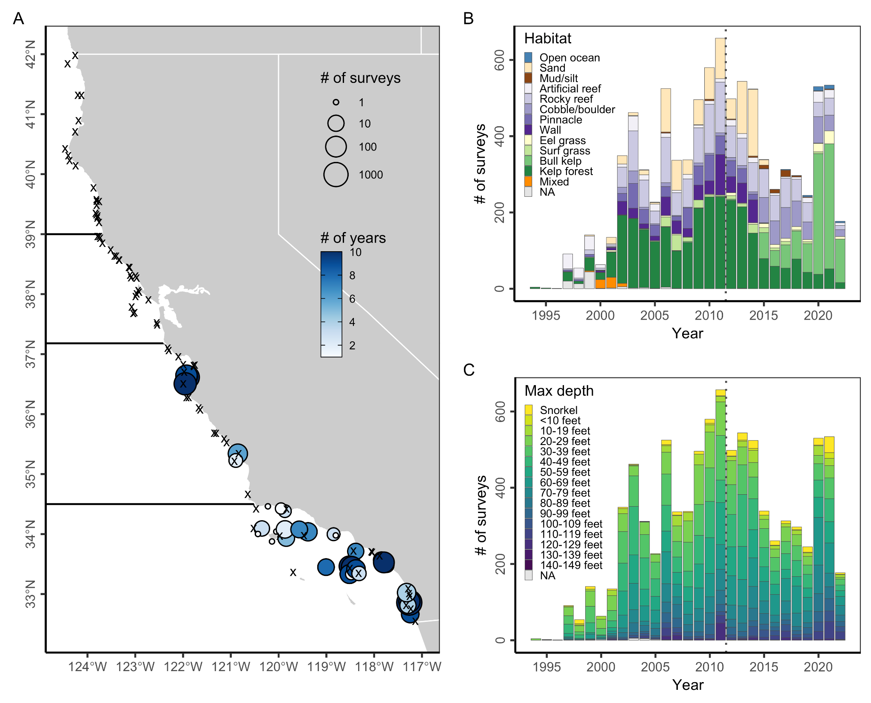

**Figure S13.** Engagement of recreational divers and snorkelers in the REEF citizen science survey program within California’s state marine protected areas (MPAs). Panel **A** shows the number of surveys (point size) conducted in California’s MPAs from 2012 through 2021 and the number of years with survey data (color ramp) for each MPA. Note log-scale in point size. Black x’s mark the 83 MPAs without any REEF surveys. Dark horizontal lines delineate the four MLPA regions. Panel **B** shows the number of surveys within California’s MPA network from 1994-2022 by habitat type. Panel **C** shows the number of surveys within California’s MPA network from 1994-2022 by depth zone.

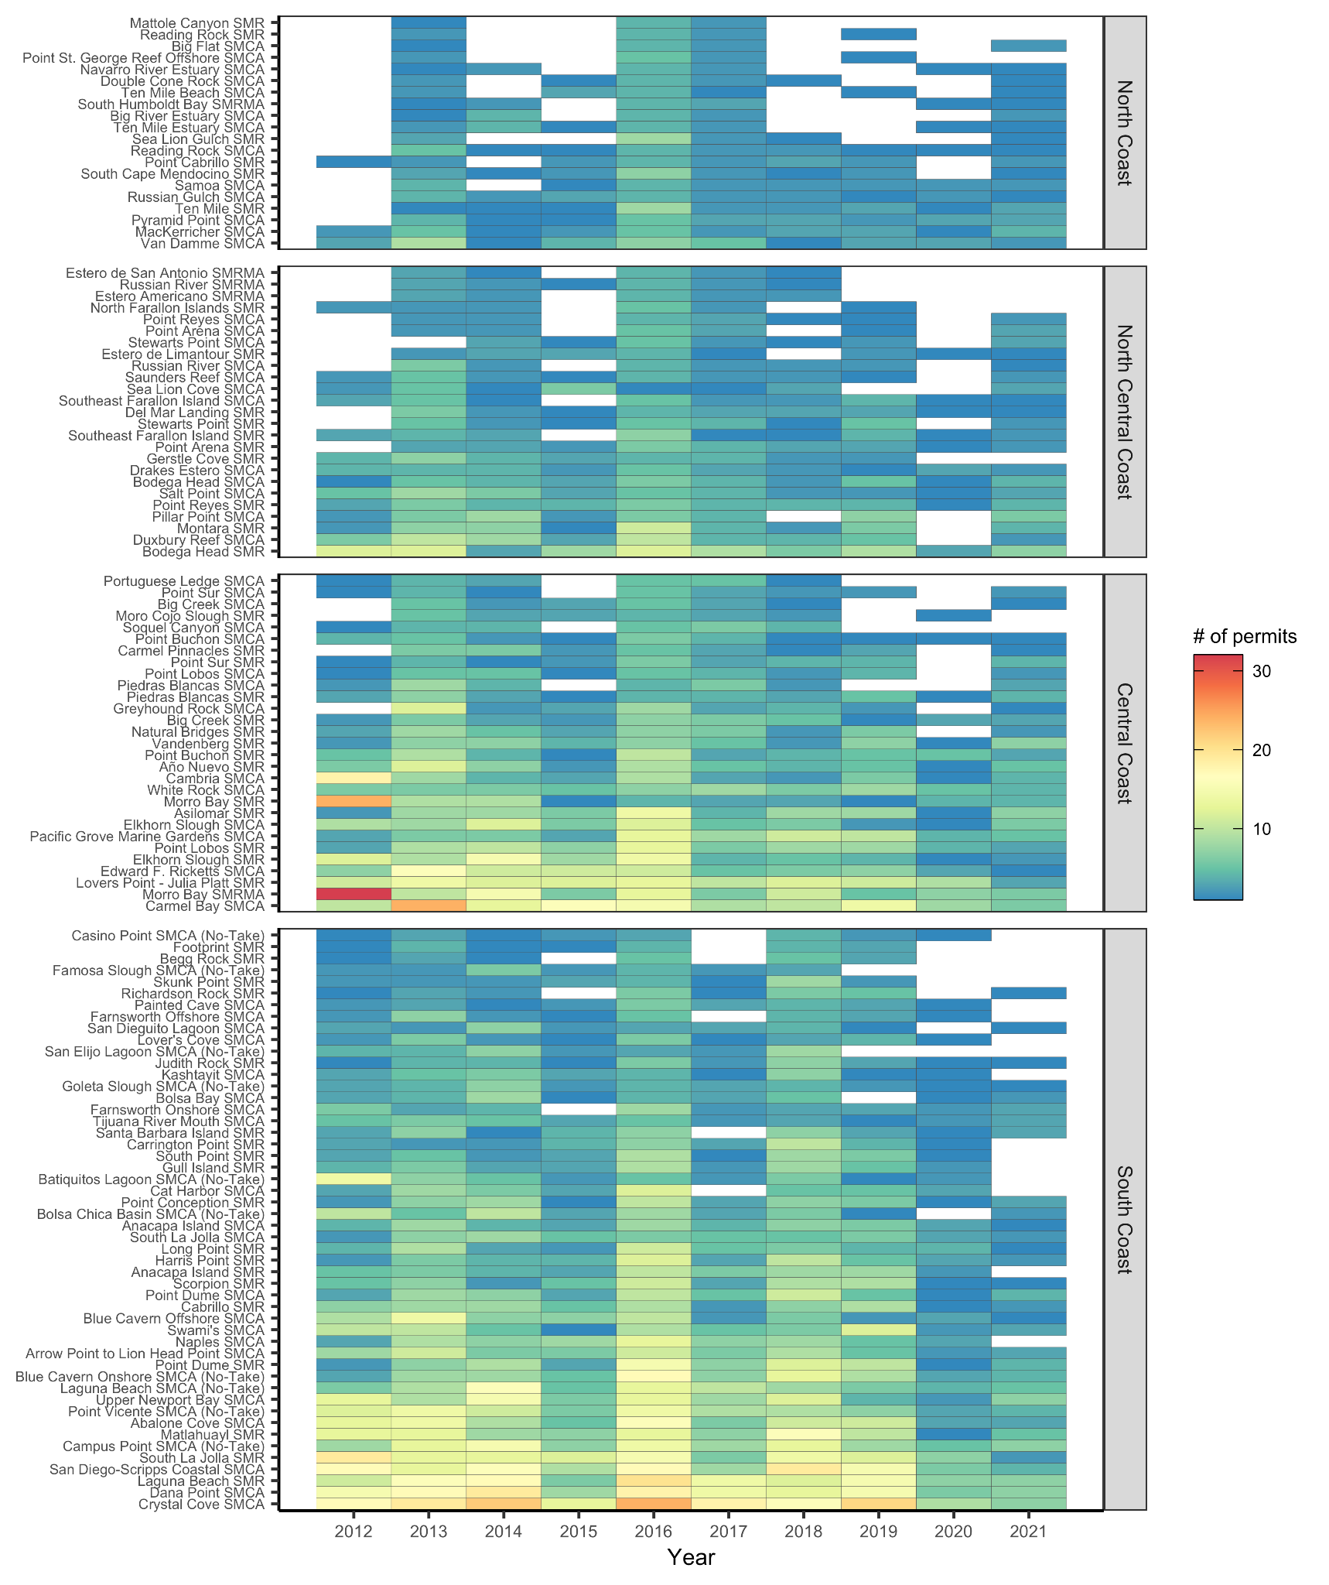**Figure S14.** Number of scientific permits issued annually from 2012 to 2021 by marine protected area (MPA). MPAs are listed in order of overall sample size within each region.

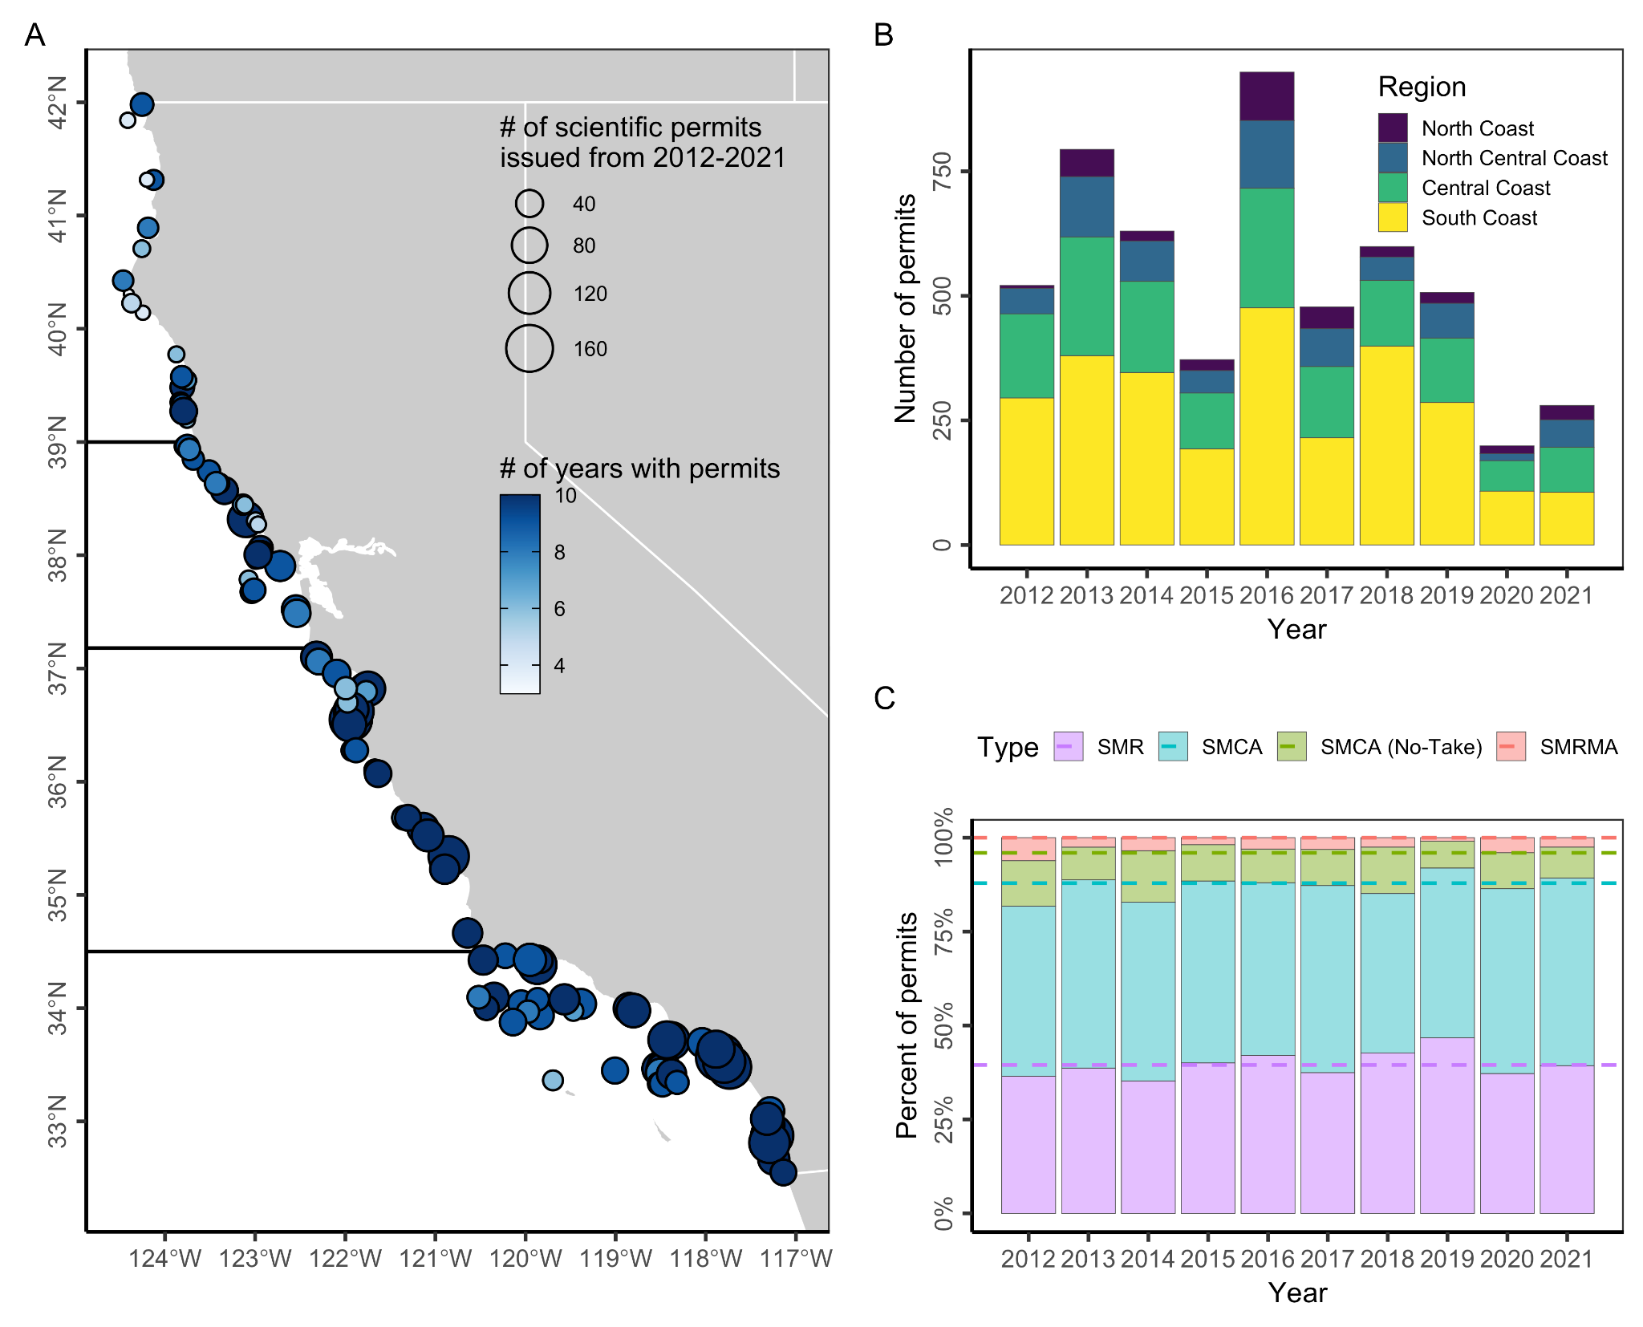**Figure S15.** Number of scientific permits issued for research within California's state marine protected areas (MPAs) from 2012 through 2021. Panel **(A)** shows the number of scientific permits issued (point size) and number of years in which permits were issued (color ramp) for each MPA. Dark horizontal lines delineate the four MLPA regions. In **(B)**, bars indicate the percentage of annual permits issued to MPAs of different designations and lines indicate the representation of MPAs of those designations in the network.

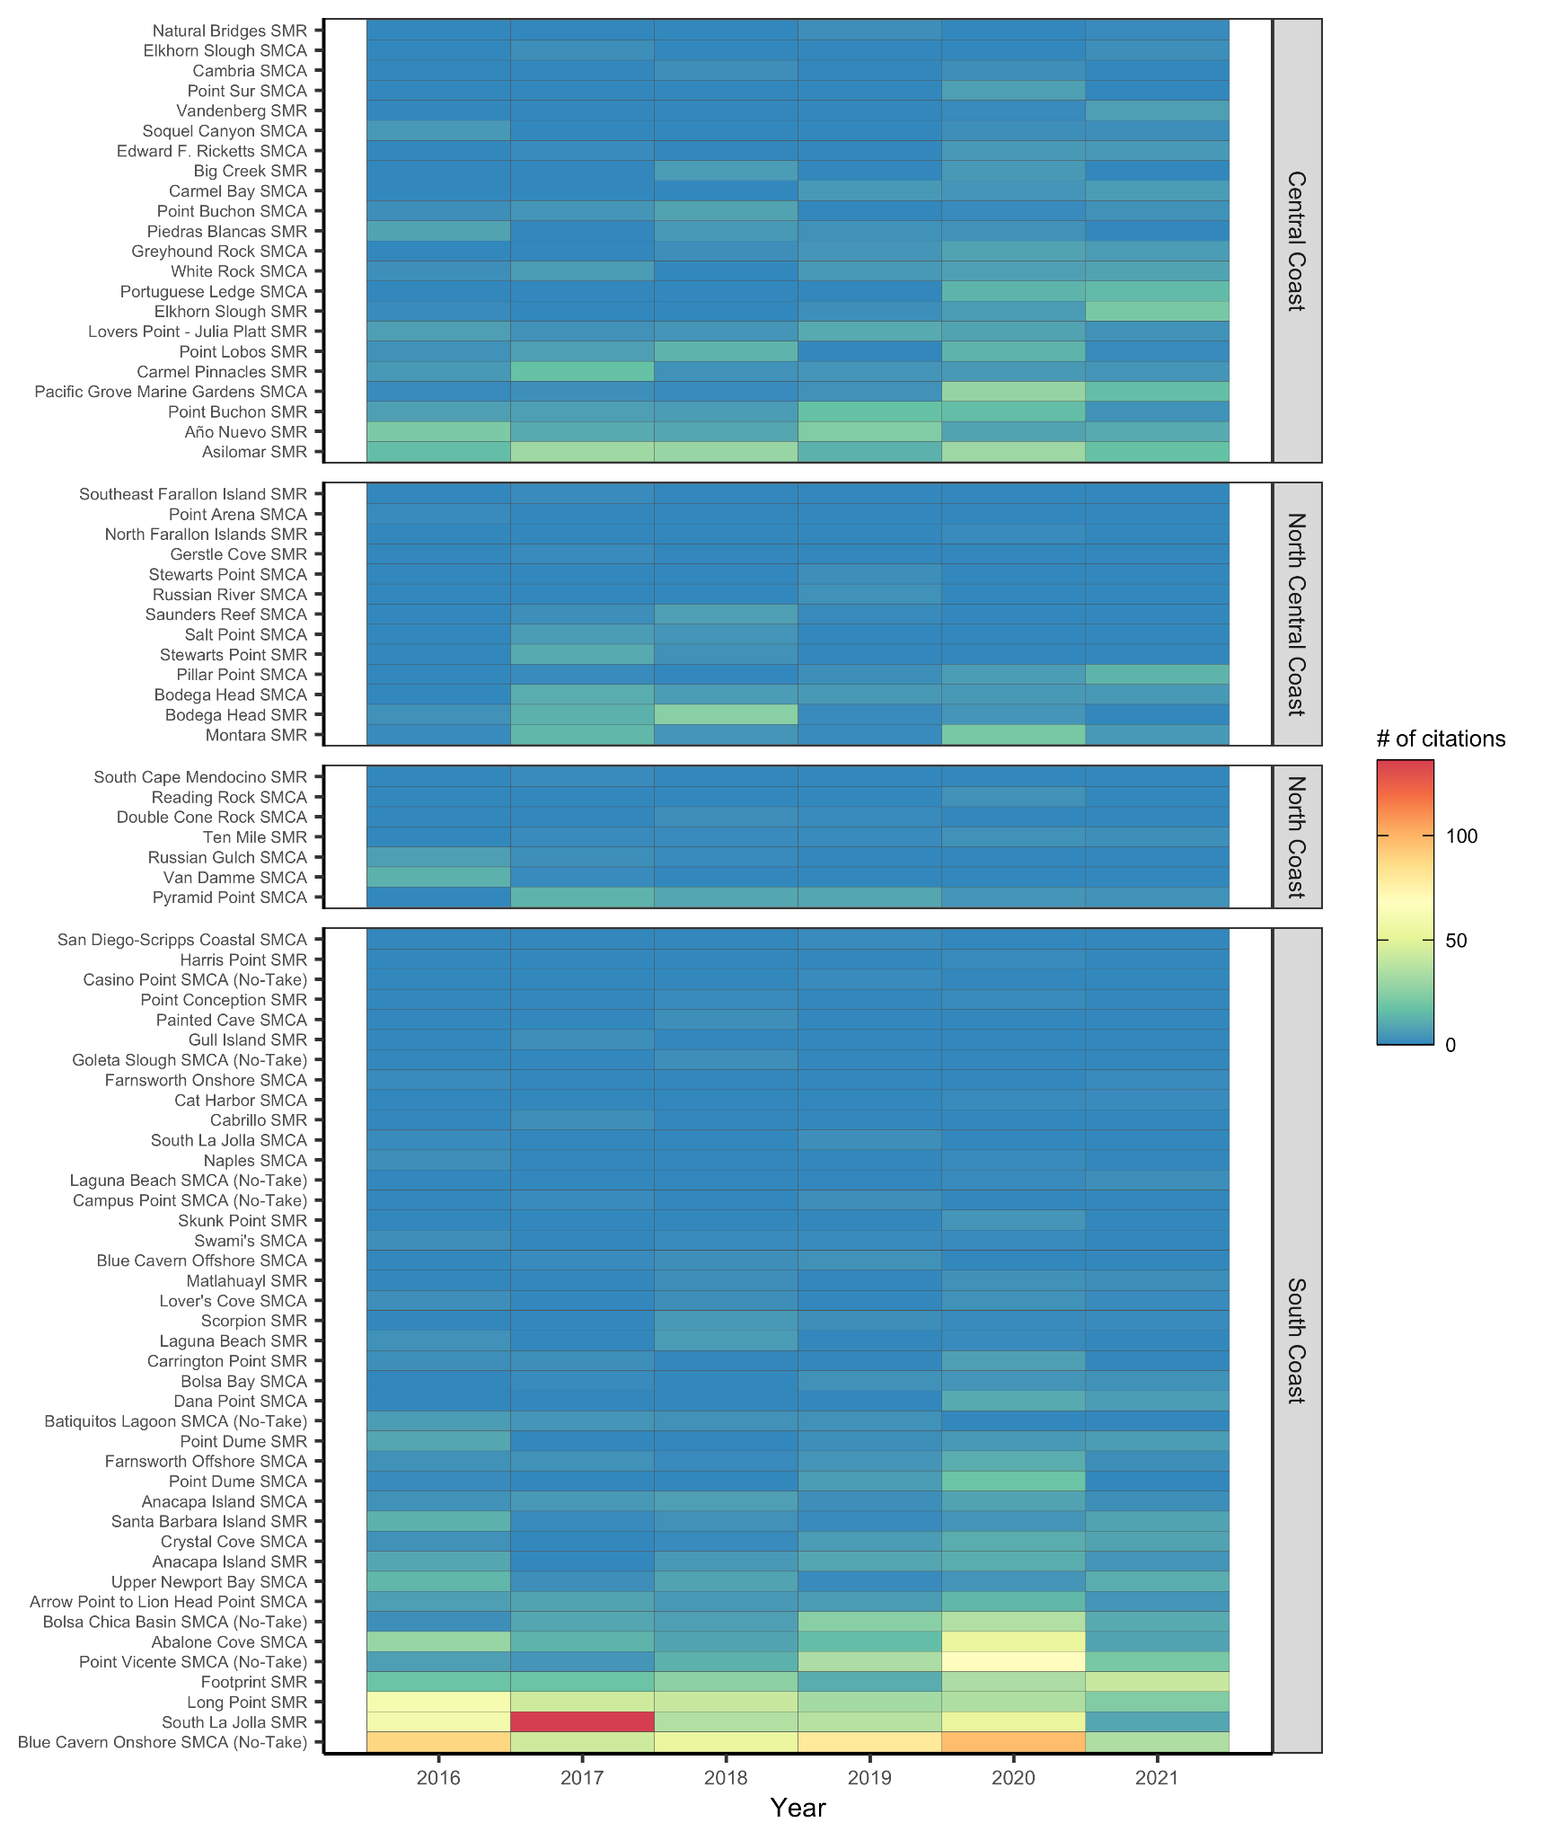

**Figure S16.** Number of citations issued by CDFW Law Enforcement for regulatory violations occurring within California’s MPAs from 2016 to 2021. MPAs are listed in order of overall sample size within each region.

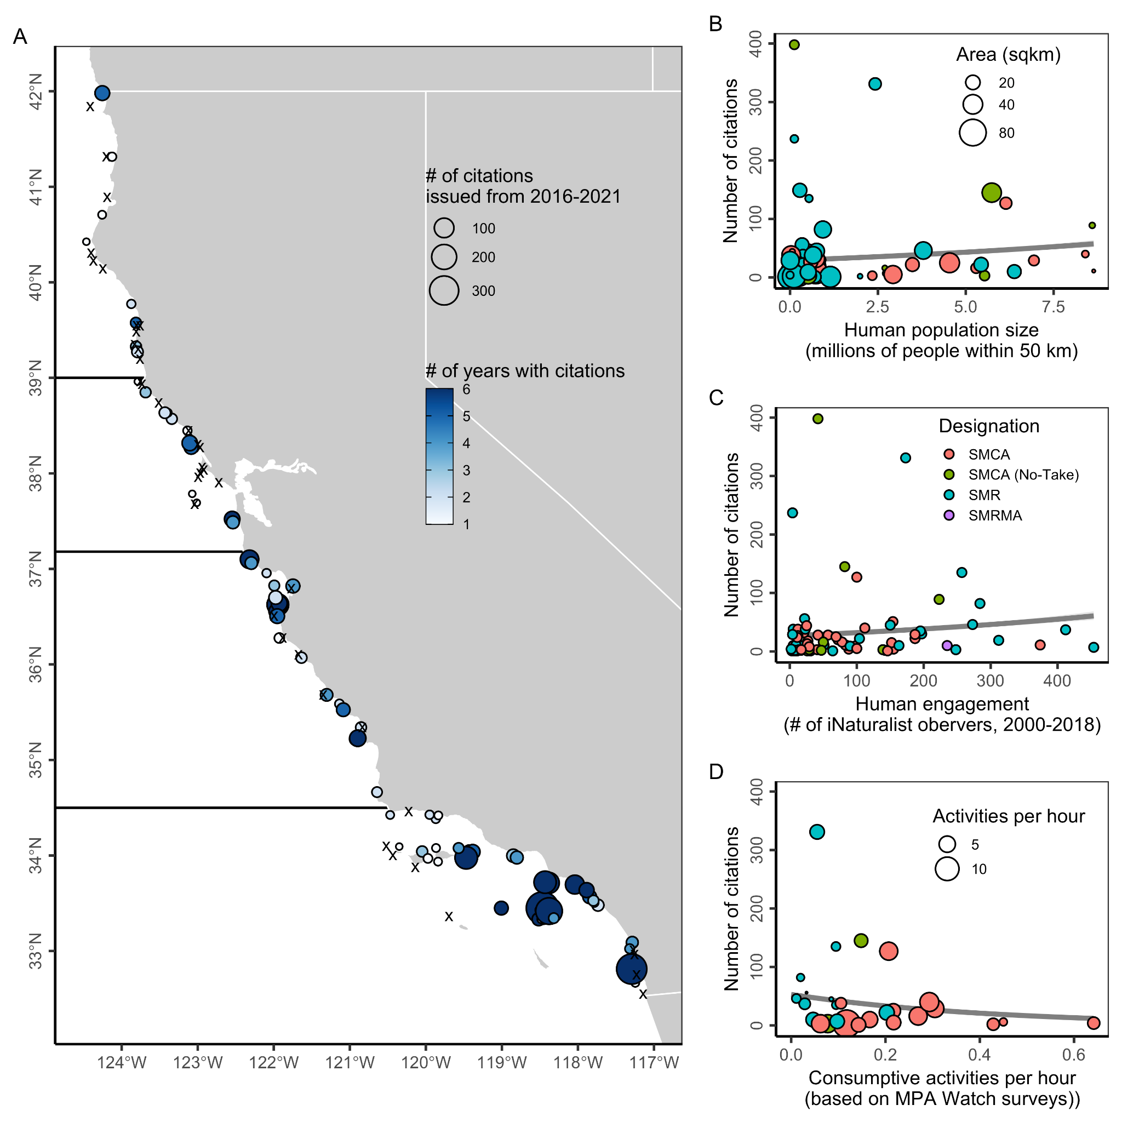**Figure S17.** Number of citations issued by CDFW Law Enforcement for regulatory violations occurring within California's state marine protected areas (MPAs) from 2016 through 2021. In Panel **A**, black x’s mark the 39 MPAs without any citations and dark horizontal lines delineate the four MLPA regions. In Panels **B-D**, the gray line and 95% confidence interval illustrate a generalized linear model assuming a Poisson distribution fit to the data.

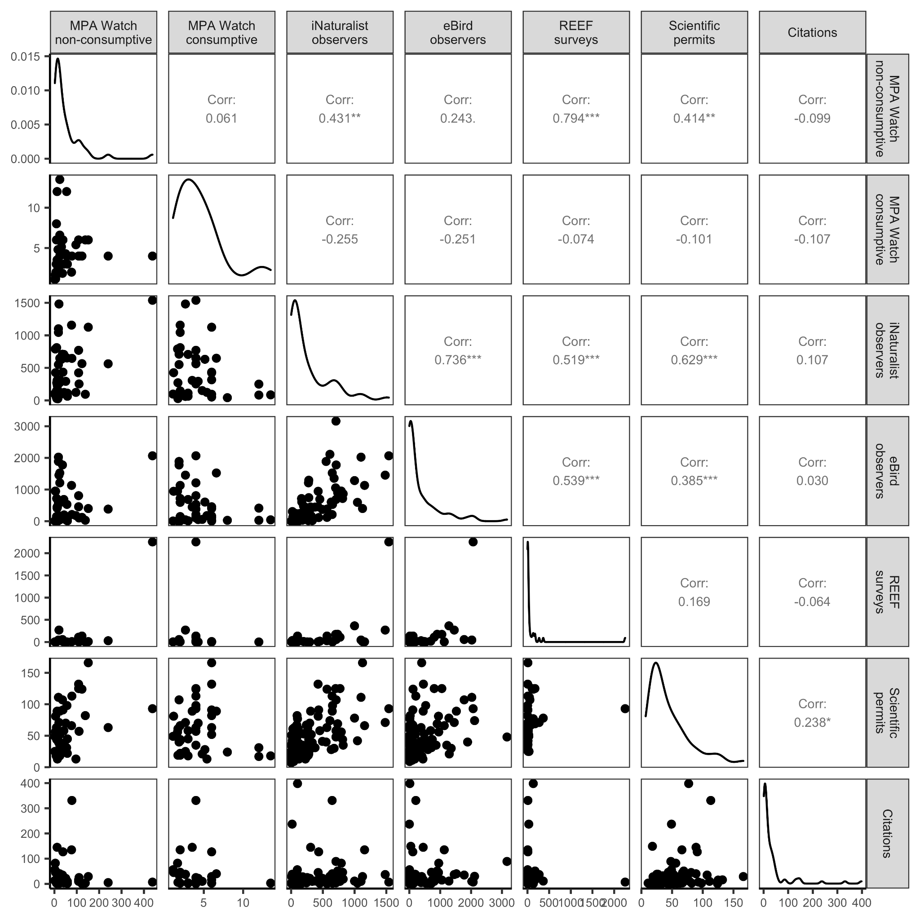**Figure S18.** Correlation between human engagement indicators. The lower section shows pairwise comparisons of engagement indicators. The upper section shows the correlation between each pairwise combination of indicators and the statistical significance of this correlation (* = p < 0.05; ** = p < 0.01; and *** = p < 0.001). The diagonal indicates the distribution of each engagement indicator. See **Table S3** for the choice of displayed indicator.

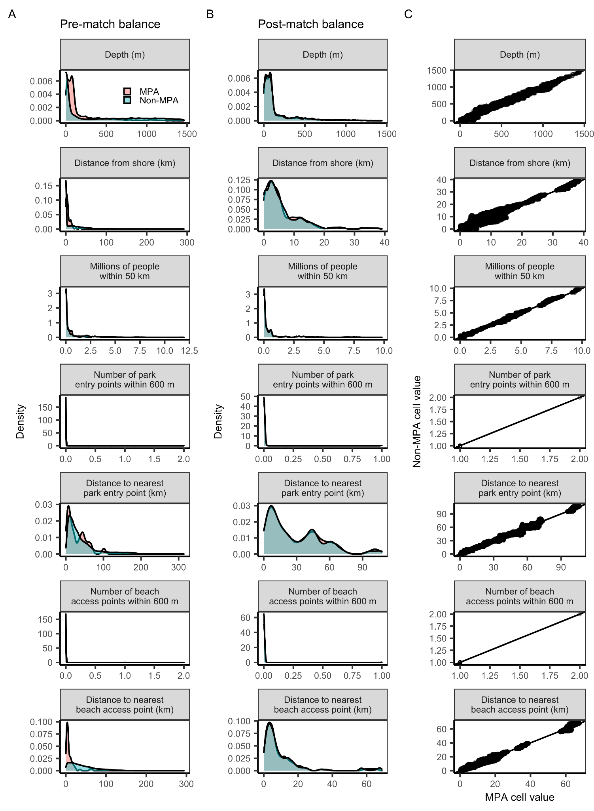

**Figure S19.** The balance of matching variables **(A)** pre- and **(B)** post-matching and the **(C)** correlation between the values of MPA and matched non-MPA raster cells. In **(C)**, the black line is the one-to-one line.

**Table S1.** California marine protected area (MPA) designations.

|  |  |  |
| --- | --- | --- |
| **Designation** | **# / area (km2)** | **Restrictions** |
| ***State marine protected areas*** | ***124 / 2207 km2*** |  |
| State marine reserve (SMR) | 49 / 1229 km*2* | Prohibits comm/rec take of all marine resources* |
| State marine conservation area (SMCA) | 60 / 880 km*2* | Prohibits comml/rec take of selected marine resources |
| State marine conservation area (no take) | 10 / 86 km*2* | Prohibits comm/rec take of all marine resources but allows permitted activities that cause damage (e.g., dredging) |
| State marine recreational management area (SMRMA) | 5 / 12 km*2* | Limits comm/rec take of marine resources but allows legal waterfowl hunting |
| ***Other state management areas*** | ***22 / 20 km2*** |  |
| State marine park (SMP) - all in SF Bay | 7 / 17 km*2* | Prohibits damage or commercial take of all marine resources; recreational take is allowed |
| State marine conservation area (SMCA) - SF Bay | 1 / 0 km*2* | Prohibits comml/rec take of selected marine resources |
| Special closure | 14 / 8 km*2* | Prohibits or restricts activities in waters adjacent to seabird rookeries or marine mammal haul-out sites |
| ***Federal marine protected areas*** | ***9 / 394 km2*** |  |
| Federal marine reserve (FMR) | 8 / 388 km*2* | Extends SMRs around the Channel Islands into federal waters |
| Federal marine conservation area (FMCA) | 1 / 6 km*2* | Extends SMCAs around the Channel Islands into federal waters |

* Marine resources can be living, geologic, or cultural

**Table S2.** Social vulnerability indicators and metrics used to calculate the social vulnerability index. Direction of influence indicates whether the metric was assumed to increase (positive) or decrease (negative) vulnerability. Data used were from the 2010 American Community Survey. Geographic unit for all data is the census tract.

|  |  |
| --- | --- |
| **Indicator** | **Direction of Influence** |
| *Housing Characteristics* |  |
| Median monthly mortgage (USD) | Negative |
| Median monthly rent (USD) | Negative |
| Median number of rooms per housing unit | Negative |
| Percent of all family households that live in mobile homes | Positive |
| *Labor Force Structure* |  |
| Percent of age 16+ population that are working females | Negative |
| Percent of age 16+ population that are working | Negative |
| *Population Composition* |  |
| Percent of families with single females as head of household | Positive |
| Percent of population age 5 and older that speak English less than “very well” | Positive |
| Percent of population whose race is white, with no other descriptors | Negative |
| Percent of the population younger than age 6 | Positive |
| *Poverty Status* |  |
| Percent of families living below the poverty line | Positive |
| Percent of people under age 18 living below the poverty line | Positive |
| Percent of people receiving cash assistance or SNAP payments | Positive |
| Percent of people age 65 and over living below the poverty line | Positive |

**Table S3.** Indicators of human engagement evaluated in this paper. The bolded metric indicates the metric used in the scorecard and accumulation curve analysis.

|  |  |  |  |
| --- | --- | --- | --- |
| **Indicator and source** | **Description** | **Metrics** | **Limitations** |
| MPA Watch (www.mpawatch.org) | **Recreation:** MPA Watch is a community science program that trains volunteers to observe and collect data on human uses of protected areas [(MPA Watch, 2022b)](https://www.zotero.org/google-docs/?HSrpFe). Volunteers use a standardized survey protocol [(MPA Watch, 2022a)](https://www.zotero.org/google-docs/?PLffbb) to record consumptive (e.g., fishing) and non-consumptive (e.g., surfing, boating, tidepooling, running, etc.) activities occurring offshore and onshore of coastal sampling sites. | **(1) the median number of activities observed per hour for surveys in which activities were observed (i.e., zeroes excluded);** (2) percent of surveys in which an activity was observed | There is limited ability to infer the legality of the consumptive activity observed by MPA Watch volunteers because some MPAs allow some forms of harvest and MPA Watch volunteers, while well-trained, are not legal authorities on MPA boundaries and regulations. |
| iNaturalist (www.inaturalist.org) | **Recreation/education:** iNaturalist is a web- and app-based platform that allows observers to submit wildlife photos for identification by amateur and professional naturalists [(iNaturalist, 2022)](https://www.zotero.org/google-docs/?Unmwvc). | **(1) number of iNaturalist users who submitted observations**; (2) number of submitted observations | Participation in iNaturalist largely depends on smartphone ownership and fluency and likely represents a biased (younger, wealthier) demographic. |
| eBird  (www.ebird.org) | **Recreation/education:** eBird is a global citizen science program that collates observations of birds submitted by birdwatchers [(eBird, 2022)](https://www.zotero.org/google-docs/?gK2fht). | **(1) number of eBird users who submitted observations;** (2) number of submitted observations | Participation in eBird is eased by smartphone ownership and fluency and likely represents a biased (younger, wealthier) demographic. |
| REEF  (www.reef.org) | **Recreation/education:** REEF is an international marine conservation organization that trains volunteer divers and snorkelers to collect and report information on marine fish and selected invertebrate and algae species [(REEF, 2022)](https://www.zotero.org/google-docs/?IryJCQ). | **(1) number of surveys conducted;** (2) number of years in which a survey was conducted | The REEF Program is based in southern California and trainings are largely conducted in this area. As a result, participation is greatly biased towards southern California. |
| Scientific permits  (CA Dept. Fish & Wildlife) | **Scientific research:** Permits issued by CDFW for scientific research provide an indicator of scientific research activity throughout California’s MPA network. | **(1) number of permits issued;** (2) number of years in which permits were issued. | There are no apparent limitations to this dataset. However, we note that there are more scientific institutions in Southern/Central CA than Northern CA and that conditions for fieldwork are worse in Northern CA. |
| Law enforcement citations  (CA Dept. Fish & Wildlife) | **Non-compliance:** Regulatory citations from CDFW’s Law Enforcement Division provide an indicator of where non-compliance occurs throughout California’s MPA network. | **(1) number of citations issued;** (2) number of years in which citations were issued. | The lack of effort information (e.g., number of patrol hours) associated with the citation frequency data limits ability to infer non-compliance rates. For example, high frequency could reflect either greater enforcement activity or greater illegal activity. |

**Table S4.** Human use activities recorded by MPA Watch volunteers.

​

|  |  |  |
| --- | --- | --- |
| **Activity type** | **Activity** | **Subcategories** |
| *Non-consumptive* |  |  |
| Onshore recreation | Beach recreation | sandy/rocky |
| Onshore recreation | Wildlife watching | sandy/rocky |
| Onshore recreation | Domestic animals | sandy/rocky; on/off leash |
| Onshore recreation | Driving on the beach |  |
| Onshore recreation | Tide-pooling |  |
| Offshore recreation | Offshore recreation (e.g. swimming) |  |
| Offshore recreation | Surfing |  |
| Offshore recreation | Other board sports |  |
| Offshore recreation | SCUBA diving or snorkeling |  |
| Boating | Kayaking |  |
| Boating | Paddleboarding |  |
| Boating | Other paddleboating |  |
| Boating | Sailing |  |
| Boating | Windsurfing |  |
| Boating | Jet skiing |  |
| Boating | Power boating |  |
| Boating | Whale watch boat |  |
| Boating | Dive boat |  |
| Boating | Work boat |  |
| Boating | Law enforcement boat |  |
| Boating | Other boating |  |
| *Consumptive* |  |  |
| Fishing | Hand collection of biota | sandy/rocky |
| Fishing | Hook and line fishing | onshore/boat; sandy/rocky (if shore); rec/comm/unknown (if boat); active/inactive (if boat) |
| Fishing | Trap fishing | onshore/boat; sandy/rocky (if shore); rec/comm/unknown (if boat); active/inactive (if boat) |
| Fishing | Net fishing | onshore/boat; sandy/rocky (if shore); rec/comm/unknown (if boat); active/inactive (if boat) |
| Fishing | Spear fishing | onshore/offshore/boat; sandy/rocky (if shore); rec/comm/unknown (if boat); active/inactive (if boat) |
| Fishing | Dive fishing | offshore/boat; rec/comm/unknown (if boat); active/inactive (if boat) |
| Fishing | Kelp harvesting | active/inactive |
| Fishing | Passenger fishing | active/inactive/unknown |
| Fishing | Unknown fishing |  |

**Table S5.** Sources of explanatory variables included in logistic regressions evaluating traits associated with charismatic and underutilized MPAs.

|  |  |
| --- | --- |
| **Variable** | **Source** |
| *Design feature* |  |
| MPA age (yr) | CDFW (2019) MPA GIS file.  Available at: https://filelib.wildlife.ca.gov/Public/R7_MR/MANAGEMENT/MPA/ |
| MPA size (km2) | CDFW (2019) MPA GIS file.  Available at: https://filelib.wildlife.ca.gov/Public/R7_MR/MANAGEMENT/MPA/ |
| Protection status  (no-take, some take) | CDFW (2019) MPA GIS file.  Available at: https://filelib.wildlife.ca.gov/Public/R7_MR/MANAGEMENT/MPA/ |
| *Habitat type* |  |
| Sandy beach (km) | CDFW MPA habitat mapping |
| Rocky intertidal (km) | CDFW MPA habitat mapping |
| Estuary (km) | CDFW MPA habitat mapping |
| Maximum kelp canopy (km2) | CDFW MPA habitat mapping |
| *Accessibility and amenities* |  |
| Distance to port (km) | CDFW (2022) Fishing ports. Available from CDFW. |
| Number of parks within 1 km | ESRI (2022) USA Parks.  Available at: https://www.arcgis.com/home/item.html?id=578968f975774d3fab79fe56c8c90941 |
| Number of parking lots within 1 km | CDPR (2022) Parking. California Department of Parks and Recreation.  Available at: https://www.parks.ca.gov/?page_id=29682 |
| Number of picnic areas within 1 km | CDPR (2022) Picnic Grounds. California Department of Parks and Recreation.  Available at: https://www.parks.ca.gov/?page_id=29682 |
| Number of campgrounds within 1 km | CDPR (2022) Campgrounds. California Department of Parks and Recreation.  Available at: https://www.parks.ca.gov/?page_id=29682 |
| *Social vulnerability* |  |
| Social vulnerability index | See methods for details. |

**Table S6.** Matching variables used in the design of counterfactual areas and their sources.

|  |  |
| --- | --- |
| **Matching variable** | **Source** |
| Depth (m) | CDFW (2011) Bathymetry. California Department of Fish and Wildlife. Available at: https://filelib.wildlife.ca.gov/Public/R7_MR/BATHYMETRY/ |
| Distance from shore (km) | CDFW (2011) Coastline. California Department of Fish and Wildlife. Available at: https://filelib.wildlife.ca.gov/Public/R7_MR/BASE/ |
| Number of people within 50 km | USCB (2010) US Census Data. United States Census Bureau. Available at: https://www.census.gov/programs- surveys/decennial- census/decade/2010/about-2010.html |
| Number of park entry points within 600 m | CDPR (2022) Park Entry Points. California Department of Parks and Recreation. Available at: https://www.parks.ca.gov/?page_id=29682 |
| Distance to nearest park entry point (m) | CDPR (2022) Park Entry Points. California Department of Parks and Recreation. Available at: https://www.parks.ca.gov/?page_id=29682 |
| Number of public beach access points within 600 m | CCC (2022) Public Access Points. California Coastal Commission. Available at: https://gis.data.ca.gov/datasets/coastalcomm::public-access-points/about |
| Distance to nearest public beach access point (m) | CCC (2022) Public Access Points. California Coastal Commission. Available at: https://gis.data.ca.gov/datasets/coastalcomm::public-access-points/about |

**Table S7.** Attributes of ‘charismatic’ and ‘underutilized’ MPAs by type of engagement, based on the results of stepwise logistic regressions. Missing values indicate the best fit model does not include the associated predictors*. In each model, “typical” MPAs were set as the reference level and evaluated against charismatic or underutilized MPAs. Coefficients returned by each model are reported as odds ratio. CI = 95% confidence interval; AIC = Akaike Information Criterion.

|  |  |  |  |  |  |  |
| --- | --- | --- | --- | --- | --- | --- |
|  | **Charismatic vs. typical** | | | **Underutilized vs. typical** | | |
| *Predictors* | *Odds Ratios* | *CI* | *p* | *Odds Ratios* | *CI* | *p* |
| (Intercept) | 0.00 | 0.00 – 0.13 | **0.007** | 0.62 | 0.24 – 1.53 | 0.302 |
| Distance to port (km) | 1.00 | 1.00 – 1.00 | 0.065 | 1.00 | 1.00 – 1.00 | **<0.001** |
| MPA size (km2) | 0.94 | 0.87 – 1.01 | 0.121 |  |  |  |
| Take? (yes/no) | 0.26 | 0.05 – 1.18 | 0.093 |  |  |  |
| Sandy beach (km) | 1.49 | 1.08 – 2.19 | **0.022** | 0.61 | 0.39 – 0.87 | **0.016** |
| MPA age (yr) | 1.58 | 1.15 – 2.29 | **0.007** |  |  |  |
| # of parks within 1 km | 1.28 | 1.09 – 1.56 | **0.006** |  |  |  |
| Rocky intertidal (km) |  |  |  | 0.80 | 0.61 – 1.03 | 0.101 |
| # of parking lots within 1 km |  |  |  | 0.42 | 0.15 – 0.71 | **0.019** |
| Observations | 71 | | | 92 | | |
| R2 Tjur | 0.466 | | | 0.446 | | |
| AIC | 59.527 | | | 84.254 | | |

* Predictors not included in the reduced models include: maxim kelp canopy (km2), estuary extent (km), number of campgrounds within 1 km, number of picnic areas within 1 km (see **Table S5** for details).